SAMET: A machine- learning web based platform for management, interpretation and analysis of IR spectral data

Dr. Amirhossein Sakhteman,Medicinal chemistry PhD, Department of Medicinal Chemistry, School of Pharmacy, Shiraz University of Medical Sciences, Shiraz, Iran

Dr. Maryam Kabiri,Pharmacy student , Department of Medicinal Chemistry, School of Pharmacy, Shiraz University of Medical Sciences, Shiraz, Iran

Introduction
Versatile supervised and unsupervised machine learning techniques are widely used in different branches of pharmaceutical sciences. Application of supervised techniques including hierarchical cluster analysis (HCA), k-means and kohonen neural network in clustering of different spectral data such as infra-red (IR) spectroscopy can lead to better interpretation as well as investigation of batch to batch variations in chemicals (1). To integrate different unsupervised learning methods as well as providing a suitable management platform in an easy to use interface, we designed and developed a web based software in django frame work by means of python and JS programming (2). SAMET (Spectral Analysis via Machine Learning Estimation of Trained models) can be hosted in both windows and linux operating systems for management and analysis of IR spectral data. This software can visualize, present descriptive interpretation for IR spectroscopy and perform unsupervised learning methods on dpt files resulting from IR spectroscopy. This platform can be utilized in different branches of pharmaceutical industry such as quality control labs.

Material and Methods

SAMET was developped as a web based platform in backend running on python 3.6 and in front end runing on HTML and javascripts.
For visualization of dpt files, we used both matplotlib in Python and amcharts in java script to provide facile and interactive visualization platform for analysis of IR data. Different clustering methods including HCA and kmeans were implemented in the backend of SAMET as python scripts using scikit learn libraries in order to provide a comprehensive machine learning analysis for batch to batch variations in pharmaceutical preparations. Meanwhile, the user can select normalization methods like SNV (standard normal variate) for baseline corrections before clustering analysis of data. In the interactive JS panel, the user can select different peaks and subsequently presence of different functional groups will be displayed in the selected regions. Different modules of SAMET were tested using dpt files resulting from an IR vertex 70 spectrometer at Shiraz University of Medical Sciences.

Results

The applicability of SAMET was verified in a case study with different batches of montelukast using ATR-IR data. The results revealed that by using a normalization method before data analysis and performing HCA, different batches of monetlukast can be recognized using SAMET as separate clusters.

Discussion

Due to different management and analysis methods implemented in SAMET, in can be presented as a novel product for visualization and investigation of batch effects in pharmaceutical industry(3). Since different clustering methods can provide results with minor changes, SAMET benefits from two different analysis methods including HCA and k-means to allow users for a better comparison and results of unsupervised methods.

Conclusion

A web based platform was developed to investigate batch to batch variation as well as interpretation of spectral data. This platform incorporates different machine learning methods in the background and can be considered as a management and analysis application in quality control and batch to batch variation.
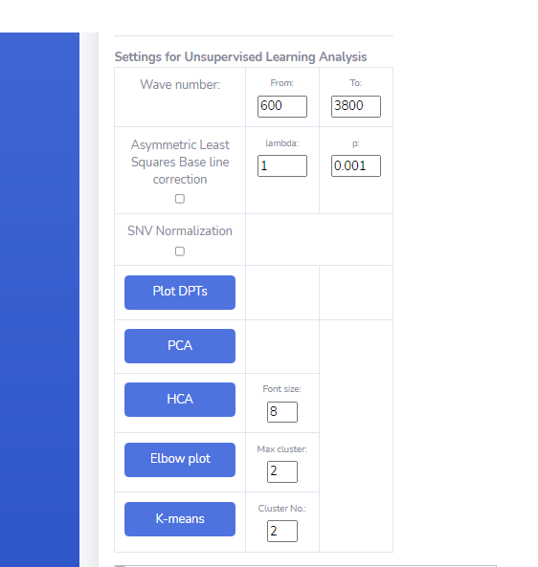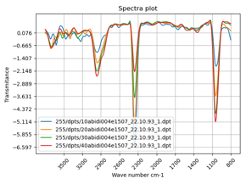

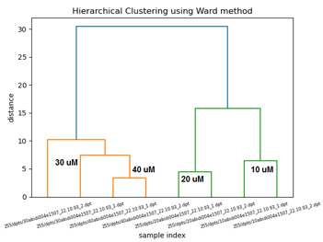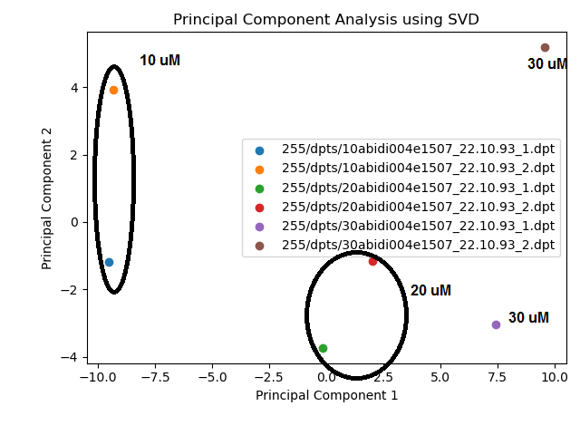

Recent Publications
1. Kumooka Y. Hierarchical cluster analysis as a tool for preliminary discrimination of ATR-FT-IR spectra of OPP acrylic and rubber-based adhesives. Forensic science international. 2009;189(1-3):104-10.
2. Forcier J, Bissex P, Chun WJ. Python web development with Django: Addison-Wesley Professional; 2008.
3. de Macêdo IYL, Machado FB, Ramos GS, do Carmo Costa AG, Batista RD, Galvão Filho AR, et al. Starch adulteration in turmeric samples through multivariate analysis with infrared spectroscopy. Food Chemistry. 2021;340:127899.

 Dr. Maryam Kabiri is a PharmD,MPH student with experience in molecular modeling,computational drug discovery, toxicological screening of synthetic and natural products and bioinformatics.The most prominent goal of her research is to find out novel in silico pipelines in drug design and discovery,molecular dynamics simulation of membrane proteins and drug delivery

Email: kabiriyasaman8@gmail.com

