Efficacy Medical Countermeasure agent and Chemical therapeutic development for repurposing against Chemical and Biological threat agents, and bio-modelling capabilities of the MCMs for CBRNe agents

Dr Salako Olatunji, CCACBWA LAGOS, Nigeria

Abstract
SodaSulphanecobalamin (Na4S5 CoC69N15H89O26) is an effective Medical Countermeasure agent against Chemical and Biological warfare Agents for critical treatment of their acute health effects, which detoxify and decentralized the toxic substances in some chemical based threat mainly. Classical chemical agent threat categories include vesicant or blister agents (e.g., sulfur mustard), blood agents (e.g., cyanide), respiratory agents (e.g., phosgene), and nerve agents (e.g., GA or Tabun, GB or Sarin, GD or Soman, and VX) as well as lung damaging agents (Chlorine, diphosgene). It dissociates the toxic components in each chemical weapon, either nerves agent, blister agent or mustard gas to a nontoxic substance when administered and doesn't have any adverse effects unlike Atropine (which has little effect on nicotinic effect, such as muscle twitching, flaccidity) and other antidotes been tested for neutralizing or countermeasures for a particular chemical-based threat. It displaces the Cyanides to a free toxic compound, thiocyanocobalamin. It removes the burns when the sulfur mustard is been contacted through skin, and eye. The antidote (SodaSulphanecobalamin) which is sulfur drug group (H-S) bends the mustard makes the MCMs removes bumps from the body, which can be used as treatment for Organic Arsenical. It also adds enzyme protease to the body which aid the development of protein in the body. However, recent studies shows that this antidote can serve as a replacement for the antidote of orange agent (2, 3, 4, 7-tetra chlorobenzodioxin) which displaced millions of Vietnam Citizens during the World War II and removes completely the w chlorine atoms attach to the benzene ring to sodium benzoate and saline. Though Mercury (I) Oxalate is been used for this antidote for the orange agent, but we all know that Mercury is highly toxic and poisonous to the human. When SodaSulphanecobalamin is been used for nerves MCMs agents, it dissociates organophosphate to phosphonic acid which helps in metabolism of the body. Baseline mean weights, time to hypotension (31 minutes 3 seconds versus 28 minutes 6 seconds), and the chemical threat agents’ dose at hypotension (5.6 versus 5.9 mg/kg) were similar. One animal in the SodaSulphanecobalamin group and 2 animals in the sodium nitrite group died during antidote infusion and were excluded from analysis. SodaSulphanecobalamin resulted in a faster return to baseline mean arterial pressure, with improvement beginning at 5 minutes and lasting through the conclusion of the study (P<.05). No statistically significant difference was detected between groups for cardiac output, pulse rate, systemic vascular resistance, or mortality at 40 minutes post intoxication.
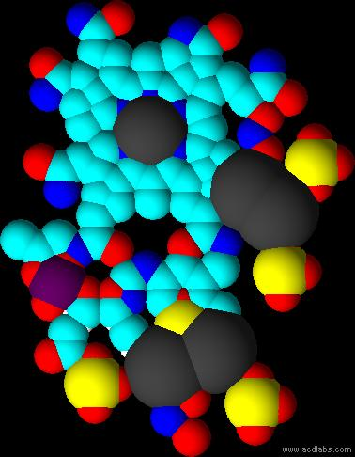

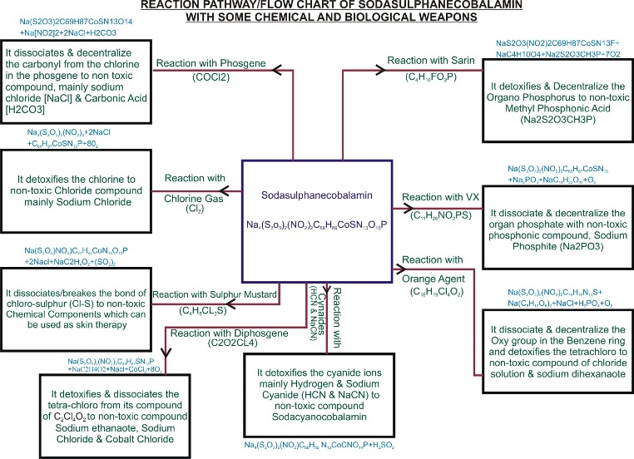

Recent Publications (minimum 5)
MILLITARY DEFENSE RESEARCH:
(I) maintain the technological capability to meet present requirements and counter future chemical warfare agent threats.
(II)Support equipment for definitive care of chemical warfare agent casualties. Providing medical management of chemical casualties to enhance survival and expedite the RTD of chemical warfare agent casualties through definitive therapies and life support technologies.
(III) Medical countermeasures for the individual service member to maintain combat effectiveness and prevent or reduce injury from battle field. Development of Skin Protectant (Ferrilatecheratine)

- Experimental determination of numerical value of dimension on physical quantities. Root mean square velocity and molecule velocity of an atom. stoichiometry and periodic properties table that shows the” INTRINSIVE AND EXTRINSIVE PROPERTIES” of all chemical elements.
- Determination of Molecular Mass and Formula for Air. Computational Mathematics and Application of Small organic Molecules.
- Antidote of orange agents (2, 3, 7, 8 - Tetrachlorobenzo-p-dioxin).
- Critical cGMP and ICH regulations for Pharmaceutical Laboratory.
- Pollution or environmental remediation studies, anthropogenic effect on petroleum. Synthetic of compound for biological evaluation. Synthetic of helium compound, which is another source of sun.

Photograph


BIOGRAPHY: Salako N. Olatunji is the Director/ C.E.O. of the Center for Countermeasures against Chemical and Biological Warfare Agent, CCACBWA, Head of Research and Development BAMAD AGRO-ALLIED COMPANY, Consultant to Lactating Specialist , Visiting Research , Federal Institute of Industrial Research Oshodi, FIIRO .Company and also ACS Chemistry Ambassador, Nigeria

