Headspace screening of alga Colpomenia sinuosa (Mertens ex Roth) Derbès & Solier, 1851 volatiles
I. Jerković, M. Zekić, M. Kranjac
Department of Organic Chemistry, Faculty of Chemistry and Technology,
University of Split, HR-21000 Split, Croatia

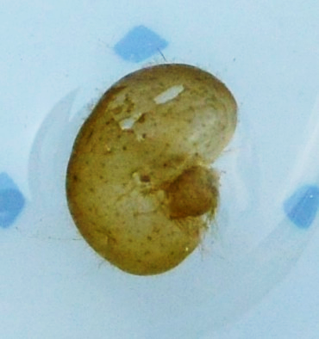
Colpomenia sinuosa (Mertens ex Roth) Derbès & Solier, 1851 is thallus bladder-like, smooth, slick, hollow, crisp, spherical to sac-like, irregularly expanded or somewhat lobed, to 30 cm diameter, 10 cm high. This golden-brown alga belongs to Scytosiphonaceae family. The sample was collected in the Adriatic sea close to Island Vis (43° 03' 47'' N, 16° 11' 15'' E). Volatiles of fresh C. sinuosa were extracted by headspace solid-phase microextraction (HS-SPME) and analysed by gas chromatography and mass spectrometry (GC-MS). In this investigation of alga headspace volatile organic compounds (VOCs) two fibers were used: polydimethylsiloxane/divinylbenzene (PDMS/DVB) and divinylbenzene/carboxene/polydimethylsiloxane (DVB/CAR/PDMS). The major C. sinuosa volatile compounds (PDMS/DVB; DVB/CAR/PDMS) were: dictyopterene D (6-[(Z)-1-butenyl]-1,4-cycloheptadiene) (26,7 %; 10,9 %), Dictyopterene C' (6-Butyl-1,4-cycloheptadiene) (11,4%, 2,7 %), dimethyl sulfid (8,4%; 18,3 %), tridecanal (5,1%; 6,3%), pentadecanal (5,0%; 2,4%), 1-pentene-3-on (2,2%; 3,4%), octan-1-ol (1,2%; 3,1%), β-Ionone (3,8%; 5,8%) and S-methyl thioacetate (-; 3,3 %). Application of headspace solid-phase microextraction enables identification of low-molecular organic compounds. Among those volatiles biologically active compound can be found, such as allelochemicals, defensive compounds, sex attractants or pheromones. This research was supported by the Croatian Government and the European Union through the European Regional Development Fund - the Competitiveness and Cohesion Operational Programme (KK.01.1.1.01) The Scientific Centre of Excellence for Marine Bioprospecting –BioProCro.
Fig. Sample of Colpomenia sinuosa collected in the port of Vis

Keywords— Colpomenia sinuosa, gas chromatography-mass spectrometry, headspace solid-phase microextraction, volatile organic compounds

Professional Biography (100-150 words)

Marina Zekić was born in Ludwigshafen, Njemačka, in 1977. She graduated in 2005 at Faculty of Chemistry and Technology, University of Split. She got her PhD degree in 2013 at Faculty of Chemical Engineering and Technology, University of Zagreb. In 2007 she started to work as an assistant at the Department of Organic Chemistry, Faculty of Chemistry and Technology in Split, where she is currently employed. She was elected to an assistant professor in 2017 (natural sciences, field chemistry). She has published 10 scientific papers cited by Current Contents.she has been involved in realization of three research projects. Currently, she is a member of project „Bioprospecting of Adriatic Sea“, K.K. 01..1.1.01.0002.

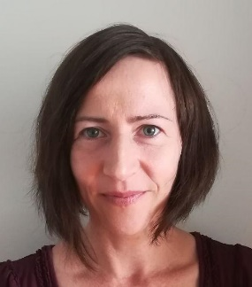

Email Id: zekic@ktf-split.hr

