Numerical evaluation of the effect of the activation method and the used activator on the development of the porous structure of the carbonaceous materials

Mirosław Kwiatkowski, Jagoda Worek

Faculty of Energy and Fuels, AGH University of Science and Technology,
al. A. Mickiewicza 30, 30-059 Krakow, Poland
Abstract:
The work presents numerical evaluation of the effect of the chemical activation method and the used activator on the development of the porous structure of the carbonaceous materials. The computer calculations were carried out based on of the adsorption isotherms of nitrogen. On the basis of the research and analyses, a significant effect of the type of the activating agent used and activation method applied on the formation of the porous structure and, consequently, on the adsorptive properties of the produced adsorbate was observed. The new adsorption models with the unique numerical procedure of the fast multivariate fitting of theoretical models to adsorption isotherms applied in this work prove highly advantageous when compared with popular methods of porous structure description by providing a wider range of information on the analysed porous structure and offering unique possibilities of evaluating reliability of the obtained information on the analysed porous structure.

Keywords: Adsorption, Carbonaceous Materials, Numerical Methods, Activation, Isotherm.

Acknowledgment: The research is led within the AGH University of Science and Technology in Krakow grant No. 11.11.210.373.
Professional Biography:
Dr. Mirosław Kwiatkowski in 2004 obtained Ph.D. degree at the AGH University of Science and Technology in Krakow (Poland), and in 2018 D.Sc. degree (habilitation) at Wrocław University of Technology (Poland). Currently he is working as an associate professor at the AGH University of Science and Technology in Krakow. His published work includes more than 45 papers in reputable international journals and 75 conference proceedings. He is the editor in chief of The International Journal of System Modeling and Simulation (United Arab Emirates), an associate editor of Micro & Nano Letters Journal (United Kingdom) and a member of the many editorial board of internationals journals as well as a member of the organizing and scientific committees international conferences in Europe, Asia and United States of America.

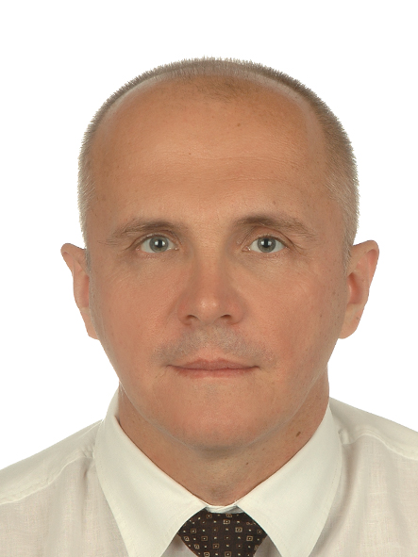

Email Id: kwiatkow@agh.edu.pl

