Abstract Template
Abstract Title: Innovative chemical technologies can improve radical chemistry?
E. Banaszak-Léonard,¹ C. Imbs,¹ V. Jeux¹

¹ EA 4297 TIMR, UTC/ESCOM, 1 rue du Réseau Jean-Marie Buckmaster, F-60200 Compiègne, France

Abstract (not more than 300 words)

Radical chemistry is of great interest in many chemical areas, such as medicinal chemistry, material chemistry or polymers, or even formulation, in order to understand and prevent radical disorders. However, despite the lasting interest in performing radical syntheses, the use of innovative techniques for a more eco-friendly approach remains occasional.
We will focus on examples showing how natural products can undergo radical transformations under innovative techniques. It will be shown that the combination of uncommon energetic devices with greener solvent can shorten reaction times, or even promote the envisioned reaction.

By using aromatic aldehydes, (un)modified aminoacids or fatty acids, the molecules from such radical processes can be used in a wide range of applications. Biocides, surfactants, electron-transfer materials or even synthons are real options for molecules valorization.

Keywords—Radical chemistry, Ultrasounds, Microwaves, Biomass

Professional Biography (100-150 words)

Estelle Banaszak-Léonard has obtained her PhD from Lorraine University at the age of 28 in the polar organometallic field. Then, she moves to Birmingham (UK) University for her first postdoctoral position, followed by a second one in Le Mans University, where she began to study azobenzenes for the CNRS Center. Since 2008, she is Assistant Professor in ESCOM/TIMR in Compiègne and in charge of the Organic Team from 2017.

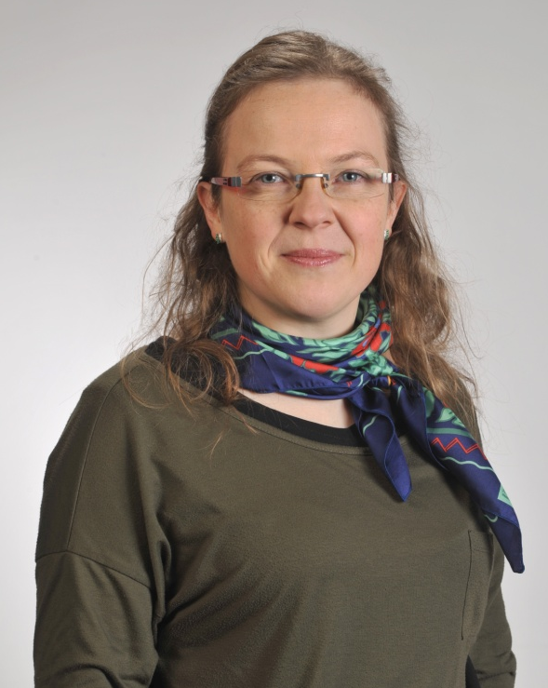
Paste your Photograph here

Email Id: e.leonard@escom.fr

Any Comments:

