Abstract Template
Electrochemical Reactions Based on [60]Fullerene Derivatives
Guan-Wu Wang

Department of Chemistry, University of Science and Technology of China, Hefei 230026, China

Electrochemical organic reactions have attracted increasing attentions of organic chemists. Fullerenes and their derivatives are electron-deficient molecules, and therefore they are electrophiles. If they are reduced by controlled potential electrolysis (CPE) and thus would undergo a umpolung process, the formed negatively charged fullerenes and fullerene derivatives are nucleophiles. I will present our recent progress in the electrochemical reactions of fullerene derivatives. Several types of natural fullerene derivatives, which were synthesized by the methodologies developed by ourselves, can be reduced to dianionic species by CPE. The formed dianionic species can then react with a different electrophiles such as benzyl bromide, ethyl bromoacetate, diethyl bromomalonate, acy chlorides, chloroformates to provide new functionalized fullerenes with new addition patterns.
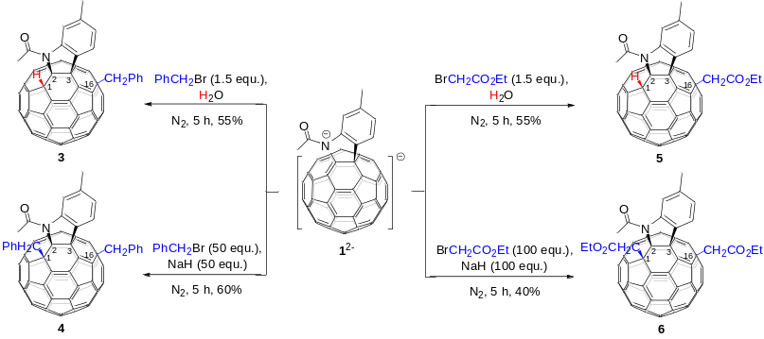
Keywords—dianionic species, electrochemistry, fullerenes, umpolung

Professional Biography
Guan-Wu Wang is currently a full professor at University of Science and Technology of China. He obtained his B.S., M.S. and PhD from Lanzhou University in 1987, 1990, 1993, respectively. He then did his postdoctoral work at Fudan University, Kyoto University, University of Kentucky, University of Chicago and Yale University. In May of 2000 he joined the University of Science and Technology of China as an awardee of the ‘‘Hundred Talents Program’’ of the Chinese Academy of Sciences (1999). He was awarded a National Science Fund for Distinguished Young Scholars (2001). He currently serves an editorial board member of Chinese Science Bulletin, Chinese Journal of Organic Chemistry, Mini-Reviews in Organic Chemistry, Current Organocatalysis, Acta Chimica Sinica, and Current Organic Chemistry. He has published over 200 scientific papers. His research interests include fullerene chemistry, mechanochemistry and C–H activation reactions.
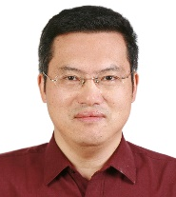

Email Id: gwang@ustc.edu.cn

