Abstract Template
Abstract Title: Mimetic peptides based on promiscuous enzyme as asymmetric catalyst in Aldol and Michael reactions
Saadi Bayat,^{a,b} Prof. Basyaruddin A. Rahmanª

ªDepartment of Chemistry, Faculty of Science, Universiti Putra Malaysia, 43400 UPM Serdang, Selangor, Malaysia
^{b}Tofigh Daru, Pharmaceutical Company, Tehran, Iran

Abstract (not more than 300 words)

Biocatalysis has emerged as an elegant and green tool for modern organic synthesis due to its high efficiency, good selectivity and environmental acceptability. Although, an enzyme is capable of catalyzing a specific reaction effectively, some unexpected experimental results have indicated that many enzymes are catalytically promiscuous. Mimetic peptides based on enzyme as a kind of important chiral scaffold are broadly identified for their obvious advantages, diverse structures and readily accessibility. Based on promiscuous aldo-keto-reductase enzymes, several mimetic peptides were designed which were synthesized and tested as multifunctional organocatalysts in direct asymmetric aldol and Michael reactions.
The asymmetric aldol and Michael reactions, as the most prominent carbon-carbon bond formation reactions, are the central study issues in the field of asymmetric synthesis. In this study, promiscuous aldo-ketoreductase (AKR) used to catalyze aldol reaction between aromatic aldehydes and ketones. Good yield (up to 75%), moderate enantioselectivity (60%), and high diastereoselectivity (dr) up to 93/7 (anti/syn) were obtained. Several mimetic peptides from AKR’s active site were designed and synthesized as asymmetric catalysts in the aldol and Michael reactions. The corresponding aldol products were produced with high yields (up to 97%) and excellent diastereoselectivities (up to 99/1 ) and enantioselectivities (up to 99.9) under mild reaction conditions. These peptides exhibit excellent catalytic activity in terms of yield, diastereoselectivity and enantioselectivity. The secondary structures of peptide catalysts provide an understanding of their mechanism.
Keywords— Asymmetric biocatalysis, Mimetic peptides, enantioselectivity,

Professional Biography (100-150 words)

Saadi Bayat was born in Iran. He received his B.Sc. in applied chemistry at Buali Sina University (Hamedan, Iran, 2000). He graduated from M.Sc. in organic chemistry at Kharazmi University (Tehran, Iran, 2008). He enrolled in the PhD programme at Department of Chemistry, Faculty of Science of university of Putra Malaysia (UPM), under supervision of Prof. Dr. Mohd Basyaruddin Abdul Rahman. The following year, he was offered scholarship from Graduate Research Assistance (GRA), UPM. Moreover, his research program focuses on mimetic peptide as asymmetric catalysis. He was as a postdoctoral research fellow for a year (May 2014-June. 2015) in UPM. He had been selected to receive Endeavor scholarship from Australian government and jointed to Dr. Bellinda Abott’s group in La Trobe university, Melbourne (July 2015-January 2016). He has published almost 20 papers in reputed journals and has been serving as an editorial board member of repute.

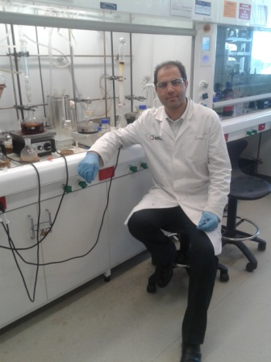Email Id:saadibayat@yahoo.com

Any Comments:
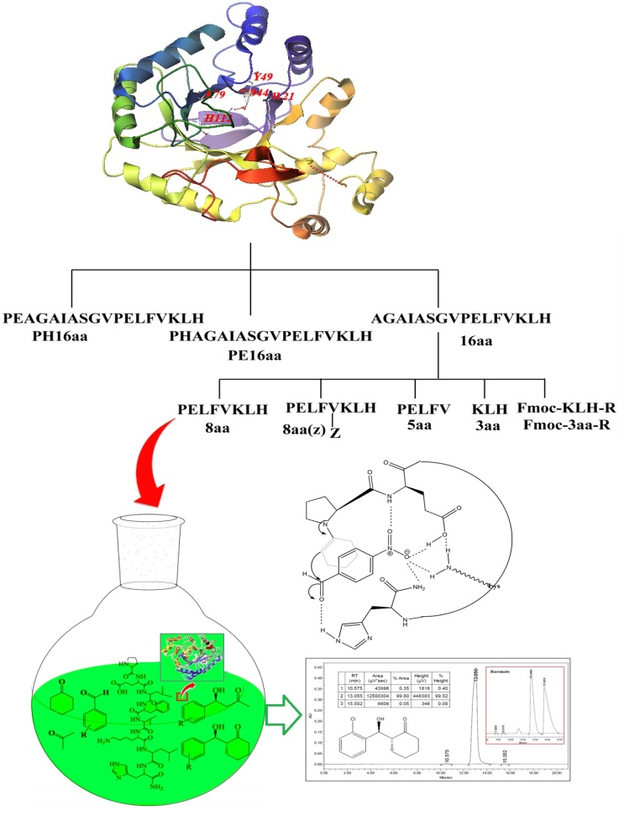
Fig.1: synthesized mimetic peptides as asymmetric organocatalyst

