Abstract Title: “Click chemistry”-based step growth polymerization: a new approach for the synthesis of novel clicking biodegradable polymers
Teng. Kantaria, Tem. Kantaria, G. Otinashvili, N. Kupatadze, N. Zavradashvili,
D. Tugushi, R. Katsarava

Institute of Chemistry and Molecular Engineering, Agricultural University of Georgia, Georgia

Abstract

The use of click chemistry in polymer science is a quickly emerging field of research. The copper(I) catalyzed azide–alkyne cycloaddition (CuAAC) click reaction has already been exploited for the synthesis of end-functionalized polymers, block copolymers, cyclic polymers, dendrimers, cross-linked materials, etc. Surprisingly, there are only few papers on the application of CuAAC click reaction in step-growth polymerization (SGP) as a chain propagation reaction, and, to our best knowledge, there are no examples of the synthesis of biodegradable polymers via CuAAC click chemistry.
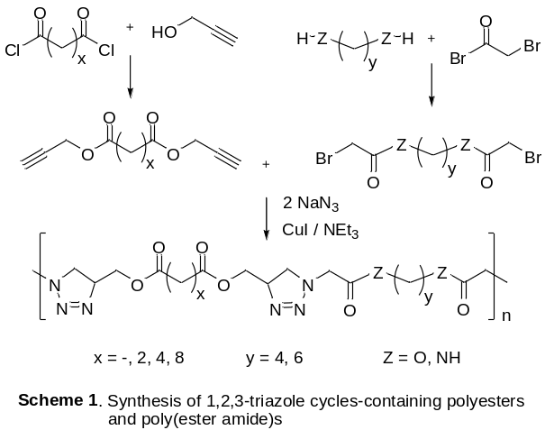In the present work we have carried out a systematic study for optimizing the CuAAC click SGP reaction for the synthesis of clicking polyesters in terms of solvent, catalyst, catalyst’s activator (ligand), monomers concentration, duration and temperature of various steps of one pot reaction. Comparing the clicking polyester’s molecular weights and yields the best parameters for the click SGP were found as: a solvent - N-Methyl-2-pyrrolidone, a catalyst – CuI, a ligand – NEt₃, a monomers concentration – 0.6 mol/L, duration of bis-azide formation step – 3 h (at room temperature), duration of SGP – 15 h, temperature of the click SGP reaction – 0° C. The established optimal conditions of the CuAAC-based SGP reaction was applied to the synthesis of a series of high-molecular-weight (Mw up to 73,000 Da) 1,2,3-triazole cycles-containing “clicking” polyesters and poly(ester amide)s (Scheme 1) which reveal improved thermal properties compared to their regular analogues. The new polymers are promising for practical applications in medicine, agriculture, and food industry as biodegradable (bioresorbable) materials, as environmentally friendly biomaterials, etc. Furthermore, one of the important advantages of the developed CuAAC click SGP is the possibility of quaternization of 1,2,3-triazole cycles of the resulting polymers which opens a way to cationic polymers – both water soluble ones and cross-linked cationic hydrogels promising for numerous biomedical applications.
Keywords— biodegradable polymers, click chemistry, CuAAC, step growth polymerization.

Professional Biography

Tengiz Kantaria has his expertise in the preparation and characterization of nanoparticles on the basis of amino acid based biodegradable poly(ester amide)s (MS thesis, 2015). Currently as a PhD student he is engaged in the synthesis and characterization of new biodegradable polymers (polyesters, polyamides, and poly(ester amide)s) via Cu(I) catalyzed alkyne–azide 1,3-cycloaddition click reaction.



Email Id: t.kantaria@agruni.edu.ge

