Abstract Template

Synthesis and reactivity of bromocyanobutadiyne: from interstellar chemistry to organic synthesis methodology

Yann Trolez

Ecole Nationale Supérieure de Chimie de Rennes, CNRS, UMR 6226, 11 allée de Beaulieu, CS 50837, 35708 Rennes Cedex 7

Abstract (not more than 300 words)

Some cyanopolyynes (the formula of which is R-(C≡C)n-CN with R = H or Me) have been detected in the interstellar medium (ISM)1 and on Titan for some of them.2,3 Our laboratory has been studying from several years these compounds by synthesizing them and studying their chemical or photochemical reactivity. However, despite the low number of atoms these compounds possess, their synthesis in laboratory still remains a scientific challenge. Thus, we have recently described a synthetic pathway for cyanopolyynes having two conjugated C≡C triple bonds (n = 2),4,5 but their superior counterparts (n = 3) stay elusive
so far.

To solve this problem, we synthesized the bromocyanobutadiyne (5-bromopenta-2,4- diynenitrile ; Br-C≡C-C≡C-CN) and reacted it with different terminal alkynes under Cadiot- Chodkiewicz conditions.6 Surprisingly, the corresponding cyanopolyynes were not obtained but more complex compounds, resulting from cascade reactions, were isolated. In particular, a diene was obtained stereoselectively when using monoacetylenic reactants. When using triisopropylsilylbutadiyne, a functionalized benzofulvene was obtained (Figure 1). The characterization of these unexpected products is based on X-ray crystallography, among other usual techniques. The mechanisms of formation of these products, which were studied both experimentally and theoretically, will be discussed.
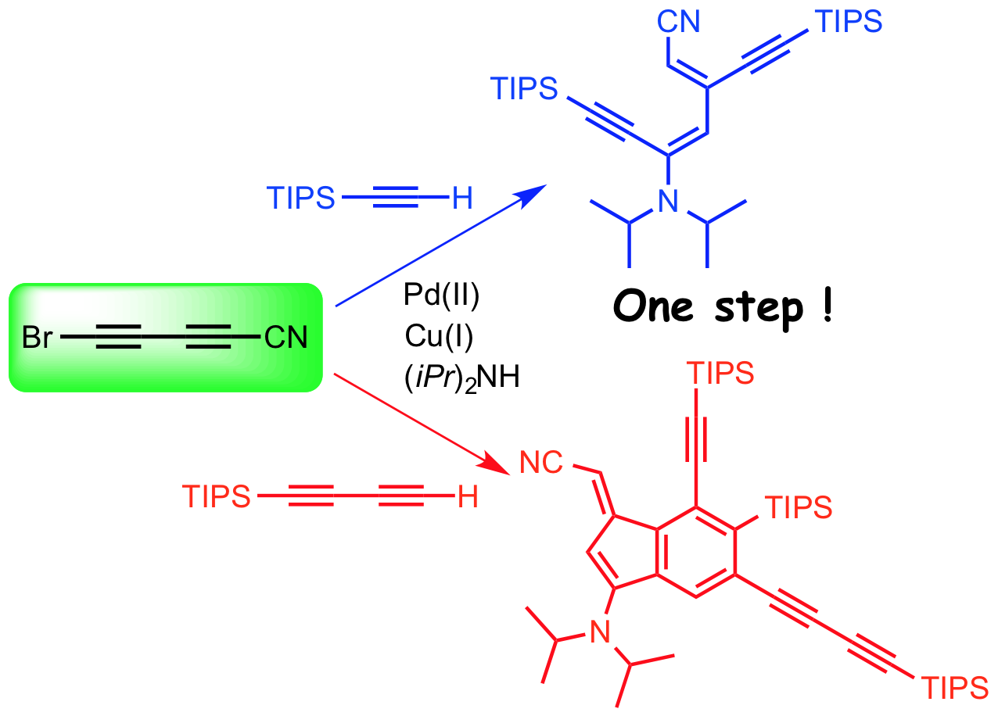

Figure 1. Reactivity of bromocyanobutadiyne with triisopropylsilylacetylene and triisopropylsilylbutadiyne

Keywords— Cascade reactions, cyanopolyynes, interstellar chemistry.

Professional Biography (100-150 words)

Yann Trolez has completed his PhD in 2010 from the University of Strasbourg under the guidance of Jean-Paul Collin and Jean-Pierre Sauvage where he worked on rotaxane-based molecular machines. He then moved to ETH Zürich in François Diederich group as a postdoctoral fellow where he worked on alleno-acetylenic compounds bearing interesting optoelectronic properties. In 2011, he was appointed assistant professor at the Ecole Nationale Supérieure de Chimie de Rennes where he now works on organic interstellar chemistry and on new cyanated compounds having interesting optical properties. He published about 30 papers in peer-review international journals.

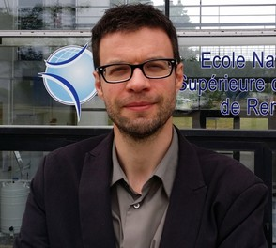

Email Id: yann.trolez@ensc-rennes.fr

1 P. Thaddeus, M. C. McCarthy, M. J. Travers, C. A. Gottlieb, W. Chen, Faraday Discuss. 1998, 109, 121-135
2 A. Coustenis, T. Encrenaz, B. Bézard, B. Bjoraker, G. Graner, G. Dang-Nhu, E. Arié, Icarus, 1993,
102, 240-260
3 V. Vuitton, R. V. Yelle, V. G. Anicich, Astrophys. J. 2006, 647, L175-L178
4 Y. Trolez, J.-C. Guillemin, Angew. Chem. Int. Ed. 2005, 44, 7224-7226
5 a) N. Kerisit, L. Toupet, Y. Trolez, J.-C. Guillemin, Chem. Eur. J. 2013, 19, 17683-17686; b) N. Kerisit, C. Rouxel, S. Colombel-Rouen, L. Toupet, J.-C. Guillemin, Y. Trolez, J. Org. Chem. 2016, 81, 3560−3567
6 N. Kerisit, L. Toupet, P. Larini, L. Perrin, J.-C. Guillemin, Y. Trolez, Chem. Eur. J. 2015, 21, 6042-
6047

