Calculation of the electronic absorption spectra of dyes using Time-Dependent Density-Functional Theory (TD-DFT)
Sefia.BRAHIM, Houari.BRAHIM
^{1.2} Department of chemistry (University of Saida,Algeria)

Abstract

The conversion efficiency of DSSC (Dye Sensitized Cell Solar) is defined by the ability of the electron transport, cheap fabrication, flexibility and intense absorption in the visible region of the spectrum. In order to find dyes satisfying these restrictions, many experimental researches have been done to synthesize and to analyze different molecules. Based on previous studies, Santosh K et all synthesized a new complexes: [M(dppf) L]; which M=Ni, Pt and Pd, L= p-tolylsulfonyl dithiocarbimate. These complexes have been characterized using spectroscopic methods (IR, ¹H, ¹³C and ³¹P NMR and UV-Vis), cyclic voltammetry and crystal X-ray diffraction. Their light harvesting properties have been investigated. The absorption spectra of these complexes were measured at room temperature in CH₂Cl₂ solution. They present absorption bands near 385-440 nm. This was interpreted to be due to ligand metal charge transfer (LMCT). The other higher energy bands at 250_350 nm are attributed to the intraligand charge-transfer (ILCT) transitions.
Our contribution to study these complexes is set theoretical spectra from quantum calculation. For each complex, a geometry optimization was done to find the optimal structure at the density functional theory (DFT) level. We used the hybrid functional B3LYP and PBE0, and 6-31G (d,p) and LANL2DZ basis set. All our calculations were performed using Gaussian09 package. The analyses of the frontier molecular orbitals have performed to identify the type of charge transfer. The electronic spectra were calculated using the time dependant density functional theory (TD-DFT). Whereas the solvent effects of methylene dichloride have been included using the integral equation formalism of the polarizable continuum model (PCM).
Keywords— TD-DFT, Dye, Absorption spectra, Eexcited state, transition.

Professional Biography
Sefia BRAHIM, PhD student, University of Saida, Algeria

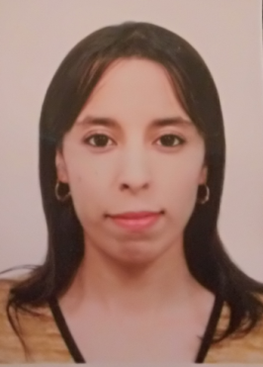

Paste your Photograph here

Email Id: safi_mah@hotmail.fr

Any Comments:

