Abstract Template
Abstract Title: Sulfated polyborate catalysed – solvent free and recyclable catalyst for efficient synthesis of betti base.
Manisha S. Patil¹, Chetan Khatri¹, Ganesh U. Chaturbhuj¹

¹ Affiliation and Address: Department of Pharmaceutical Sciences and Technology, Institute of Chemical Technology, Matunga (E), Mumbai, 400019, Maharashtra, India.

Abstract
In 1900 ,Betti was the first to prepare 1-(a-aminobenzyl)-2-naphthol by simple Condensation of 2-naphthol with benzaldehyde and ammonia.¹ Aminoalkyl naphthols ( Betti bases) and amidoalkyl naphthols with 1,3-amino-oxygenated Functional group are considered as a class of biologically natural active products and potent drugs, which include many nucleosides, antibiotics, and human immunodeficiency virus protease inhibitors, such as lopinavir and ritonavir.² Several Lewis and Brønsted acids such as SnCl₄5H₂O,³ polymer-supported sulfonic acid,⁴ ionic liquids,⁵ nano-sulfated zirconia,⁶ [HMIM]C(CN)₃,⁷ ZrO(OTf)₂,⁹ Bi(NO₃)₃.5H₂O⁹ have been applied to catalyze this transformation. However these catalytic systems suffer from one of the following limitation such as the use of expensive and toxic reagents/catalysts, limited availability of reagent, hygroscopicity as well as instability of the reagents, use of strong protic media, harsh reaction condition, long reaction time, low yields, tedious work up procedure.
In this work efficient, mild and eco-friendly procedure of 1-aminoalkyl-2-phenol/betti base from one pot three component condensations of Aldehyde, Phenol and Morpholine in presence of sulfated polyborate catalyst, under solvent-free condition at 100 °C (Scheme 1). The catalyst has been prepared and used as a Bronsted as well as Lewis acid catalyst for the reaction. The catalyst was prepared by dehydration of boric acid followed by sulfonation and characterized by different analytical techniques such as potentiometric analysis, FTIR, XRD, SEM-EDAX.¹⁰ The major advantages of the present method are short reaction time, high yields, Aqueous work-up procedure, Low cost, stable, reusable catalyst and solvent-free reaction conditions are the key features of the present protocol.
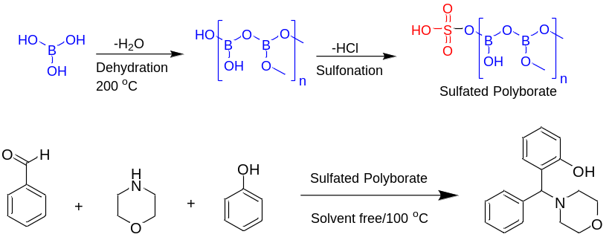
Scheme 1. Schematic representation of sulfated polyborate catalyzed betti reaction of aldehyde, morpholine and phenol.

Keywords— Sulfated polyborate, Betti Base, Solvent free, Recyclable catalyst

References
- Cardellicchio, C.; Capozzi, M.A.M.; Naso, F. Tetrahedron: Asymmetry. 2010, 21, 507-517
- E. Juaristi, Enantioselective Synthesis of b-Amino Acids, John Wiley & Sons, New York, 1997.
- J. safari, Z. Zarnegar, J. Mol. Catal. A: Chem. A 379 (2013) 269.
- M. Hajjami, F. Ghorbani, F. Bakhti, Appl. Catal., A 470 (2014) 303.
- A.R. Hajipour, Y. Ghayeb, N. Sheikhan, A.E. Ruoho, Tetrahedron Lett.50 (2009) 5649.
- Zali, A. Shokrolahi, Chin. Chem. Lett. 23 (2012) 269.
- Das, K. Laxminarayana, B. Ravikanth, B.R. Rao, J. Mol. Catal. A:Chem. A 261 (2007)
- H. Hashemi, A.R. Sardarian, J. Iran. Chem. Soc. 10 (2013) 745.
- M. Wang, Y. Liang, T.T. Zhang, J.J. Gao, Chin. Chem. Lett. 23 (2012)65.
- C. K. Khatri, D. S. Rekunge, G. U. Chaturbhuj, New J. Chem. 2016. 40, 10412–10417.

Professional Biography

Manisha Patil has completed her M. Pharm at the age of 24 years from North Maharashtra University and Ph.D. studies from Institute of Chemical Technology. She has recently published 3 papers in reputed journals in short time.


Paste your Photograph here
Email Id: msp214@gmail.com

