Preparation, characterization and applications of Heteropolyacid-clay nano-composite as a heterogeneous catalyst for some organic reactions

Dr. Bashir Ahmad Dar
Higher education Govt. of J&K India, India

Abstract:
Heteropoly acids in pure form are advantageous as catalysts due to their low volatility, low corrosiveness, high acidity, activity and flexibility. But the drawbacks in these homogeneous liquid phase catalysts lie in their low surface area (1–10 m²/g) and the problem of separation from the reaction mixture. To overcome the above mentioned problems to be more effective for catalytic reactions, HPAs are usually impregnated on different porous materials. The type of carrier, its textural and structural properties influence the thermal stability and the catalytic activity of Keggin-type heteropolyacids.
Clays have been reported to act as catalysts or catalyst supports because of their layer structure, high surface area, pore volume, pore diameter and higher surface acidity¹⁻³. Thus clays can be used as an efficient support for HPAs and it is believed that uniform dispersion of HPAs on porous clay support with high surface area increases the overall acidity and catalytic activity of the composites. High activity of vanadium-containing HPAs and the property of clays as catalyst support prompted us to explore the activity of vanadium substituted TPA supported on clay as a heterogeneous catalyst for the various organic reactions.
The present work is intended to synthesize clay-supported heteropolyacid as a novel heterogeneous, reusable and inexpensive catalyst. This Keggin-type heteropolyacids (HPAs), typically represented by the formula H_{8-x} [XM₁₂O₄₀], (X = heteroatom, x is its oxidation state and M = addenda atom) have been extensively used in acid catalyzed reactions.⁴ Vanadium substitution in the Keggin structure enhances the catalytic activity of the HPAs.⁵ We have used this catalyst for different organic transformations like one pot synthesis of 2,3-dihydro-2- phenylquinazolin-4(1H)-ones, one pot synthesis of β-phosphonomalononitriles and one pot synthesis of dihydropyrimidinones etc.
This catalyst afforded excellent results in very short reaction times and shows high selectivity for different organic reactions. The catalyst could be recycled and reused several times. The reactions occur at room temperature in presence of small amount of the catalyst. No column purification is required and products can be purified by simple crystallization.

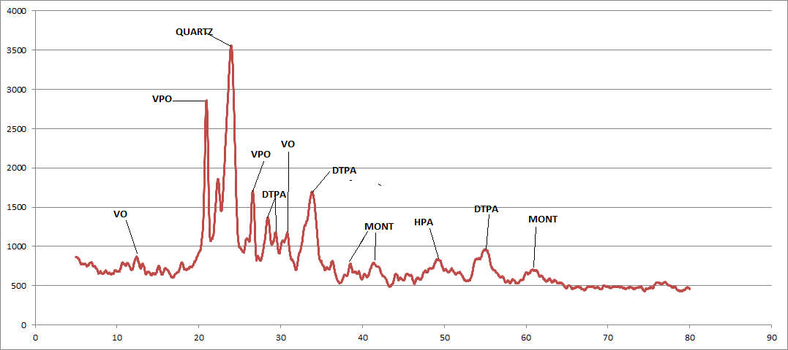
Figure: Powder X-ray diffraction for heteropolyacid supported on montomorillonite

Figure: SEM image of Heteropolyacids clay nanocomposite

References

- Bashir Ahmad Dar et. al. Applied Catalysis A: General 466 (2013) 60– 67
- Bashir Ahmad Dar et. al. Applied Clay Science 80–81 (2013) 351–357
- Bashir Ahmad Dar et. al. Applied Catalysis A: General 470 (2014) 232– 238
- Bashir Ahmad Dar et. al. Journal of Industrial and Engineering Chemistry 19 (2013) 407–412
- Bashir Ahmad Dar et. al. Tetrahedron Letters 55 (2014) 623–628

