A New Class of Biopolyether its Synthetic Analogs and their Anticancer Efficacy
V.Barbakadze, PhD, D.Sci, Tbilisi State Medical University I.Kutateladze Institute of Pharmacochemistry, Tbilisi, Georgia

Abstract
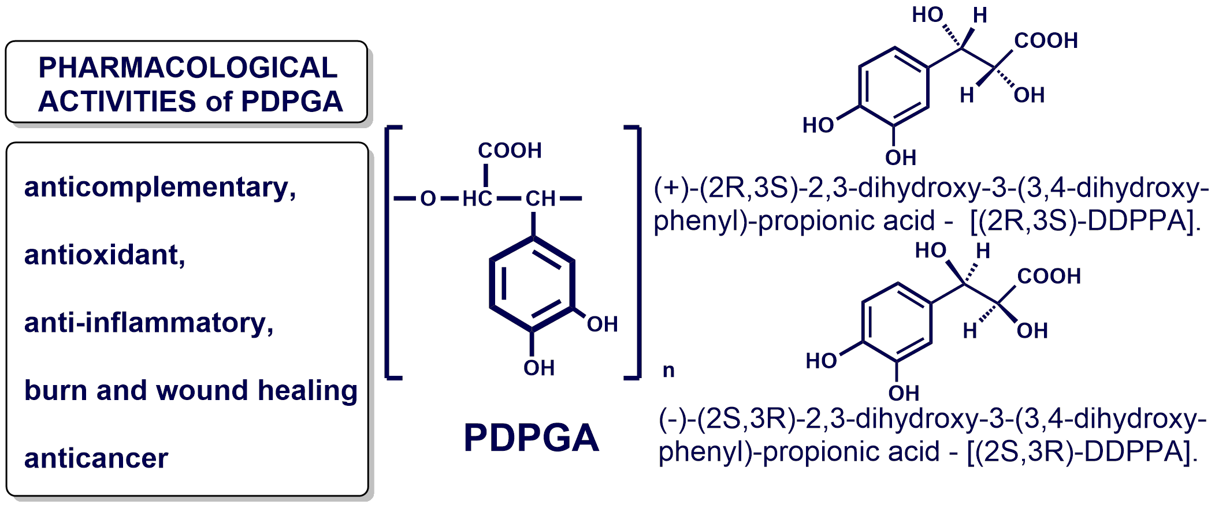
Within the field of pharmacologically active biopolymers the area of stable polyethers seems rather attractive. The high-molecular fractions from the several species of two genera Symphytum and Anchusa were isolated by ultrafiltration of water-soluble crude polysaccharides on the membrane filter with cut-off value of 1000 kDa. According to IR, ¹³C and ¹H NMR, 1D NOE, 2D heteronuclear ¹H/¹³C HSQC and 2D DOSY experiments the main structural element of these preparations was found to be a new regular polymeric molecule. The polyoxyethylene chain is the backbone of this biopolymer. 3,4-Dihydroxyphenyl and carboxyl groups are regular substituents at two carbon atoms in the chain. The repeating unit of this regular caffeic acid-derived polyether, is 3-(3,4-dihydroxyphenyl)glyceric acid residue. Thus, the structure of natural polymer under study was found to be poly[oxy-1-carboxy-2-(3,4-dihydroxyphenyl)ethylene] or poly[3-(3,4-dihydroxyphenyl)glyceric acid] (PDPGA). Such caffeic acid-derived biopolymer to our knowledge has not been known and has been identified for the first time. This compound represents a new class of natural polyethers. In order to compare biological properties of natural polymer with its synthetic analogues, racemic and pure enantiomeric forms of PDPGA as well as a methylated analogue of PDPGA - poly[2-methoxycarbonyl-3-(3,4-dimethoxyphenyl)oxirane] [poly(MCDMPO)] were synthesized. The racemic monomer and its virtually pure enantiomers (+)-(2R,3S)-2,3-dihydroxy-3-(3,4-dihydroxy-phenyl)propionic acid [(2R,3S)-DDPPA] and (-)-(2S,3R)-2,3-dihydroxy-3-(3,4-dihydroxyphenyl)propionic acid [(2S,3R)-DDPPA] were synthesized for the first via Sharpless asymmetric dihydroxylation of trans-caffeic acid derivatives using an potassium osmiate catalyst, a stoichiometric oxidant N-methylmorpholine-N-oxide and enantio-complementary catalysts cinchona alkaloid derivatives (DHQ₎₂-PHAL and (DHQD)₂-PHA as chiral auxiliaries. Poly[2-methoxycarbonyl-3-(3,4-dimethoxyphenyl)oxirane] [poly-(MCDMPO)] was obtained via ring opening polymerization of MCDMPO using a cationic initiator. PDPGA is endowed with intriguing pharmacological activities as anticomplementary, antioxidant, anti-inflammatory, burn and wound healing and anticancer properties. PDPGA and its synthetic monomer exerted anticancer activity in vitro and in vivo against androgen-dependent and -independent human prostate cancer (PCA) cells via targeting androgen receptor, cell cycle arrest and apoptosis without any toxicity, together with a strong decrease in prostate specific antigen level in plasma. Comparative investigation of antioxidant properties of natural polymer and its synthetic monomer revealed that the latter appeared 40 fold active than polymer, however anticancer efficacy of PDPGA against

Image
human PCA cells is more compared to its synthetic monomer. Poly(MCDMPO) did not show any activity against PCA. Overall, this study identifies PDPGA as a potent agent against PCA without any toxicity, and supports its clinical application.

Recent Publications
- Barbakadze V, et al. (2005) Poly[3-(3,4-dihydroxyphenyl)glyceric acid], a new biologically active polymer from Symphytum asperum Lepech. and S.caucasicum Bieb. (Boraginaceae). Molecules 10, 9:1135-1144.
- Barbakadze VV et al.(2007) Antioxidant and anticomplementary activity of poly[3-(3,4-dihydroxyphenyl)glyceric acid] from Symphytum asperum and S. caucasicum. Pharmaceutical chemistry journal 41, 1:14-16.
- Merlani M, et al. (2010) Enantioselective synthesis and antioxidant activity of 3-(3,4-dihydroxyphenyl)-glyceric acid - basic monomeric moiety of a biologically active polyether from Symphytum asperum and S. caucasicum. Chirality 22, 8:717-725.
- Shrotriya S et.al (2012) Poly[3-(3, 4-dihydroxyphenyl) glyceric] acid from comfrey exerts anti-cancer efficacy against human prostate cancer via targeting androgen receptor, cell cycle arrest and apoptosis. Carcinogenesis 33, 8:1572-1580.
- Merlani M et al. (2015) Ring-opening polymerization of a 2,3-disubstituted oxirane leading to a polyether having a carbonyl–aromatic π-stacked structure. Polymer Chemistry 6, 11:1932-1936.
- Tedesco D, Fabini E, Barbakadze V et al (2015) Stopped-Flow Enantioselective H PLC-CD Analysis and TD-DFT Stereochemical Characterization of Methyl Trans-3-(3,4-Dimethoxyphenyl)Glycidate. Chirality 27, 12:914-918.

 Biography
Vakhtang Barbakadze has his expertise in isolation and structure elucidation of a new series of plant polyethers, which are endowed with pharmacological properties as anti-cancer agents. Besides, he interested in enantioselective synthesis and biological activities of basic monomeric moiety of these biopolyethers, synthesis of enantiomerically pure epoxides as chiral building blocks for the production of synthetic analogues of natural polyethers. He has completed his Ph.D and D.Sci. in 1978 and 1999 from Institute of Organic Chemistry, Moscow, Russia and Institute of Biochemistry and Biotechnology, Tbilisi, Georgia, respectively. He is the head of Department of plant biopolymers and chemical modification of natural compounds at the Tbilisi State Medical University Institute of Pharmacochemistry. 1996 and 2002 he has been a visiting scientist at Utrecht University, The Netherlands, by University Scholarship and The Netherlands organization for scientific research (NWO) Scholarship Scientific Program, respectively. He has published more than 86 papers in reputed journals.
Email: v_barbakadze@hotmail.com
Notes/Comments

