Neuroscience versus Artificial Intelligence. Human brain can learn better and faster than any machine that exists

Humans are considered to be unique, but when it comes about competing with computers, they are truly spectacular at many things, like pattern recognition, language skills and abilities, imagination and creative thinking and most importantly, emotions.
Computers are designed to improve at pattern recognition, but, so far, most of the programs developed aren’t able to manage the way humans do. In terms of pattern recognition, face recognition is a classic example. Humans are able of recognizing faces in a wide variety of contexts and combinations. Particularly, on this topic, pattern recognition, computers are not at all as good as humans are. Not to mention emotions, states and feelings.
Computers are extremely fast and they can be faster than now. When a task like mathematical calculation is translated into an algorithm which is a set of instructions, a computer will accomplish it more quickly than the average human beings, but achieving this is not enough to say that computers learn faster than humans.
The purpose of this work is to underline the supremacy of the brain over any form of artificial intelligence known so far. Researchers explored the model information processing abilities of human neurons and they replicated it somehow, but human brain and mind are such a complex, still un-mapped structure, that it is impossible to model it entirely and accurately. So, instead of feeding this competition, I propose focusing on designing human’s brain map and enhance personal self-management skills, leading to equilibrium, self-control, happiness and success.

Image

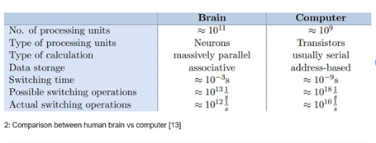

Recent Publications (minimum 5)
- Sc, M & Singh, Simranjeet. (2020). Prediction of Depth Maps using Semi-Supervised Learning
- Von Neumann, J. The Computer and the Brain (Yale University Press, New Haven, CT, 2012), 3rd ed.
- Patterson, D.A. & Hennessy, J.L. Computer Organization and Design (Elsevier, Amsterdam, 2012), 4th ed.
- Hassan, M. A., & Rizvi, Q. M. (2019). Computer vs human brain: An analytical approach and overview. International Research Journal of Engineering and Technology, 6(10), 580–583.
5. Hsu, J. (2015). Estimate: Human Brain 30 Times Faster than Best Supercomputers. IEEE Spectrum: Technology, Engineering, and Science News

Photograph



Laura Ion is a PhD student in Psychology at Selinus University of Sciences and Literature, Italy. She is an Associate Member within American Psychological Association and a Graduate Member within the British Psychological Society. She has published articles in the field of Psychology and Neuroscience in reputed Journals like Scientific Research-Psychology Journal and SAERA (School of Advanced Studies, Research and Accreditation, Spain)
Email:office@byyourbrain.com

Notes/Comments:

