Abstract Template
Abstract Title: Catalysis around furfural as valuable biobased platform
C. Len¹

¹ Chimie ParisTech, CNRS, Institut de Recherche de Chimie Paris, PSL Research University, 11 rue Pierre et Marie Curie, F-75231 Paris, France

Abstract (not more than 300 words)

With an increasingly severe outlook for depleting oil-based resources, wood based biomass and especially plant waste rich in lignocellulosic feedstocks, appear to be the main alternative to produce many kinds of platform molecules such as furan derivatives. However, recent researches have shown that other kinds of carbohydrates as alginate derivatives could also be exploited as feedstocks for furfural production. As a molecule platform chemical, furfural permits to produce a large range of chemicals having different properties and utilities as solvents, plastics, fuel additives. One important valorization route of furfural is the liquid phase catalytic hydrogenation. Whereas molecular hydrogen is mostly used in industrial hydrogenation processes, recent studies also showed that alcohols can be used as reductants from which hydrides can be transferred catalytically to furfural. These two strategies: hydrogenation and transfer hydrogenation were developped in batch as well as in continuous flow for the production of value-added chemicals such as 2-methylfuran. Our works explore the catalytic behavior in batch and continuous flow of mono- and bimetallic metal catalysts (Cu, Pd, Pt, Ni) supported on various types of materials (microporous, mesoporous). Methodology, recyling, metal leaching will be discussed.

Keywords— catalysis, green chemistry, continuous flow, furfural

Professional Biography (100-150 words)

Prof. Dr. Christophe Len received his Ph.D. in 1995 from the Université de Picardie Jules Verne followed by a post-doctoral fellow at the University of Hull (England). In 1997, he became assistant Professor at UPJV and was promoted to full Professor in 2004 at the Université de Poitiers (France). In 2010, he moved as full Professor at the Université de Technologie de Compiègne – UTC (France). In 2017, he developed his research in Chimie ParisTech (France). He has published more than 175 original publications and review articles, 8 book chapters and 9 patents. Among recent awards and recognition to his scientific career, he was promoted Honorary Professor of the University of Hull, England (2012-2018), Honorary Life Fellow of Indian Society of Chemists and Biologists (ISCB, 2014), Fellow of the Association of Carbohydrate Chemists and Technologist of India (ACCTI, 2015) and Fellow of the Royal Society of Chemistry (FRSC, 2015). In 2017, he has been honored with 2017 Glycerine Innovation Award sponsored by the American Cleaning Institute and the National Biodiesel Board. Moreover, He is member of different editorial board: Molecules, Catalysts, Scientific Reports (Nature). His current research explores organic chemistry and catalysis applied to biomass.

Recent Publications (up to 5)

- Delbecq F, Wang Y, Muralidhara A, El Ouardi K, Marlair G, Len C (2018) Hydrolysis of hemicellulose and derivatives – A review of recent advances in the production of furfural. Frontiers in Chemistry 6:146-174.
- Wang Y, Len T, Huang Y, Tabaoda AD, Boa AN, Ceballos C, Delbecq F, Mackenzie G, Len C (2017) Sulfonated Sporopollenin as an efficient and recyclable heterogeneous catalyst for dehydration of D-xylose and xylan into furfural. ACS Sustainable Chemistry & Engineering 5:392-398.
- Garcia-Olmo AJ, Yepez A, Balu AM, Prinsen P, Garcia A, Mazière A, Len C, Luque R (2017) Activity of continuous flow synthesized Pd-based nanocatalysts in the flow hydroconversion of furfural. Tetrahedron 73:5599-5604.
- Wang Y, Prinsen P, Triantafyllidis KS, Karakoulia SA, Yepez A, Len C, Luque R (2018) Batch vs continuous flow performance of supported mono- and bimetallic nickel catalysts for catalytic transfer hydrogenation of furfural in isopropanol. ChemCatChem 10:3459-3468.
- Wang Y, Prinsen P, Triantafyllidis KS, Karakoulia SA, Trikalitis PN, Yepez A, Len C, Luque R (2018) Comparative study of supported monometallic catalysts in the liquid-phase hydrogenation of furfural : batch and continuous flow. ACS Sustainable Chemistry & Engineering 6:9831-9844.
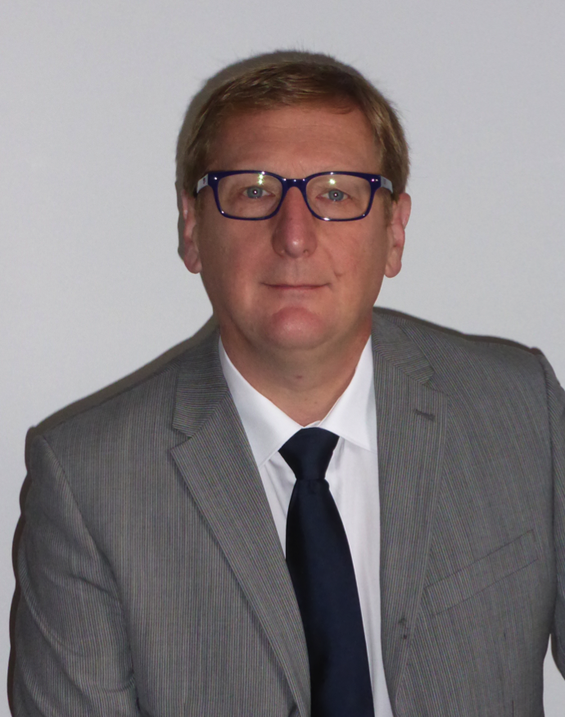

Paste your Photograph here

Email Id: christophe.len@chimieparistech.psl.eu

Any Comments:

