Mn-based MOFs as efficient catalysts for catalytic conversion of carbon dioxide into cyclic carbonates and DFT studies
Dr Yuanfeng Wu, Prof. Guomin Xiao,
Southeast University, Nanjing, China

Abstract (300 word limit)
The metal organic framework materials of [(CH₃NH₃][Mn(COOH)₃] (MA-MnF), [(CH₃CH₂NH₃][Mn(COOH)₃] (EA-MnF), and [C₃H₅N₂][Mn(COOH)₃] (Im-MnF) were easily prepared under room temperature, and further employed as the highly-efficient catalysts for catalytic conversion of carbon dioxide into cyclic carbonates. The metal organic frameworks including MA-MnF, EA-MnF, Im-MnF were studied via several characterizations such as XRD, FT-IR, XPS, N₂-adsorption, TG-DSC, CO₂-adsorption and NH₃-TPD. Interestingly, Im-MnF compound was observed to possess the highest catalytic activity among the studied compounds, which is associated not only with the amounts of basic sites, but also related to the nitrogen-containing species. Various reaction parameters including reaction temperature, reaction time, catalyst loading, reaction pressure as well as recyclability and coupling scope were explored. 97.27% conversion of allyl-glycidyl ether (AGE, TOF: 36.78 h⁻¹) and 97.66% selectivity to allyl-glycidyl carbonate (AGC) were obtained under the explored optimized conditions (100 ºC, 15bar, 6h, 1.0 wt.% of AGE). In addition, only a slight downward in catalytic activity was found when the sample was reused twice. Furthermore, coupling reactions of CO₂ with various epoxides were also performed, of which, the yield of the cyclic carbonates followed the order: Epichlorohydrin > Allyl glycidyl ether > Styrene oxide > Cyclohexene oxide> Propylene oxide. Finally, a mechanism was proposed for explaining carbon dioxide insertion into epoxide. Besides density functional theory (DFT) calculations were also performed on Gaussian 09 Packages (M06 method//6-31g(d, p) for main-group element, ECP-Lanl2DZ for Mn element). The calculated results were in good agreement with the DFT calculation.

Image
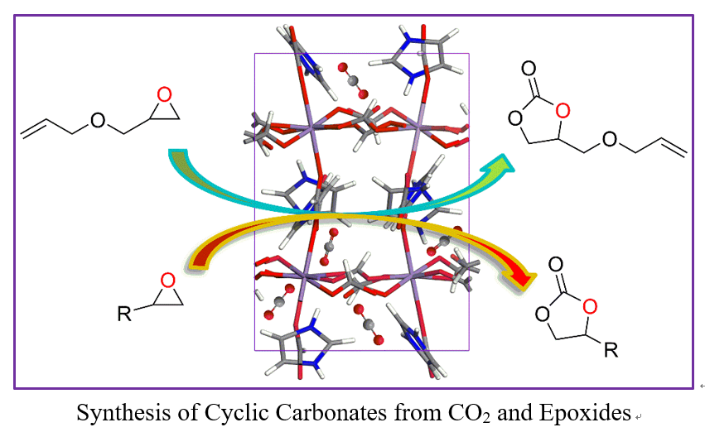
Recent Publications (minimum 5)
- Wu YF, Song XH, Xu SQ, Zhang JH, Zhu YL, Gao LJ, Xiao GM (2019) 2‑Methylimidazole Modified Co‑BTC MOF as an Efficient Catalyst for Chemical Fixation of Carbon Dioxide. Catalysis Letters 149:2575–2585
- Wu YF, Song XH, Xu SQ, Yu Tao, Zhang JH, Qi Qi, Gao LJ, Zhang Jin, Xiao GM (2019) [(CH3)2NH2][M(COOH)3] (M=Mn, Co, Ni, Zn) MOFs as highly efficient catalysts for chemical fixation of CO2 and DFT studies. Molecular Catalysis 475:110485.
- Wu YF, Song XH, Zhang JH, Xu SQ, Gao LJ, Zhang J, Xiao GM (2019) Mn-based MOFs as efficient catalysts for catalytic conversion of carbon dioxide into cyclic carbonates and DFT studies. Chemical Engineering Science 201:288–297
- Song XH, Wu YF, Pan DH, Zhang JH, Xu SQ, Gao LJ, Wei RP, Zhang J, Xiao GM(2018) Dual-linker metal-organic frameworks as efficient carbon dioxide conversion catalysts. Applied Catalysis A, General 566:44–51.
- Zhang S, Zhang H, Cao FX, Ma YY, and Qu YG (2018) Catalytic Behavior of Graphene Oxides for Converting CO2 into Cyclic Carbonates at One Atmospheric Pressure. ACS Sustainable Chem. Eng. 6:4204−4211

Photograph

 Biography (150 word limit)
Dr Wu has his expertise in catalysis and passion in exploring the metal organic framework materials for catalytic conversion of CO₂ into fine chemicals. His studied field based on density functional theory (DFT) calculation has confirmed the possible reaction path for CO₂ cycloaddition. He has built kinetic models for CO₂ chemical fixation, glycerol transesterification and dye degradation after years of experience from theoretical study and engineering application. The foundation is based on Arrhenius equation mainly reveals the relationship between conversion rate and reaction temperature for eliminating internal effects on the chemical reactions.
Email: wuyuanfeng2015@163.com

Notes/Comments:

The work was financially supported by the National Natural Science Foundation of china (Nos. 21676054, 21406034), and Scientific Research Foundation of Graduate School of Southeast University (No. 3207049714)

