Metal triflates: Versatile acid catalysts for the valorisation of carbohydrates in various media
Iurii Bodachivskyi¹, Unnikrishnan Kuzhiumparambil², D. Bradley G. Williams¹*
¹ School of Mathematical and Physical Sciences
² Climate Change Cluster
Faculty of Science, University of Technology Sydney, NSW 2007, Australia

Abstract
Acid-catalysed conversion of carbohydrates into organic building block chemicals (platform molecules) is a promising pathway towards a large portfolio of industrially useful molecules alternative to petrochemical products. Many saccharides, such as cellulose or its monomer glucose, are naturally abundant and easily accessible for large volume renewable production of chemicals. The conversion of these carbohydrates into platform molecules is challenging because the transformation is a multistage process, which relies differentially upon Lewis acid catalysis and Brønsted acid catalysis. In addition, and besides the catalyst, there is an optimum set of reaction conditions that favours each step of the process, and these conditions are frequently mutually exclusive. The focus of this work is on the use of acidic metal trifluoromethanesulfonates as catalysts, as well as their Brønsted acid or Brønsted base assisted analogues, in selective transformations of glucose and cellulosic substrates in various solvents, such as water, methanol or ionic liquids. The study covers fundamental insights of this chemistry to identify the roles of the catalysts and solvents in these complex processes. The resulting knowledge has made it possible to convert carbohydrates into a range of value added molecules in desirable yields and under mild conditions.

Recent Publications
- Acid-catalyzed conversion of carbohydrates into value-added small molecules in aqueous media and ionic liquids. I. Bodachivskyi, U. Kuzhiumparambil, D.B.G. Williams, ChemSusChem. 2018, 11, 642.
- Linear and macrocyclic water soluble polyacylhydrazones and their utilisation in coatings, A.M. Daines, H. Robinson, M. Glenny, D.B.G. Williams, S.F.R. Hinkley, Progr. Org. Coat. 2018, 121, 38.
- Protecting group-free use of alcohols as carbon electrophiles in atom efficient aluminium triflate-catalysed dehydrative nucleophilic displacement reactions. A. Cullen, A. Muller, D.B.G. Williams, RSC Advances, 2017, 7, 42168-42171.
- Cellulose is a source of water dispersible renewable film-forming materials, D.B.G. Williams, J.M. Mason, C.J. Tristram, S.F.R. Hinkley, Macromol. 2015, 48, 8497.
- Aluminum triflate catalysed tandem reaction of D-galactal: toward chiral benzopyrans, chromenes and chromans, S.B. Simelane, H.H. Kinfe, A. Muller, D.B.G. Williams, Org. Lett. 2014, 16, 4543.

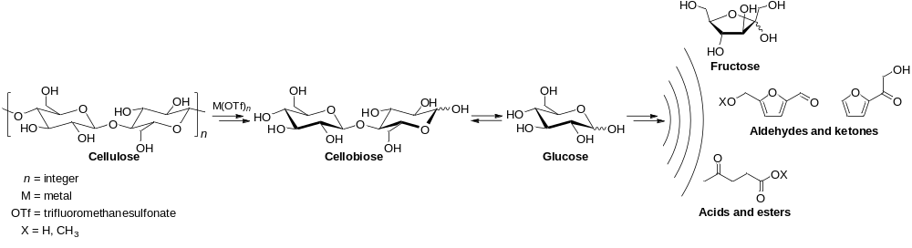

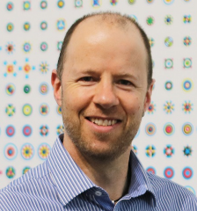
Bradley Williams has a passion for method development. His work has focussed on the use of transition metal catalysts and acidic catalysts, both Lewis and Lewis-acid assisted Brønsted acids, in high efficiency organic transformations. His interests span industrially oriented value add processes such as hydroformylation and hydroalkoxycarbonylation to advanced multistep reactions involving carbohydrate substrates. His current work includes an interest in the use of biomass as feedstocks for industrial processes. Career-wise, Bradley has worked in five countries in academia and in industry. He in enamoured with use-inspired fundamental and applied research..
Email: Bradley.Williams@uts.edu.au

Notes/Comments:

