Design of Electrocatalysts for Solid Oxide Fuel Cell Application: A Mechanistic Approach

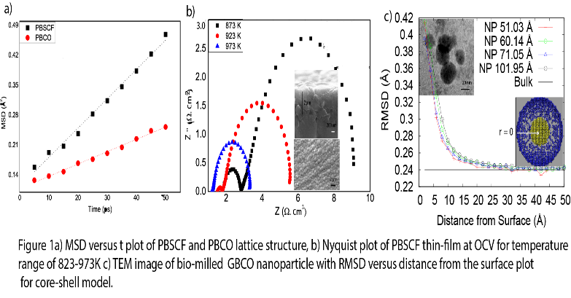
Uzma Anjum¹, M. Ali Haider¹
- Renewable Energy and Chemical Laboratory, Chemical Engineering, IIT Delhi, India

Abstract

Anisotropy in the layered structure is attributed for higher oxygen diffusivity in the Ln (Ln = Pr Gd) plane as compared to the Ba plane of the double perovskite. The diffusivity in PrBa_{0.5}Sr_{0.5}Co_{2-x}Fe_{x}O_{5+δ} (PBSCF, 1.18x10⁻⁷ cm²s⁻¹) was calculated to be higher by an order of magnitude as compared to PBCO (3x10⁻⁸ cm²s⁻¹ at 873 K, Figure 1a). In order to understand the relative control of surface reaction and bulk diffusion, dense thin-film of electrodes of PBSCF with < 500 nm grain sizes was deposited using spray pyrolysis (Figure 1b). In parallel, Density Functional Theory (DFT) calculations were utilized to calculate the surface (ϒ) and oxygen vacancy (E_{ov}) formation energies. The E_{ov} (98.4 kJ/mol) in the Gd plane of GBCO was measured to be lower than that of Ba plane (E_{ov}=266.3 kJ/mol). However, the surface energy of the Ba plane was measured to be minimum ϒ=7.2 kJ/mol, which makes it the most exposed surface, while it is least diffusive for oxygen anions. Therefore, larger size bulk microstructures of GBCO were measured to give lesser than expected oxygen anion diffusivity (D=6.04x10⁻¹⁰cm²s⁻¹). GBCO particles of reduced size are expected to expose higher energetic Gd plane, which may enhance diffusivity. The average particle size was observed to be ~20 nm in case of bio-milling synthesis of GBCO leading to a 20% improvement in the ASR of electrode (Figure 1c). MD simulation on a GBCO nanoparticle showed, the diffusion in nanoparticles to represent two distinct regimes; one corresponding to the surface and other the bulk. Stability of nanoparticles were validated by calculating the root mean square deviation (RMSD) of atomic positions in MD simulations. The thickness (20A⁰) of diffusive surface shell regime was observed to be particle size independent, while the thickness of the diffusive core regime varies with the size of nanoparticle (Figure 1c).

Recent Publications
- U. Anjum, T.S. Khan, M. Agarwal, and M. A. Haider, “Identifying the Origin of the Limiting Process in a Double Perovskite PrBa_{0.5}Sr_{0.5}Co_{1.5}Fe_{0.5}O_{5+δ} Thin-Film Electrode for Solid Oxide Fuel Cells” (Under Review, ACS Applied Materials & Interfaces).
- Tuhin S. Khan*, Sarwar Hussain*, Uzma Anjum*, M. Ali Haider, "In-silico Screening of Metal and Bimetallic Alloy Catalysts for SOFC Anode at High, Intermediate and Low Temperature Operations" (* Equal Contribution) Electrochimica Acta, 281,654-664, 2018.
- Uzma Anjum, Manish Agarwal, T. S. Khan and M Ali Haider, “Ca-Doped Double Perovskite PrBa_{0.8}Ca_{0.2}Co₂O_{5+δ} Thin-Film Electrodes: Experimental and Theoretical Study”, ECS Transactions 78(1): 499-506, 2017.
- Uzma Anjum, Saumye Vashishtha, Manish Agarwal, Pankaj Tiwari, Nishant Sinha, Ankit Agarwal, S. Basu, M. Ali Haider, “Oxygen anion diffusion in double perovskite GdBaCo₂O_{5+δ} and LnBa_{0.5}Sr_{0.5}Co_{2-x}Fe_{x}O_{5+δ} (Ln=Gd, Pr, Nd) electrodes”, International Journal of Hydrogen Energy, 41, 7631–7640, 2016.
5. Uzma Anjum, Saumye Vashishtha, Nishant Sinha, M. Ali.Haider, "Role of Oxygen Anion Diffusion in Improved Electrochemical Performance of Layered Perovskite LnBa_{1-y}Sr_{y}Co_{2-x}Fe_{x}O_{5+δ} (Ln = Pr, Nd, Gd) Electrodes" Solid State Ionics, 280, 24–29, 2015.

 Biography

Uzma Anjum research is focus on the design of electrode materials for solid oxide fuel cell. She is working on a variety of projects related to both theoretical and experimental research on developing material for solid oxide fuel cells. She has shown a remarkable ability of producing results from limited experimental facilities, which has helped her group in producing encouraging results. On the theoretical side she has developed a deep understanding of molecular dynamics simulation, Density Functional Theory, and microkinetic modeling calculations and has performed simulations on double perovskite material in order to calculate the oxygen anion transport property in different system.

Email: uzmi.rocks@gmail.com

