Electrically self-healing thermoset nanocomposites
Dr Rodrigo Araya-Hermosilla, PhD, Programa Institucional de Fomento a la I+D+i (PIDi), Universidad Tecnológica Metropolitana, Chile

Abstract (300 word limit)

In this project, there have been designed and prepared electrically conductive nanocomposites based on thermally reversible thermoset polymers. The thermosets, which are based on reversible covalent and physical interactions, are reinforced with multi-walled carbon nanotubes (MWCNTs) to render nanocomposites with electrically induced self-healing properties. This is a relatively new concept currently used in the design of light long-lasting and flexible materials for electronics, actuators, sensors, coatings and structural materials. For these particular systems, the healing process occurs via the nanoscopic heat generation when an electrical current passes through the conductive nanostructured network (e.g. well-connected MWCNTs network). The so-called Joule effect (or resistive heating) activates the intrinsic self-healing ability of the thermally self-mendable matrices to heal structural damage and prolong the service life of the material. Current results have shown self-healing behavior of these materials at nano and micron-scale and the enhancement in mechanical properties at macro-scale. Moreover, the research contributes with the state-of-the-art of nanocomposites capable to sense (via electrical measurements) undetectable cracks and recover structural damage by electrical resistive heating. Among several advantages, this approach guarantees a faster healing process even at nano-scale level, thus representing an extraordinary alternative for curing and self-healing in engineering thermoset applications. It is certainly expected that the novelty of this approach will pave the way toward the scale-up of the proposed materials at industrial level.

Image
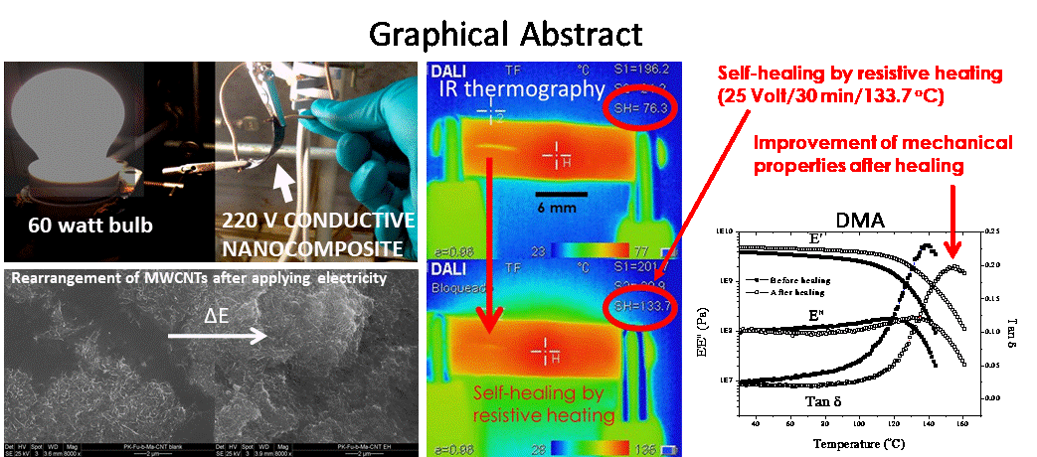
Recent Publications (minimum 5)
- Nicola Migliore, Lorenzo Polgar, Rodrigo Araya-Hermosilla, Patrizio Raffa, Francesco Picchioni, Andrea Pucci. (2018) Effect of the polyketone aromatic pendent groups on the electrical conductivity of the derived MWCNTs-based nanocomposites. Polymers 10 (6): 618.
- Polgar LM, Criscitiello F, van Essen M, Araya-Hermosilla R, Migliore N, Lenti M, Raffa P, Picchioni F, Pucci A. (2018) Thermoreversibly Cross-Linked EPM Rubber Nanocomposites with Carbon Nanotubes. Nanomaterials 8: 58.
- R. Araya-Hermosilla, A. Pucci, E. Araya-Hermosilla, P. P. Pescarmona, P. Raffa, L. M. Polgar, I. Moreno-Villoslada, M. Flores, G. Fortunato, A. A. Broekhuis and F. Picchioni (2016) An easy synthetic way to exfoliate and stabilize MWCNTs in a thermoplastic pyrrole-containing matrix assisted by hydrogen bonds. RSC Advances 6: 85829.
- R. Araya-Hermosilla, G. M. R Lima, P. Raffa, G. Fortunato, A. Pucci, I. Moreno-Villoslada, M. Flores, A. A. Broekhuis and F. Picchioni (2016) Intrinsic self-healing thermoset through covalent and hydrogen bonding interactions. European Polymer Journal 81: 186.
- R. Araya-Hermosilla, G. Fortunato, A. Pucci, P. Raffa, L. Polgar, A. A. Broekhuis, P. Pourhossein, G. M. R Lima, M. Beljaars and F. Picchioni (2015) Thermally reversible rubber-toughened thermoset networks via Diels-Alder chemistry. European Polymer Journal 74:229.

Photograph

Biography (150 word limit)
Dr R. Araya-Hermosilla study the chemical modification of alternating aliphatic polyketones and their interaction with carbonaceous nanostructures. He seeks to solve practical problems in aquaculture and related industries by using self-healing thermoset materials and self-repairing conductive nanofilms with electrical stimulus.
Email: rodrigo.araya@utem.cl

Notes/Comments:

Acknowledgements: Fondecyt Postdoctorado 3170352, Fondecyt_Postdoctorado 3160648, Fondecyt Regular 1181695

