POLAND SYNDROME :A CASE REPORT
Assoc. Prof. Dr. Arife Zeybek
Mugla Sıtkı Kocman University, School of Medicine, Department of Thoracic Surgery ,Mugla / Turkey

A 29-year-old male patient was accepted to our outpatient clinic with blunt trauma to the right side of the chest. After a physical examination and radiological evaluations, no trauma-related complications on the right side of the chest were detected, however, an asymmetry in the left chest wall, an upward-positioned nipple at the left side and collapsed left chest wall and abdomen were noted. When palpated, absence of costal cartilage of the 5th-10th rib on the left chest wall and muscle weakness on the chest wall and anterior abdominal wall was identified and a 20×15 cm area of hypopigmentation on the left chest wall – the area that was separated by a sharp border on the same level as the skin was noted (Figure 1). No pathological findings or symptoms were found in the rest of the physical examination. There was no paradoxical respiration or dyspnea in the patient. Respiratory reserves were found to be within normal limits.
On the thoracic CT scan, total agenesis of the left PMj, PMi hypoplasia, left rectus abdominis xiphoid adnexa head aplasia, and left 5th–10th costal cartilage defects were detected. These findings implied PS and accompanying dextrocardia (Figures 2–3). No congenital heart disease was detected by echocardiographic evaluation performed by a cardiologist. No decrease or change in the arterial bloodstream was reported in the upper left extremity or left subclavian arterial Doppler USG. A moderate level of hepatosplenomegaly was noted in the abdominal USG. There was no abnormality in the vertebral or skeletal structure.

Corresponding author:
Arife Zeybek, Assoc. Professor, Department of Thoracic Surgery, Mugla Sıtkı Koçman University, School of Medicine, Turkey, Tel: 90 252 2114855; E-mail: arifezeybek@mu.edu.tr

Figure Legends :
Figure 1: The absence of anterior costal ribs is observed with an inspection in an adult patient
Figure 2: Dextrocardia was observed in the chest x-ray of the adult patient.
Figure 3: Total absence of left pectoral major muscle were observed by computed tomography

Figure 1

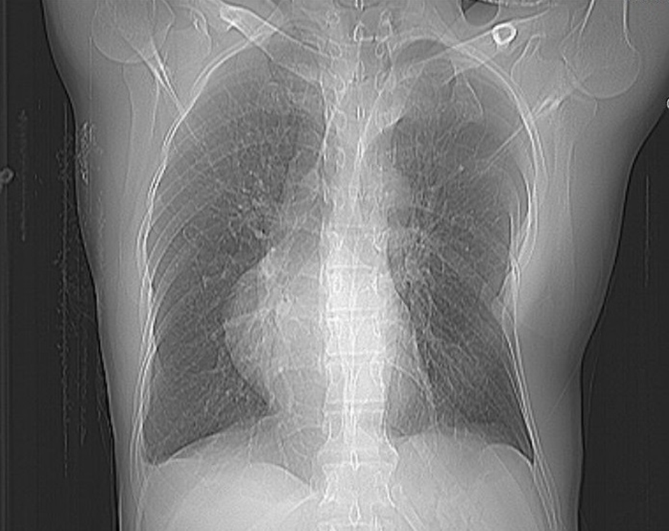

Figure 2

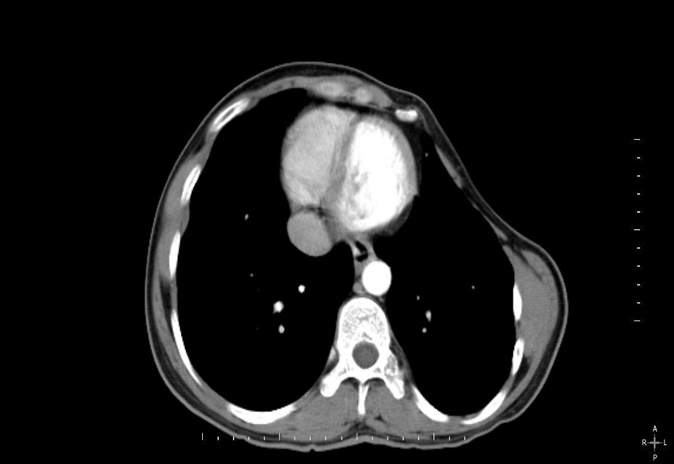
Figure 3

