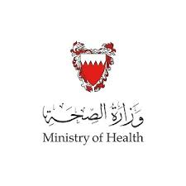
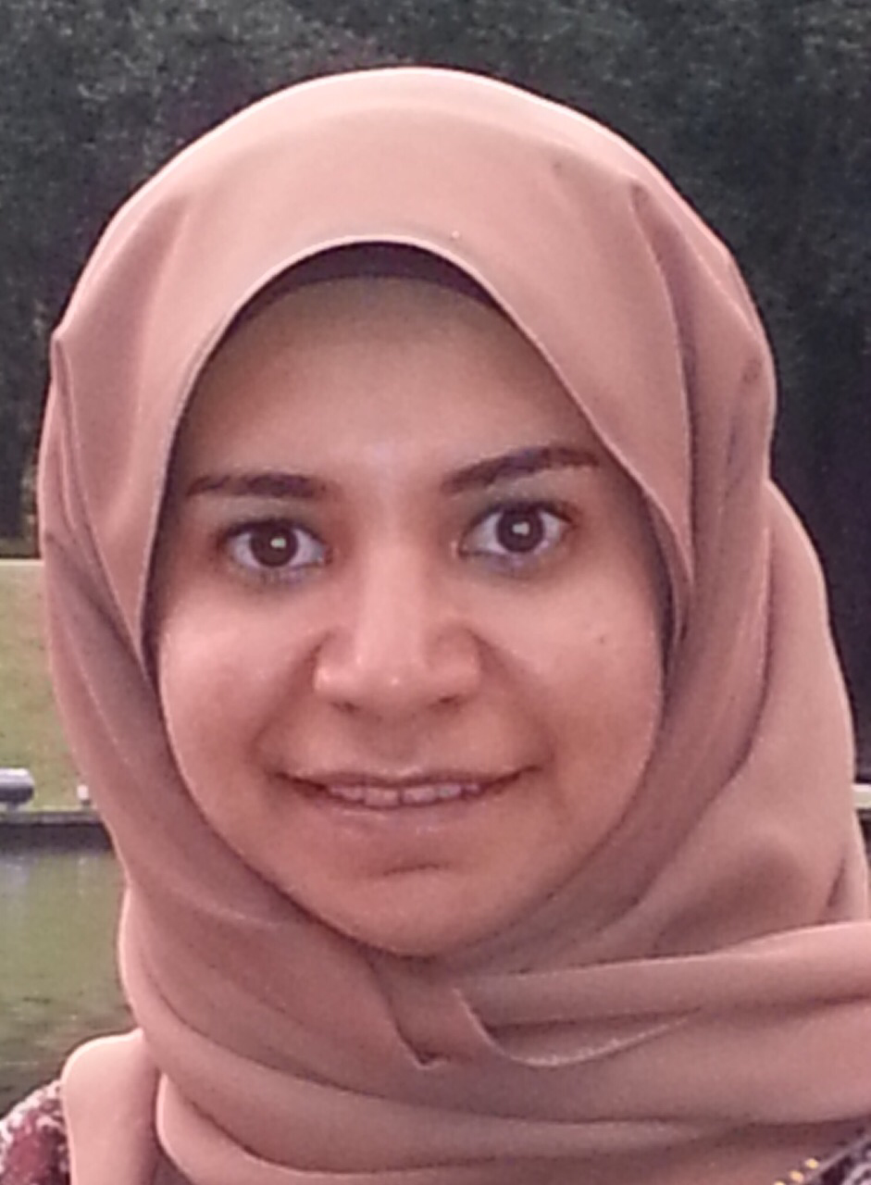

Primary Angiosrcoma of the breast in elderly female, Systematic Review
Raja Eid,MBBCh,MRCS,CABS

Angiosarcoma of the breast is a rare and considered to be the most malignant of all breast tumors, arising from the endothelial vascular linings and could be primary or secondary to lymphedema or radiation therapy. It usually encountered in younger age group.

Herein, where are presenting an unusual case where 77 year- old female developed 4 cm painless right breast mass, confirmed radiologically. Core biopsy had revealed sclerosed papillary lesion with small fragment infiltrated by hormonal positive adenocarcinoma of mammary NST. Patient was started on neoadjvant hormonal therapy ( Letrozole ) based on her core biopsy result, Her tumor showed no response and increased in size. Therefore she underwent Mastectomy. Unexpectedly her final histopathology report shows high grade angiosarcoma with no epithelial elements.

Angiosarcomas of the breast are rare tumors with poor prognosis, where diagnosis and treatment could be challenging. Mastectomy stays the counter stone of treatment with no much supportive evidence in favor of chemotherapy or radiation.

Biography

1.Dr.Raja Eid
MBBS, MRCS, CABS
chief Surgical Resident at Salmaniya Medical Complex(SMC),Kingdom of Bahrain
MBBS with honor -King Faisal university , Kingdom of Saudi Arabia
MRCS – Royal college of England 2012
Arab board of General Surgery 2015

Presenting author details
Full name: Dr.Raja Eid
Contact number: 0097333775529
Email id: dr.raja.eid@gmail.com
Category: (Oral presentation/ Poster presentation/E
Session name: EuroSSicon-Barcelona- May 2019
Research interest: Case Reports and clinical trials

