“Plate on plate” rib fixation: A novel technique for when you realize that you needed a longer plate.

EeeLN Buckarma, M.D.¹, Clara Kit Nam Lai, M.B.B.S.², Mariela Rivera, M.D.¹, Henry Schiller, M.D.¹

Abstract

Background

Fixation of complex rib fractures and fractures associated with poor bone quality can pose a technically challenging operation. We present a novel “plate on plate” technique to extend fixation across additional fractures encountered on a rib after an initial plate has already been placed and for ribs with multiple segmental fractures for a long distance without enough room to place separate plates. We have also used this technique to allow for extreme in-plane contouring when a single plate cannot be adequately contoured.

Case presentations

Our case report includes two 80-year-old females with medical history significant for osteoporosis who presented to the emergency room with multiple rib fractures including flail segments. Each patient was taken to the operating room for surgical stabilization of their rib fractures after failure of non-operative management. Many of the patients’ fractures were not visible on axial imaging due to poor bone quality or cartilaginous involvement. Moreover, lower rib fractures involving the costal cartilages required extreme in-plane contouring beyond what we could achieve with a single plate with our available instrumentation. Both patients underwent a novel plate on plate technique to achieve extend fixation once an initial plate had been placed, for extremely long segments of rib with multiple segmental fractures as well as to achieve extreme in-plane contouring.

Conclusion

The plate on plate technique is a feasible way to obtain rib fracture stabilization in patients when additional fractures are encountered after initial plate placement as well as to address extreme in-plane contour challenges.

Background

Surgical stabilization of rib fractures (SSRF) is gaining increasing popularity as treatment for multiple rib fractures and traumatic flail chest. Several randomized controlled trials and meta-analyses have demonstrated that SSRF is associated with reductions in the incidence of pneumonia, duration of ventilation, and the length of stay in the intensive care unit (ICU) when compared to non-operative management. ¹⁻³ While there is growing evidence for the benefits of SSRF, there is no consensus on the best approach, technique, or choice of hardware in SSRF.⁴ With an increasing elderly population with poor bone quality at risk of rib fractures, fixation is particularly technically challenging in part because of the presence of occult fractures not visible by axial imaging. We present two cases in which we were able to improvise a solution using titanium rib fracture stabilization to extend our fixation ex post facto, to apply plates to extremely long segments of fracture ribs where there is not enough space between fractures to place additional plates and to achieve extreme in-plane contouring during rib fixation.

Case presentations

Case 1: An 84-year-old female with a past medical history significant for chronic alcohol use, osteoporosis and vitamin-D deficiency presented to the emergency room after she fell from standing height. Radiographic imaging in the emergency department revealed multiple right-sided rib fractures, involving both anterior and posterior rib fractures.

She was admitted to the hospital and enrolled in our rib fracture pain management protocol. Despite this, over the next 48 to 72 hours she had poor pulmonary toilet and progressive atelectasis documented by serial chest x-rays. 3-D CT chest reconstruction images revealed rib fractures on the right 2-9 with flail segments of ribs 2-8. She was taken to the operating room where the Acute Innovations RibLoc U+ system was used to stabilize anterior ribs 2-8 and posterior ribs 6-9. As her bone quality seemed adequate to achieve purchase of the bicortical screws, the back portion of the RibLoc U + plate system was removed. We have recently adopted this practice from our experience with infected rib fracture stabilization hardware to allow for easier removal of these plates should it be necessary in the future. We proceeded to plate the displaced rib fractures identified by CT scan but noted further instability of multiple ribs after screw fixation of our plates. We subsequently identified severaloccult non-displaced rib fractures not seen on axial or 3-D images from her CT scan. This included fractures at the costochondral junctions. A 115-mm plate was chosen to bridge four palpable fractures of this rib. After contouring the plate, we drilled and screwed the plate with multiple screws including intermediate screws. After placement of the 115-mm plate, we encountered a costochondral junction fracture that would need to be bridged to provide stability. Rather that removing the 115-mm plate we elected to place another plate to try to extend our stabilization. Here we utilized our plate-on-plate technique, taking a 50-mm RibLoc U plate, cutting the back off, placing it around the cartilage medially, and overlapping two of the screw holes laterally (Fig.1). This gave excellent stabilization.

A right sided chest tube was placed and bilateral transversus abdominis plane blocks were performed. Postoperative chest x-ray was obtained and due to sufficient lung volumes, the patient was extubated in the operating room.

Case 2: An 87-year-old female with a past medical history significant for giant cell arteritis, polymyalgia rheumatic, and steroid- induced osteoporosis presented to our emergency room following a high –speed motor vehicle crash. On arrival, she was awake and interactive but in respiratory distress with tachypnea, labored breathing and obvious right-sided paradoxical chest wall motion. She was immediately intubated for respiratory failure. Subsequently, she underwent a CT scan which demonstrated bilateral mildly displaced 2nd - 10th rib fractures on the right with flail segments in the 3rd, 4th and 7th ribs (Fig. 2a). On the left she sustained 1st - 4th and 6th -11th ribs fractures (Fig 2b).

On hospital day 2 the patient underwent SSRF with the RibLoc U Plus system. The patient’s bone quality was extremely poor and so we did not modify the U-portion of the plate to ensure that the screws would adequately lock into the posterior of the U-plate. Multiple small incisions were made over the palpable areas of instability. Again, we encountered occult nondisplaced fractures discovered intraoperatively that were not identified on axial imaging, including several fractures extending out to costal cartilages. This resulted in ribs with multiple fractures of long flail segments without enough space between the fractures to place separate plates. These complex fractures made it challenging to obtain the appropriate plate curvature, due to extreme in-plane contour at the costochondral junction. Despite using the available tools from the RibLoc system we were not able to obtain adequate in-plane contour to allow the plate to conform to the acute angle made from the rib across the costochondral junction to the costal cartilage. Therefore, our ‘plate on plate’ technique was used on several particularly challenging ribs that required this extreme in-plane contouring (Fig. 3). We stabilized the 2nd to 9th ribs bilaterally and used the ‘plate on plate’ technique on the right 3rd, 4th and 7th ribs, and on the left 8th and 9th ribs. 4b

Chest tubes were placed bilaterally and incisional vacuum-assisted closure (VAC) therapy was utilized. The plates were not palpable and the patient had not reported any discomfort related to the implant.

Discussion

In our experience we have found that a novel ‘plate on plate’ technique has been useful in patients with complex rib fractures needing additional length to bridge fractures discovered ex post facto, once a plate has already been applied to the rib. This has helped us to avoid removing a plate and drilling new holes in osteoporotic patients in which this would presumably would further weaken or damage the rib. We have also applied this technique in the uncommon situation in which we were unable to provide enough in-plane bend to the plate to follow the contour of the rib across the costochondral junctions. This technique entails using a medium length plate (e.g. 115 to 155mm) to span the problematic fracture segment and overlapping it as needed anteriorly with a shorter plate (e.g. 75mm) to augment the in-plane contour and improve stability around the rib.

The principles of fracture fixation require that a rib plate traces the rib diaphysis and remains in contact with the rib surface over the entire plate length to achieve a durable fixation construct.⁵ There are three principals to consider when contouring a plate to the surface of the rib: out-of-plane bending, in-plane contour, and twist (Fig. 4).⁶ The in-plane contour is the most difficult to achieve during intraoperative bending. It is crucial to achieve the correct contouring of the plates for optimal long term success. Plates need to be flush with the outer cortex of the rib. Moreover, inadequate in-plane contouring can limit the number of screws placed across fractures to fix the plate to the rib. Thus, inadequate contouring on the rib prostheses can result in instability and nonunion at the fracture site. ⁴ Fitting a short plate for fixation of a single rib fracture can readily be accomplished by out-of-plane bending to the general curvature of the rib. However, long bridging plates that support an entire flail segment have been considered fundamental for operative stabilization yet contouring complicated plate becomes more complicated as the length of the plate increases. In our experience, twist and in-plane contouring become much more critical for longer plates to maximize contact with the rib.

Precontoured plating systems, (e.g. Matrix RIB, DePuy Synthesis), have been developed to address contouring issues. However, we would argue that since the design of the precontoured plates is based on data from human cadaveric ribs and the plates are precontoured to fit an average rib shape, it may not be applicable in some patients with difficult anatomy and poor bone quality.

Our experience demonstrates that it is possible to overcome the limitations of non-precontoured systems in SSRF with flexible use of plates and equipment across different plating systems. The ‘plate on plate’ technique with the Acute Innovations RibLoc U Plus system can be used to address extremely long segments of fractures where there is insufficient room to add plates between fractures and also for extreme in-plane contour for fixation of complex rib fractures in the acute setting.

Conclusion
In conclusion, the ‘plate on plate’ technique is an innovative and feasible way to achieve optimal contouring in difficult rib fractures with extreme in-plane contour.

Figure 1.

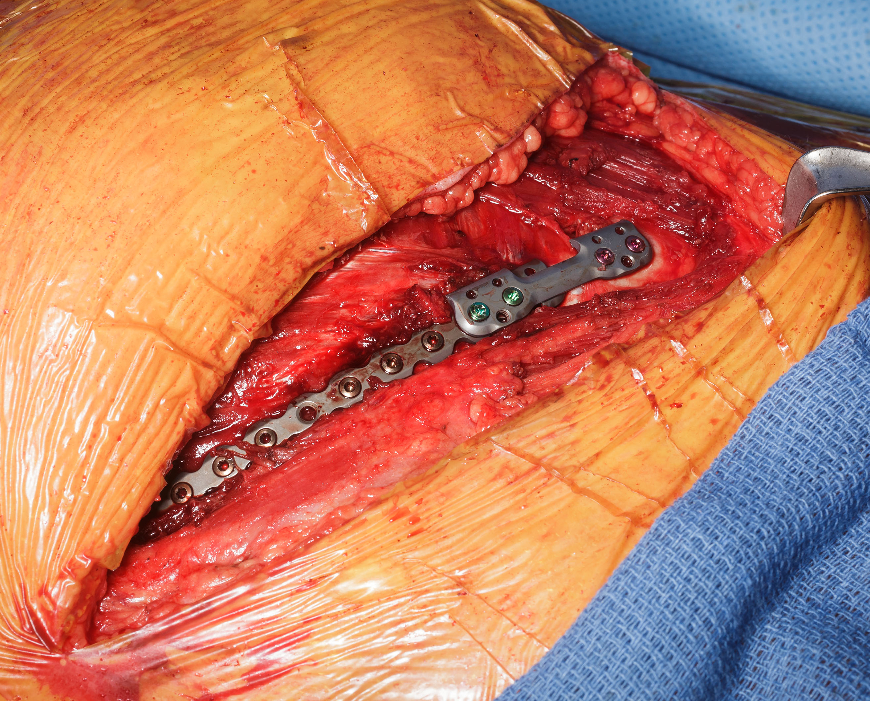

Figure 2a.

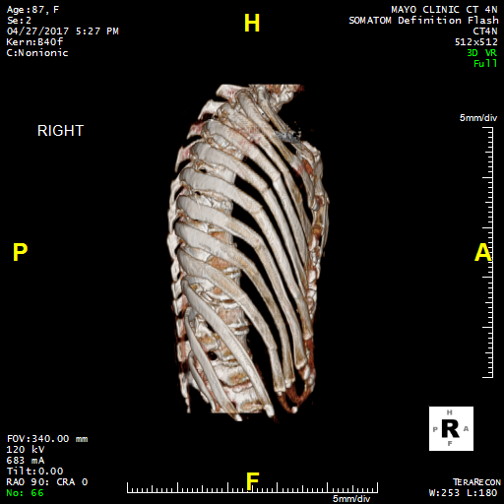

Figure 2b.

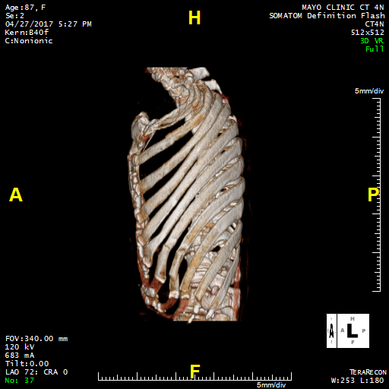

Figure 3.
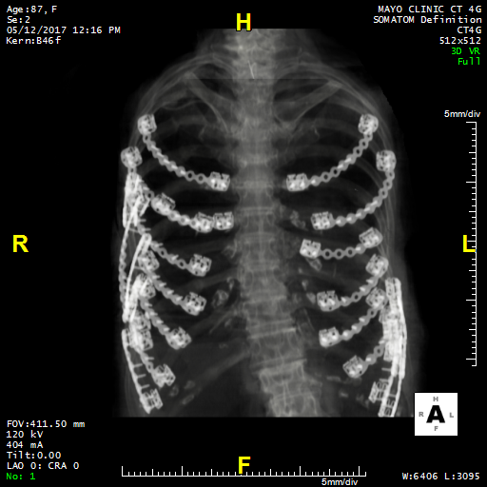

Figure 4.

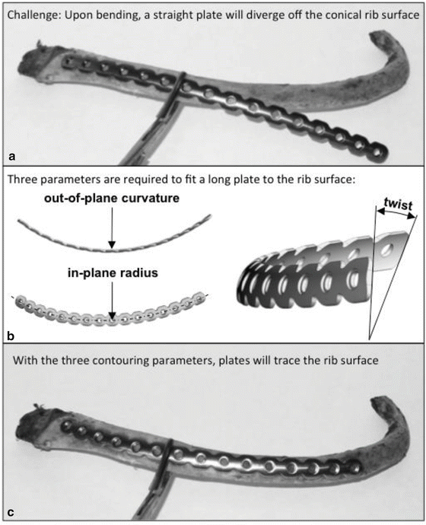

References

1. Coughlin TA, Ng JW, Rollins KE, Forward DP, Ollivere BJ. Management of rib fractures in traumatic flail chest: a meta-analysis of randomised controlled trials. Bone Joint J. Aug 2016;98-b(8):1119-1125.
2. Pieracci FM, Lin Y, Rodil M, et al. A prospective, controlled clinical evaluation of surgical stabilization of severe rib fractures. J Trauma Acute Care Surg. Feb 2016;80(2):187-194.
3. Swart E, Laratta J, Slobogean G, Mehta S. Operative Treatment of Rib Fractures in Flail Chest Injuries: A Meta-analysis and Cost-Effectiveness Analysis. J Orthop Trauma. Feb 2017;31(2):64-70.
4. Marasco S, Saxena P. Surgical rib fixation - technical aspects. Injury. May 2015;46(5):929-932.
5. Bottlang M, Helzel I, Long WB, Madey S. Anatomically contoured plates for fixation of rib fractures. J Trauma. Mar 2010;68(3):611-615.
6. Mohr M, Abrams E, Engel C, Long WB, Bottlang M. Geometry of human ribs pertinent to orthopedic chest-wall reconstruction. J Biomech. 2007;40(6):1310-1317.

