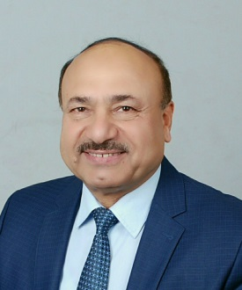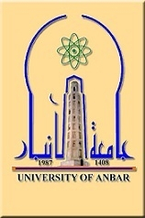

Coexistence of Ocular Myasthenia Gravis and Graves' Disease in
a Three Years Old Female.

Zaid Rasheed Al-Ani, CABP, DCH. Professor of Pediatrics, College of Medicine, University of Anbar. Senior consultant pediatrician, Al-Ramadi Maternity & Children Teaching Hospital, Anbar, Iraq.

A 14 years old female developed acute ptosis of the right eye at three years age followed by the second eye and diagnosed as myasthenia gravis after a positive response to SC neostigmine and normal fundoscopy, brain CT scan, and general investigations. The condition failed to respond to adequate Mestinon (Pyridostigmine) therapy. Five months later developed rolling of the eyes, convergent squint, bilateral ophthalmoplegia, proptosis, goiter and signs of graves' disease. Investigations showed high T4, low TSH, normal anti acetylcholine, ANA, anti SM antibodies, EEG, brain MRI, and CT scan of the chest. The condition diagnosed as a coexistence of myasthenia gravis with graves' disease. Carbimazole 5 mg/day was added but still the ophthalmoplegia and ptosis persist. Prednisolone added for three months but no response. As she passed more than three years with the disease without developing systemic signs of myasthenia gravis, the condition then diagnosed as ocular myasthenia gravis with graves' disease. With age, the ptosis and ophthalmoplegia interfered with her social and school performance in spite of the increased Mestinon therapy to 45 mg 6 hourly. in 2016 when she was 12 years old, reevaluation investigations showed all normal except enlarged thymus on CT scan of the chest and positive nasalis muscle EMG. Thymectomy done after plasmapheresis. Three weeks after operation, ptosis start to improve followed by gradual improvement of ophthalmoplegia. Now, after 2 years from operation, ptosis and ophthalmoplegia improved to about 70% and the euthyroid goiter reduced in size on only Mestinon 60 mg six hourly without antithyroid therapy.


Biography
Zaid Rasheed Al-Ani is a Professor of Pediatrics Doctor completed his MBChB from Basrah University, Iraq, in 1978 and the Arabic Board of Pediatrics specialty (CABP) in 1992 from Baghdad University. He is a senior teaching staff in the College of Medicine, University of Anbar since 1993, taught lectures and clinical training of pediatrics for undergraduates and DCH & CABP postgraduates. He is a senior consultant pediatrician in Al-Ramadi MCH Teaching Hospital and the director and project designer of the "Western Iraq Center for Congenital Anomalies Registry and Surveillance" in Al-Ramadi MCH teaching hospital, and a member of different Research Discussion Committees in the DCH, CABP, and PhD theses discussions. He published more than 15 original papers in different reputed journals, and a reviewer of many papers published in different reputed international Journals.

Presenting Author:
Professor Zaid Rasheed Al-Ani.
Email: zaidrasheedalani@yahoo.com
Mobile: 009647807442775.
Presentation: Oral.
Session name: Pediatrics allergy and immunology. Track 2-6
Research interest: pediatrics immunology, birth defects.

