

Title: “The Ochre” anchoring the diagnosis of a multisystem disorder – A Case Report.

Author (s) Name: Radhika S R
Kempegowda institute of medical sciences and health.
Bangalore, INDIA

Introduction : Endogenous ochronosis is a rare autosomal recessive disorder of metabolism caused by deficiency of homogentisic acid oxidase and resulting in accumulation of homogentisic acid in collagenous structures-skin, cartilage, and other connective tissues.

Case report : A 65 yr old male, farmer by occupation was referred to our department with palmoplantar pigmentation since 10 yrs. On examination, the patient had multiple bluish-grey cavior like pigmented plaques on plams, soles, ear and face. A D/D of argyria, arsenical keratosis, palmoplantar psoriasis was made. Skin biopsy was adviced. It showed thickened collagen bundles which were ochre colored and dilated lymphatics with yellow brown secretions within- features were of ochronosis. A special stain with methylene blue was positive. On retrospective examination, he had bluish pigmentation of nails and eyes. Detailed history revealed recurrent joint pains, recurrent pain abdomen since many years. He is a k/c/o HTN, he also underwent a surgical procedure 16 yrs back for ? renal stones. The present hospital admission was for acute pain abdomen and the patient underwent cholecystectomy for cholelithiasis.
Thus we confirmed our diagnosis as endogenous ochronosis.

Conclusion : The diagnosis of this multisystem disorders is usually missed out, because of its nonspecific presentation except for the mucocutaneous pigmentation and banana bodies on HPE of skin. The great saying “SKIN IS THE WINDOW FOR SYSTEMIC DISORDER” is proved again here.

Figures if any (BW/Color):

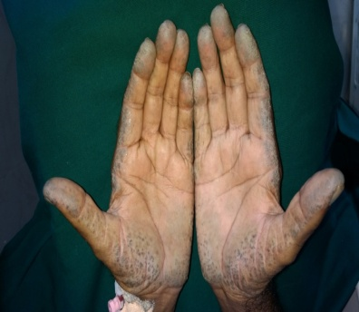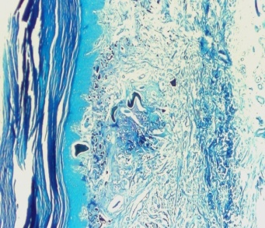
Methylene Blue stain: Thickened collagen bundle- “Banana bodies”(4x)

Biography
I Radhika S R, 2nd year Post graduate, persuing my M.D Dermatology Venereology and Leprology from KIMS college under RGUHS university in bangalore, INDIA.
Presenting author details
Full name: RADHIKA S R
Contact number: 9036092365
Email id:radhikaramamurthy24@gmail.com
Category: (Oral presentation/ Poster presentation)
Session name: others
Research interest: clinical dermatology

