Date: October 17, 2017

Letter of Invitation

Dear Dr.Ali Assiry,
Euroscicon Ltd. along with Case Reports-2018 Organizing committee affably invites you to "8th International Conference on Case Reports, 2018" to be held on May 28-29, 2018 at London, UK. We are glad to inform you that your abstract titled “Oral Rehabilitation of Diastrophic Dysplasia – A Rare Case Report” has been accepted for oral presentation. You are invited to be a Speaker at Case Reports-2018.
We welcome you to unite with us to share the knowledge and view on the theme “Clinical and Medical Case Reports that pave way for an advanced healthcare”.

We look forward to seeing you at London, United Kingdom.
For more details about Case Reports 2018,
PS: http://casereports.euroscicon.com/
Best regards;
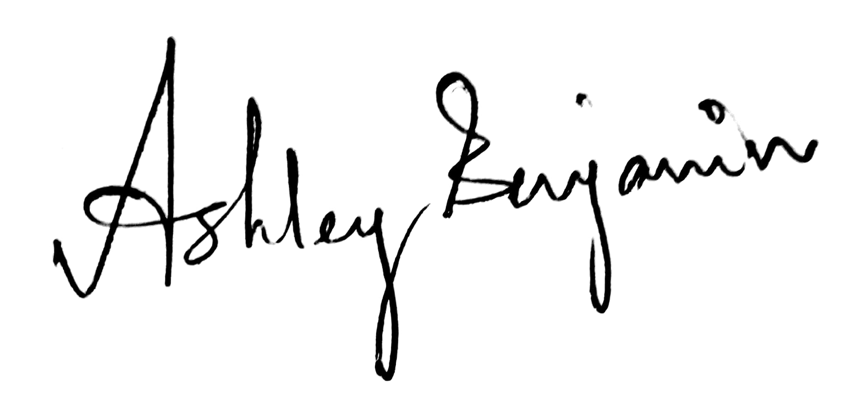
Ashley Benjamin
Program Manager| Case Reports 2018
Euroscicon Ltd
High stone House, 165 High Street,
Barnet, Hertfordshire EN5 5SU, UK
Phone: +44-2033182512
Fax: +6567228528
E: casereports@eurosciconmeetings.com

Organizing Committee
Alireza Heidari
President, American International Standards
USA
Oswin Grollmuss
(GHRMSA), France

Alaa Abdelrazik
University of Bradford, UK

Engy Abdellatif
The University of Manchester, UK

M Durval Campos Kraychete
Bahia Federal University, Brazil

Shagufta Ahsan
Shore Medical Centre, USA

Sanjay Chandragiri
Sanjay Chandragiri, USA

Samarth Burle
Yorkshire School of Paediatrics, NHS
England, United Kingdom, UK

Samia Sulaiman Alnugali
King Saud University, Saudi Arabia

Major Scientific Sessions

• Dentistry Case Reports

• Paediatrics Case Reports

• Cardiology Case Reports

• Neurology Case Reports

• Human Pathology Case Reports

• Oncology Case Reports

• Drug Interactions Case Reports

• Surgery Case Reports

• Obstetrics & Gynaecology Cases

• Medicine Case Reports

• Case Reports in Ophthalmology

• Case Reports in Clinical Autopsy

• Gastroenterology Case Reports
• Anaesthesiology Case Reports

Euroscicon Ltd | Highstone House, 165 High Street, Barnet, Hertfordshire EN5 5SU, UK | T: +44-2033182512

Disclaimer: This official invitation letter is to attend Case Reports-2018 only

