Title: Coronary angiogram and graft study with single diagnostic catheter in dextrocardia: Best approach for cath lab with limited resources
Abstract
Dextrocardia (DC) is a rare congenital anomaly. The incidence of coronary artery disease is similar to the general population. Dextrocardia presents several challenges due to abnormal location of the heart, mirror image pattern of aortic arch and its branches, and abnormal coronary origin and orientation, and it becomes more difficult when grafts are cannulated through trans-radial access, all with single catheter.
We have performed coronary angiogram and graft study through trans-radial access using only one diagnostic catheter due to limited resources in developing country.

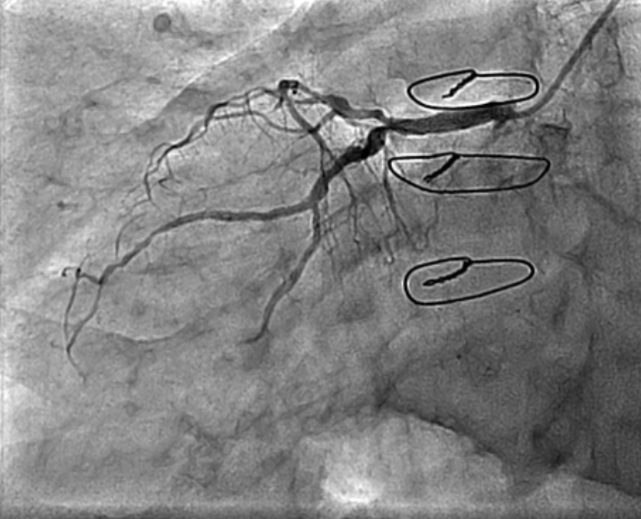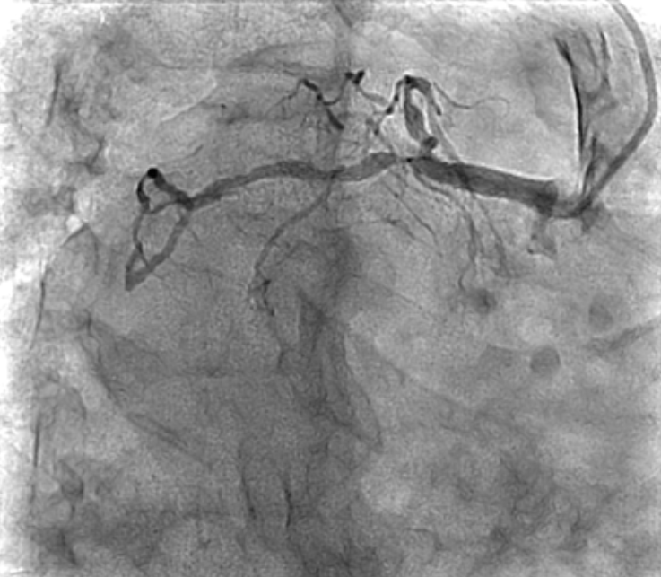Native Coronary angiogram
Native Coronary Angiogram 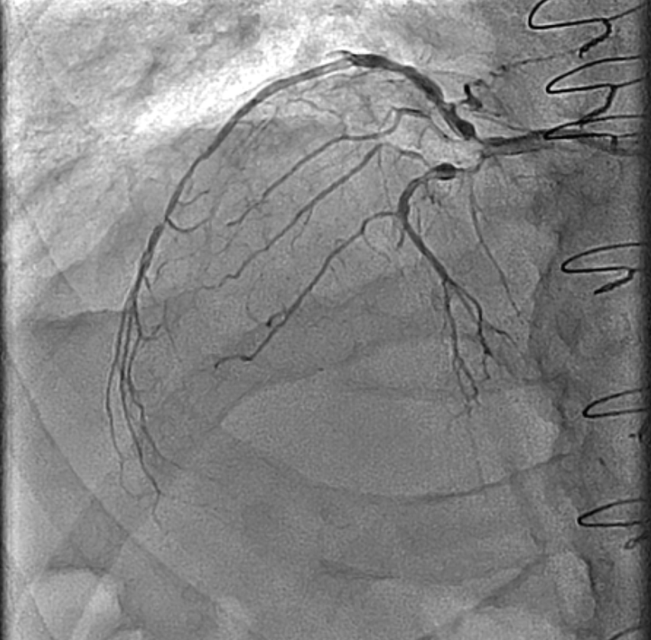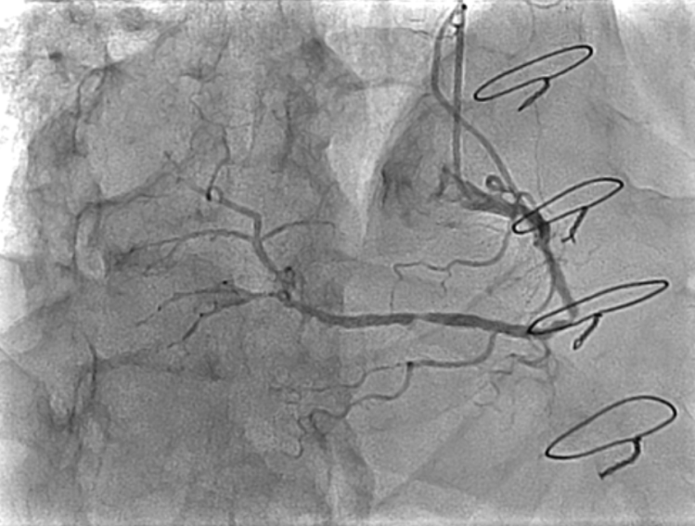
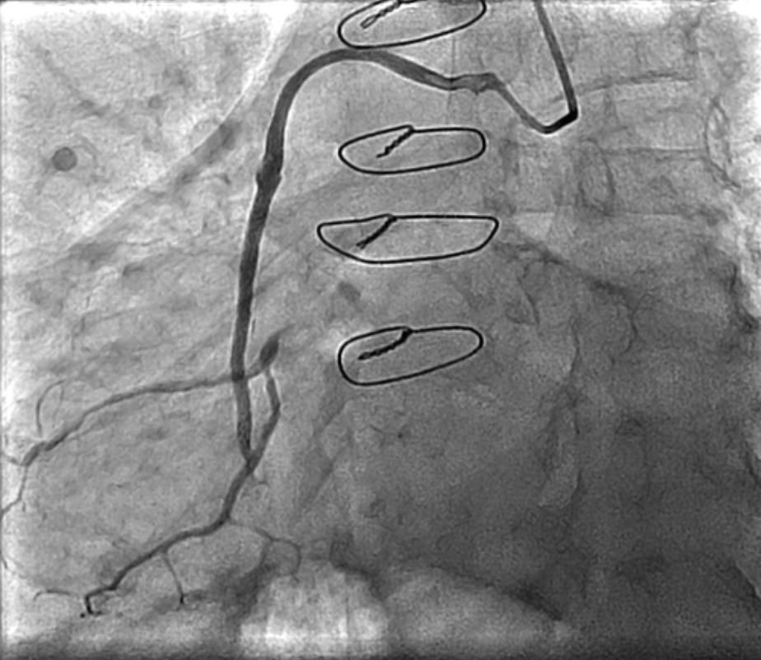RSVG to OM 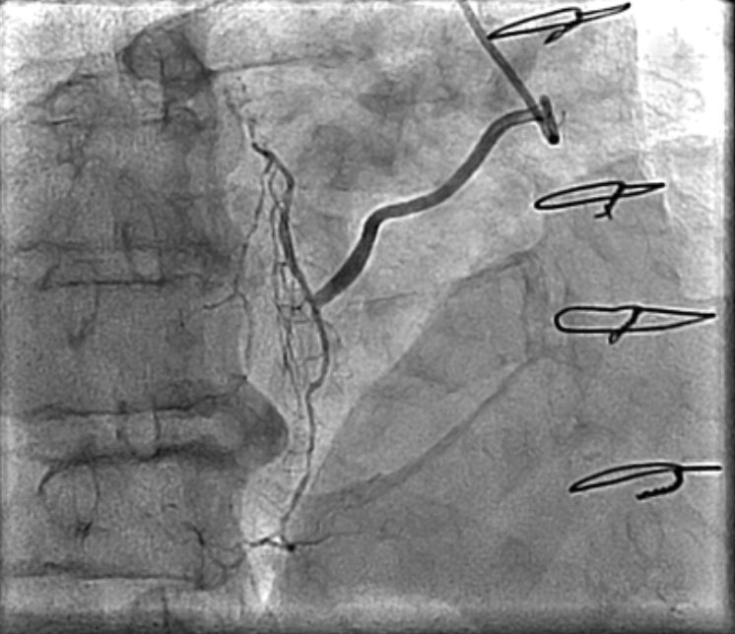RSVG to LAD

