Severity of Pulmonary Embolism and Echocardiographic Parameters
Dr. Doina Ranga, MD, University Assistant, PhD Student, Nicolae Testemițanu State University of Medicine and Pharmacy.
Prof. Natalia Caproș, MD, PhD, Habilitated Doctor in Medical Sciences, Nicolae Testemițanu State University of Medicine and Pharmacy.

Abstract
Statement of the Problem: Acute pulmonary embolism (PE) is associated with significant hemodynamic disturbances, including right ventricular (RV) overload, pulmonary hypertension, and impaired right ventriculo-arterial coupling. Persistent RV dysfunction after the acute event may contribute to adverse long-term outcomes and post-PE syndrome. Echocardiographic evaluation may provide important prognostic information regarding RV recovery and residual hemodynamic abnormalities. Methodology & Theoretical Orientation: This study included 170 patients diagnosed with acute PE. Patients were stratified into high-risk, intermediate-high-risk, and intermediate-low-risk groups according to PE severity. Echocardiographic assessment was performed at admission, 6 months, and 12 months following the acute episode. Structural and functional cardiac parameters analyzed included RV diameter, pulmonary artery systolic pressure (PSAP), tricuspid annular plane systolic excursion (TAPSE), and TAPSE/PSAP ratio. Statistical analysis included intergroup comparisons and Pearson correlation analysis. Findings: At admission, high-risk patients demonstrated significantly higher rates of RV overload, paradoxical interventricular septal motion, pulmonary hypertension, and severely reduced TAPSE/PSAP ratio compared with intermediate-risk groups (p<0.05). Significant differences were identified for RV diameter, PSAP, TAPSE, and TAPSE/PSAP ratio. At 6 months, partial recovery of RV function was observed, although pulmonary hypertension persisted in a substantial proportion of patients. At 12 months, RV overload decreased markedly and TAPSE/PSAP normalized in most patients; however, residual pulmonary hypertension remained frequent. Strong correlations were identified between echocardiographic parameters evaluated at 6 and 12 months (p<0.001). Conclusion & Significance: Severe PE is associated with significant RV dysfunction and persistent pulmonary hypertension. Serial echocardiographic evaluation demonstrated progressive RV recovery over 12 months, while the TAPSE/PSAP ratio appears to be a valuable marker for long-term assessment of RV functional recovery after acute PE.
Image
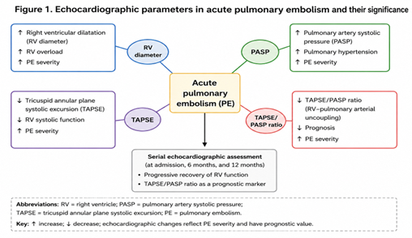
Recent Publications
- Nasser MF, Jabri A, Limaye S, Sharma S, Hamade H, Mhanna M, et al. (2023) Echocardiographic evaluation of pulmonary embolism: A review. Journal of the American Society of Echocardiography 36:1045-1058.
- Lyhne MD, et al. (2024) Right ventricular-pulmonary artery coupling for prognostic assessment in acute pulmonary embolism. European Heart Journal 45:1-10.
- Çizgici AY, et al. (2023) Utility of TAPSE/sPAP ratio in acute pulmonary embolism for prediction of adverse outcomes. Kosuyolu Heart Journal 26:45-53.
- Li Q, Wang Y, Chen X et al. (2024) Echocardiographic assessment of right ventricular-pulmonary artery coupling and prognostic significance in acute pulmonary embolism. Eur J Intern Med 121:15-22.
- Mostafa A, Medhat M, Alhosary H, Amin W (2024) Role of right ventricular-pulmonary arterial coupling assessed by echocardiography to predict adverse outcomes in patients with acute pulmonary embolism. Egypt Heart J 76:122.

Photograph

Biography
Dr. Doina Ranga is a medical doctor, university assistant, and PhD student at Nicolae Testemițanu State University of Medicine and Pharmacy. Her scientific activity is focused on acute pulmonary embolism, with particular interest in risk stratification, echocardiographic assessment, and prognostic evaluation of patients.
Her research integrates clinical evaluation, cardiovascular imaging, and statistical analysis to identify predictive markers of right ventricular dysfunction and long-term outcomes. She is actively involved in clinical research, academic teaching, and multidisciplinary collaborations in the field of cardiovascular medicine.
Dr. Ranga has contributed to several scientific studies and conference presentations focused on hemodynamic alterations in pulmonary embolism, the role of echocardiography in monitoring ventricular recovery, and the prognostic significance of parameters such as TAPSE, PSAP, and the TAPSE/PSAP ratio in patients with acute pulmonary embolism.

Email: domnica2604@gmail.com

