Electrocardiographic findings and cardiovascular risk profile in Paralympic athletes
Dr. Javad Norouzi, PhD, National Olympic and Paralympic Committee, Iran.
Dr. Mehdi Anvari, MD, National Olympic and Paralympic Committee, Iran.
Dr. Shamsedin Taghavi, MD, National Olympic and Paralympic Committee, Iran.
Dr. Mohammad Reza Mahmoodkhani, National Olympic and Paralympic Committee, Iran.

Abstract (300 word limit)

Paralympic athletes are a special group of elite athletes with unique cardiovascular issues. However, there are limited data regarding cardiovascular screening in Paralympic athletes. From April 2019 to July 2021, male Paralympic athletes, underwent cardiac screening including history, physical examination, 12-leads electrocardiogram (ECG), echocardiography and blood test. Athletes were classified according to the sports disciplines into three groups: 1) skill (archery, shooting, taekwondo, judo); 2) power (powerlifting, discus throwing, shot putting, javelin throwing) and 3) mixed (sitting volleyball, wheelchair basketball, rowing), as well as divided base on the type of disability into two groups: 1) athletes with spinal cord injury (SCI), and 2) athletes with non-spinal cord injuries (NSCI). Among 82 Paralympic athletes, there were 19 in skill, 25 in power, and 38 in mixed sports disciplines and 24 had SCI and 58 had NSCI. There were no abnormalities observed in echocardiography. Normal ECG findings were seen in 28 athletes (34.1%) with a higher prevalence in athletes with NSCI (41.3%) and participated in mixed (47.3%) sports (p<0.001). Borderline ECG findings were detected in 6 (7.3%) with more frequent in athletes with SCI (12.5%) and participated in power (16%) sports (p<0.001). The prevalence of abnormal ECG findings were 3.6%. Cardiac risk factors including hypertension was detected in 8 (9.7%); triglycerides >200 mg/dl in 21 (25.6%), total cholesterol >200 mg/dl in 15 (18.2%), 25-hydroxyvitamin D3 <30 ng/ml in 35 (42.6%), low-density lipoprotein cholesterol >130 mg/dl in 8 (9.7%), very low-density lipoprotein cholesterol ≥50 mg/dl in 15 (18.2%) and high-density lipoprotein cholesterol <40 mg/dl in 7 (8.5%); that were significantly more frequent in athletes with SCI and athletes participated in power sports disciplines (p<0.001). This study emphasizes that Paralympic athletes especially those with SCI and participating in power sports disciplines are not immune from cardiovascular risk factors and requires more medical care attention.
Image
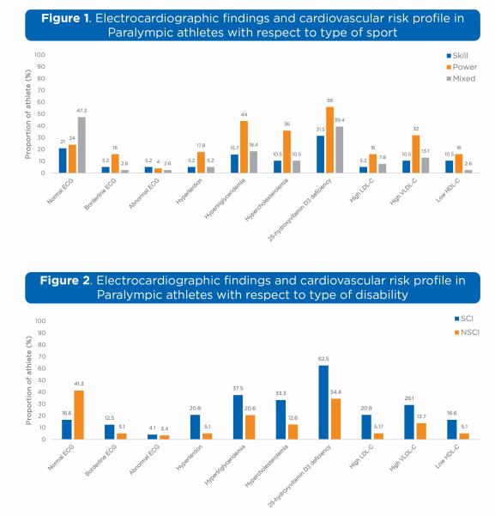
Recent Publications (minimum 5)
- Norouzi J, Papadakis M, Akbarnejad A, Anvari M (2022) The role of pre-participation cardiac evaluation in the management of an athlete with premature ventricular contraction-induced cardiomyopathy: a case report. European Heart Journal - Case Reports 6:5.
- Norouzi J, Soori R, Akbarnejad A, Choobineh S (2021) Right Ventricular Remodeling Following Intense and Prolonged Endurance Training. medical journal of mashhad university of medical sciences 64:4.
- Sabouri M, Norouzi J, Zarei Y, Hassani Sangani M, Hooshmand Moghadam B (2020) Comparing high-intensity interval training (hiit) and continuous training on apelin, APJ, NO, and cardiotrophin-1 in cardiac tissue of diabetic rats. Journal of Diabetes Research 2020
- Eskandari M, Pournemati P, Hooshmand Moghadam B, Norouzi J (2019) The Interactive Effect of Aerobic Exercise and Supplementation of Blue-Algae (Spirulina) on Anthropometric Indexes and Cardiovascular Risk Factors in Diabetic Men. Sadra Medical Journal 8:1
- Eskandari M, Norouzi J (2019) Evaluation of the Effect of short-term Barberry Juice Supplementation on humoral immune response in active girls following exhaustive exercise activity: A randomized double-blind clinical trial. Razi Journal of Medical Sciences 26:2

Photograph

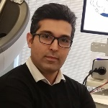Biography (150 word limit)
Dr. Javad Norouzi is a cardiovascular exercise physiologist and member of sports cardiology department of the national Olympic committee of Iran with expertise in cardiac assessment of athletes. During obtaining his PhD degree at the University of Tehran/ Iran, he spent training course in sports cardiology at the institution of sports medicine and science of the national committee of Italy under direct supervision of Prof. Antonio Pelliccia. He is the director of Oxygen sports cardiology center. His research focused on the development of innovative strategies for preventing and predicting of cardiac disease in elite athletes and young people.
Email: j.norouzi2@gmail.com
Notes/Comment

