Surgical and Interventional Treatments of Congenital Heart Diseases in Da Nang Hospital, Vietnam
Xuan Tuan Ho, MD, Ph.D. School of Medicine and Pharmacy - The University of Danang, Vietnam

Abstract (300 word limit)
Background
We conducted this study to explore the trend and the percentage of congenital heart disease (CHD) visited Da Nang hospital from 2010 to 2015. Another objective was to develop criteria that help to classify atrial septal defect (ASD) patients as patients suitable for surgical or transcatheter closure procedures. In addition, we compared the effectiveness and safety of surgical and transcatheter methods for ASD patients.
Methods
The data involved the information of all CHD patients treated in Da Nang hospital from January 2010 to December 2015. The selection involved all the patient cases treated with surgical and transcatheter closure procedures. All cases without clear data on transcatheter or surgical intervention were excluded. A total of 1220 cases were eligible for the study. All the data collected was based on paper medical records.
Results
A total of 1220 CHD patients were recruited in the study, of which 58.9% were women, and 41.1% were men. Most of CHD patients belonged to the age group of 0-9 (70.2%). A total of 266 ASD patients were included in the study, of which 186 women (69.9%) and 80 men (30.1%). The distribution of male and female proportions was relatively similar between years. After adjusting for sufficient rim among ASD patients, the cut-off point of the length of the defect for an operation would be 34.1 mm, while the width of the defect would be 33.3 mm. Both surgical and transcatheter closure procedures were safe for ASD patients. The total price for a case of ASD operation was significantly higher than that for a case of transcatheter closure.
Conclusion
We suggest that Vietnam should continue investing more in early diagnosis and treatment for CHD patients. Hospital in Vietnam should update the technology and find transcatheter closure devices with reasonable prices so that more ASD patients would afford to use.
Image

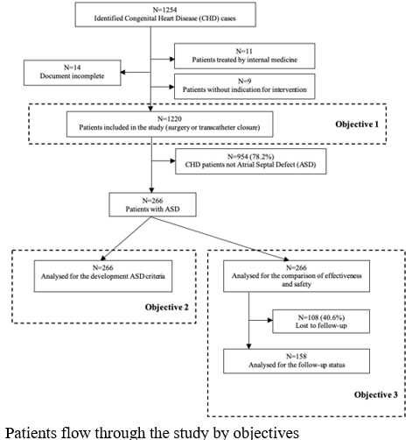
Recent Publications (minimum 5)
- Xuan Tuan Ho (2020) Trends in the prevalence of atrial septal defect and its associated factors among congenital heart disease patients in Vietnam.
- Ho Duc Hung (2020) The Prevalence of Myopia and Factors Associated with It Among Secondary School Children in Rural Vietnam.
- Nguyen Van Son (2020) Trends and Factors Associated with Comprehensive Knowledge about HIV among Women in Vietnam.
- Xuan Tuan Ho (2020) Cost comparison of transcatheter and operative closures for patients with secundum atrial septal defects in Vietnam.
- Xuan Tuan Ho (2021) Surgical and Interventional Treatments of Congenital Heart Diseases in Da Nang Hospital, Vietnam.

Photograph

 Biography (150 word limit)
Dr has his expertise in evaluation and passion in improving the health and wellbeing, especially in congenital heart disease. His research based on patients ‘s data from one developing country creates new pathways for improving healthcare for congenital heart disease patients. He has finished this research after years of experience in research, evaluation, teaching and administration both in hospital and education institutions.
Email: drhoxuantuan@gmail.com
Notes/Comments:

