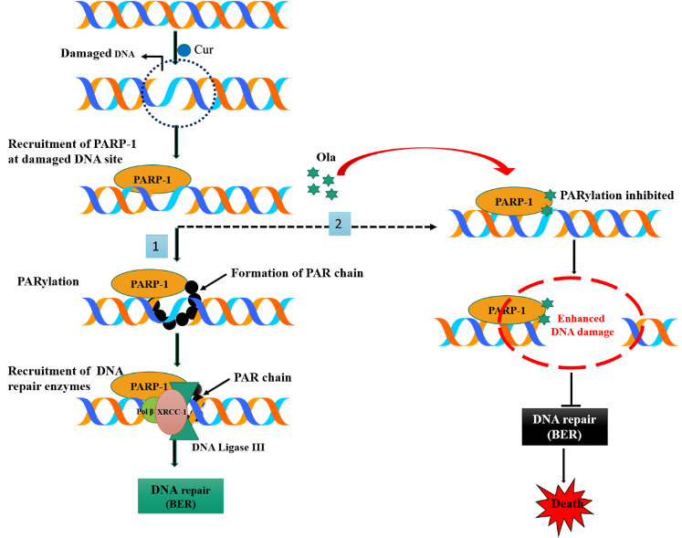
PARP inhibitor Olaparib Enhances the Apoptotic Potentiality of Curcumin by Increasing the DNA Damage in Oral Cancer Cells through Inhibition of BER Cascade. Sefinew Molla, Krushna Chandra Hembram Subhajit Chatterjee, Deepika Nayak, Chinmayee Sethy, Rajalaxmi Pradhan & Chanakya Nath Kundu

Abstract
Although Olaparib (Ola, a PARP-inhibitor), in combination with other chemotherapeutic agents, was clinically approved to treat prostate cancer, but cytotoxicity, off-target effects of DNA damaging agents limit its applications in clinic. To improve the anticancer activity and to study the detailed mechanism of anti-cancer action, here we have used bioactive compound curcumin (Cur) in combination with Ola. Incubation of Ola in Cur pre-treated cells synergistically increased the death of oral cancer cells at much lower concentrations than individual optimum dose and inhibited the topoisomerase activity. Short exposure of Cur caused DNA damage in cells, but more increased DNA damage was noticed when Ola has incubated in Cur pre-treated cells. This combination did not alter the major components of homologous recombination (HR) and non-homologous end-joining (NHEJ) pathways but significantly altered both short patch (SP) and long patch (LP) base excision repair (BER) components in cancer cells. Significant reduction in relative luciferase activity, expression of BER components and PARylation after Cur and Ola treatment confirmed this combination inhibit the BER activity in cells. Reduction of PARylation, decreased expression of BER components, decreased tumor volume and induction of apoptosis were also noticed in Cur + Ola treated Xenograft mice model. The combination treatment of Cur and Ola also helped in recovering the body weight of tumor-bearing mice. Thus, Cur + Ola combination increased the oral cancer cells death by not only causing the DNA damage but also blocking the induction of BER activity.

Fig. The schematic representation of the probable mechanism of Cur + Ola mediated apoptosis

Recent Publications
- Molla, S., Hembram, K.C., Chatterjee, S., Nayak, D., Sethy, C., Pradhan, R. and Kundu, C.N., 2019. PARP inhibitor Olaparib Enhances the Apoptotic Potentiality of Curcumin by Increasing the DNA Damage in Oral Cancer Cells through Inhibition of BER Cascade. Pathology & Oncology Research, pp.1-13.
- Sethy, C., Goutam, K., Nayak, D., Pradhan, R., Molla, S., Chatterjee, S., Rout, N., Wyatt, M.D., Narayan, S. and Kundu, C.N., 2018. Clinical significance of a pvrl 4 encoded gene Nectin-4 in metastasis and angiogenesis for tumor relapse. Journal of Cancer Research and Clinical Oncology, pp.1-15.
- Hembram, K.C., Chatterjee, S., Sethy, C., Nayak, D., Pradhan, R., Molla, S., Bindhani, B.K. and Kundu, C.N., 2019. A comparative and mechanistic study on the anti-cancer activity of quinacrine based silver and gold hybrid nanoparticles in head and neck cancer. Molecular pharmaceutics.
- Molla, S., 2016. Review on Human Immune Response against Hepatitis B Virus (HBV) Infection. J Emerg Dis Virol. 2(3).
- Molla, S., Munshea, A. and Nibret, E., 2015. Seroprevalence of hepatitis B surface antigen and anti HCV antibody and its associated risk factors among pregnant women attending maternity ward of Felege Hiwot Referral Hospital, northwest Ethiopia: a cross-sectional study. Virology journal, 12(1), p.204.

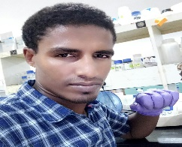Biography
I, Sefinew Molla, am a PhD scholar (4th year) in Cancer Biology division, school of Biotechnology, KIIT University Odisha, India. My research area is mainly focused on DNA damage response in which I chose bioactive compound and PARP inhibitor to inhibit cells internal repair system. I am studying the detailed mechanisms involved in the process.
Email: msefab2017@gmail.com

