Functional Changes of Cells and DNA by Electromagnetic Waves in the Case of Cancer

Ignat Ignatov^{1*} Christos Drossinakis²

1. DSc, Professor, Scientific Research Center of Medical Biophysics (SRCMB),
N. Kopernik Street, 32, Sofia 1111, Bulgaria
2. Dr. h.c, Professor, IAWG - INTERNATIONALE Akademie für Wissenschaftliche Geistheilung, Königsteiner Str. 61 a, 65929 Frankfurt Höchst, Germany

*E-mail of the corresponding author: mbioph@dir.bg
Abstract
The co-authors of the research are Reneta Toshkova, Elisaveta Zvetkova ,Georgi Gluhchev.
Studies were conducted with model systems of influence of Drossinakis with electromagnetic (e.m.) fields and infrared thermal field (ITF) (Ignatov, Mosin, Niggli, Drossinakis, 2013). The purpose of research is to analyze effects over DNA. In the report is carried out analysis of effects over water and physiological saline. Results are achieved with blood serum of hamsters and physiological processes in hamsters with tumors. The analyses with water are conducted using the methods Nonequilibrium Energy Spectrum (NES) and Differential Nonequilibrium Energy Spectrum (DNES) (Antonov, 1992; Ignatov, 1998). Experiments are carried out with the influence of tumor cells of a mouse in water. It is observed reduction of DNES spectrum according to the control sample of cells in healthy animals. (Antonov, 1992). Reduction is also observed in DNES spectrum in blood serum of people having oncological diseases, compared to the one of healthy people (Ignatov, 2012). Such a reduction is most prevalent in (-0.1387 eV; 8.95 µm; 1117 cm⁻¹). In research of the effects of e.m. fields in water and blood serum from hamsters the range is (-0.08 – -0.14 eV) (8.9 –15.5µm) (645–1129 cm⁻¹). Research is conducted for the effects over Graffi tumor that was implanted in hamsters (Toshkova, Ignatov, Zvetkova, Ignatov, Gluhchev, Drossinakis, 2019). Studies are conducted with pH and oxidation redox potential (ORP) effects of e.m. fields over physiological saline (Gluhchev, Ignatov, Drossinakis, 2019).

Keywords: Infrared thermal field (ITF), electromagnetic fields (e.m. fields), experimental Graffi solid tumor, energy spectrum, NES and DNES methods.

Introduction
In conducted studies with blood serum are analyzed parameters of electromagnetic hydrogen bonds. The hydrogen bonds are electromagnetic among bipolar molecules, where the hydrogen is connected to an atom with large electronegativity, such as nitrogen (N) and oxygen (O). In Fig. 1a are shown hydrogen bonds in DNA. In Fig. 1b is presented donor-acceptor interaction. In Fig. 1c are shown hydrogen bonds in water.

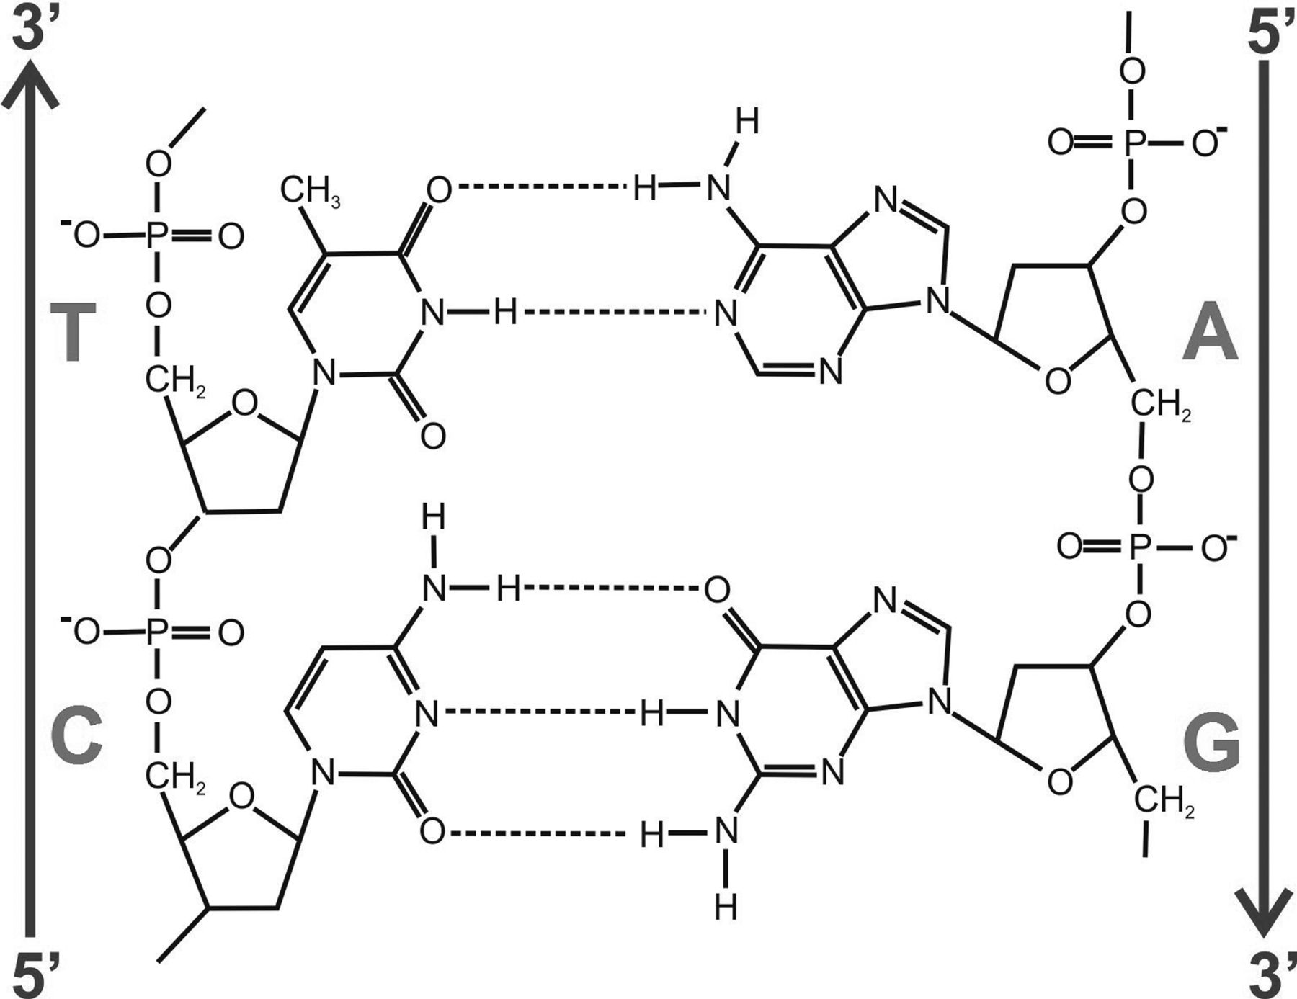

Figure 1a Hydrogen bonds among H and N or O in DNA

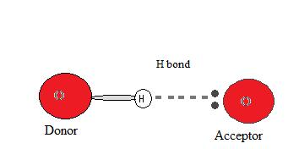

Figure 1b Donor-acceptor interaction of hydrogen bonds among H and N, F or O

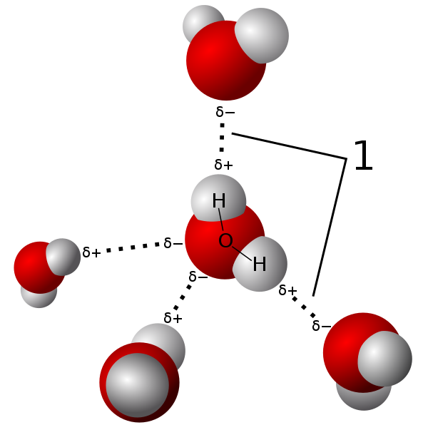

Figure 1c Hydrogen bonds among water molecules

The water is a medium of living processes. The molecules of DNA in the cells are in the form of double helix. The pentose phosphate skeleton of both chains is placed outwards, and the nitrogenous bases are pointed towards the inside of the spiral, and are connected to each other with weak hydrogen bonds.
The multiple, although weak hydrogen bonds, provide stability to the molecule of DNA. The oxygen and nitrogen are electronegative atoms in the nitrogenous bases. Each separate nucleotide contains phosphate, deoxyribose saccharide, and one of the four nitrogenous bases separated into two categories – purine and pyrimidine. The purine bases adenine (A) and guanine (G) are larger and contain two aromatic rings. The pyrimidine bases cytosine (C) and thymine (T). Research shows that the range of e.m. interaction of hydrogen bonds in DNA varies from 1 to 10 THz (10¹²Hz)(30 –300 µm)( 33.4 – 333.6 cm⁻¹) (Tang et al., 2018). In such a range are conducted studies of the DNA changes in cancer diseases (Calvin et al., 2012). The authors investigate within the range 21 до 37 THz (8.9 –15.5µm) (645–1129 cm⁻¹) of effects over cancer cells, as the radiation of e.m. waves is in such a range (Ignatov, Mosin, Niggli, Drossinakis, 2013).
During research with physiological saline is studied the change of pH and ORP.
During the influence with e.m. waves is researched the survival rate of hamsters with tumors, as well as the change in size of tumor. The DNA damage contributes to ageing and cancer, as the result depends on the type and number of lesions (injury) in DNA. The cancer related diseases are one of the main reasons for changes in DNA (Hoeijmakers, 2009). During the influence with e.m. fields is observed change of erythrocytes and the animal hair of hamsters. (Toshkova, Ignatov, Zvetkova, Gluhchev, Drossinakis, 2019).

2. Materials and methods

2.1. Experimental animals
Hamsters, breed “Golden Syrian”, aged 2-4 months with weight around 90-100 g were used in the trials. The animals were grown in standard conditions in individual plastic cages with free access to food and water.

2. 2. Experimental tumor model
Tumor cells (1-2.10⁶) from the experimental Graffi solid tumor are transplanted subcutaneously in the back of hamsters. Between days 7 and 15 after the transplantation tumor appears, grows progressively and the hamsters die around 30-35 days. In this tumor model 100% tumor transplantation and 100% mortality are observed. No spontaneous tumor’s regression takes place. (Toshkova, 1995).

2.3. Influence by electromagnetic and infrared thermal fields
This type of influence is delivered by Christos Drossinakis who holds the hamsters in the hands for a couple of minutes (Fig. 2).

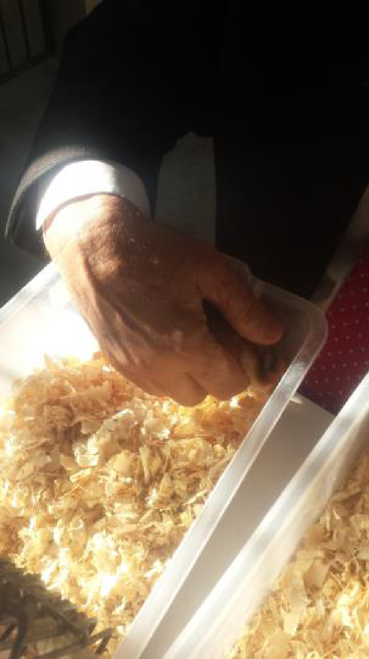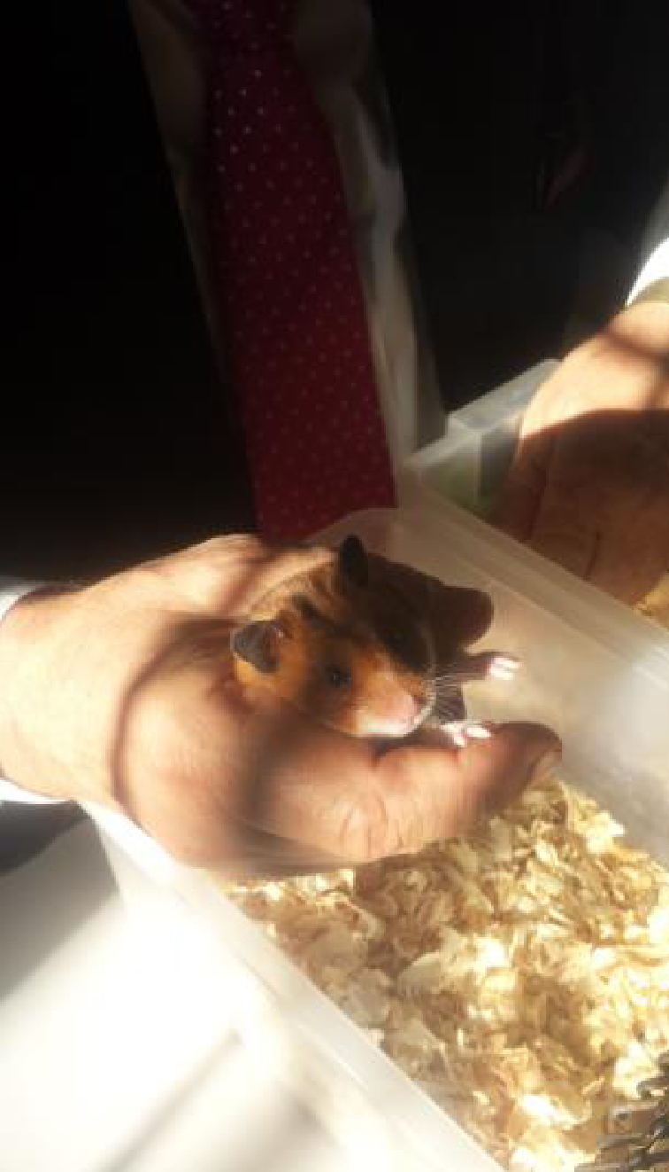

Figure 2. Bioinfluence with Infrared Thermal Field and e.m. waves on hamsters with experimental tumor

2.4. Hematology examination
Blood smears from experimental Graffi tumour-bearing and control hamsters are prepared, stained by May-Gruenwald Giemsa method and examined light-microscopically.

2.5. Ethical aspects
All experiments were conducted in accordance with the European convention for protection of vertebrate animals, used for experimental and other scientific purposes (OJ L 222) and approved from the National Veterinary Medical Office.

2.6. NES and DNES Spectral Analyses
The device for DNES spectral analysis based on an optical principle was designed by A. Antonov. For this, a hermetic camera for evaporation of water drops under stable temperature (+22–24 ⁰С) conditions was used. The water drops were placed on a water-proof transparent pad, which consisted of thin maylar folio and a glass plate. The light was monochromatic with filter for yellow color with wavelength at λ = 580±7 nm. The device measures the angle of evaporation of water drops from 72.3⁰ to 0⁰. The DNES-spectrum was measured in the range of -0.08– -0.1387 eV or λ = 8.9–13.8 µm using a specially designed computer program. The main estimation criterion in these studies was the average energy (∆E_{H...O}) of hydrogen O...H-bonds between H₂O molecules in water samples and hamster serum blood.

3. Results

3.1. Influence of e.m. waves over hydrogen bonds in water medium. Hydrogen bonds in DNA
In the Fig. 3 are presented the four monomers building DNA - deoxyadenosine, deoxycytidine, deoxyguanosine, deoxythymidine. With the arrows are marked the hydrogen bonds. DNA is located in water medium, and effects of e.m. fields over hydrogen bonds oxygen-hydrogen are being investigated.

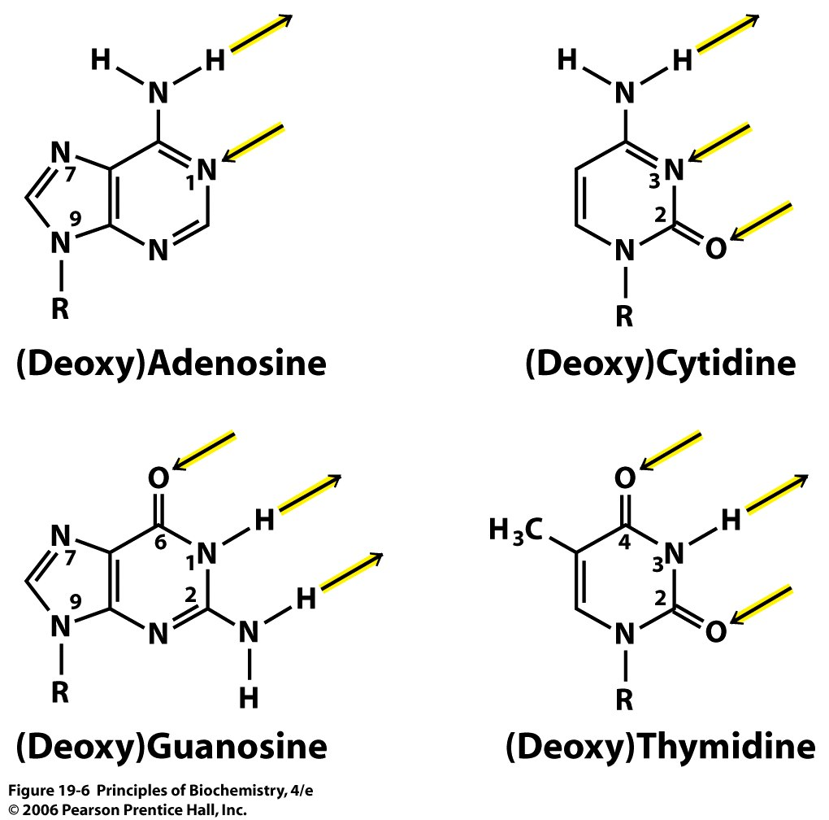

Figure 3. Four monomers, which are created DNA – deoxyadenosine, deoxycytidine, deoxyguanosine, deoxythymidine

3.2. Results with pH and ORP
In order to assess the bio-influence over blood is used physiological saline, compatible with the human blood, consisting of 0.9% solution of NaCl. Before the experiment are measured 50 ml from a bottle containing 0.5 l from the solution that perform the role of a control sample.The bottle with the remaining 450 ml are held from the operator for a time period of 20 minutes.For the control sample and the solution with bioinfluence are measured the parameters pH, ORP (Оxidation Reduction Potential) and electric conductivity in milliamperes. The achieved results are presented in the following Table 1
Table 1.
 | pH | ORP (mV)
Control Sample | 6.96 | 150
Sample with e.m. waves | 6.25 | 150

They show that:
1. There is a decrease of 0.71 рН of the sample compared to the control sample.
2. No difference is reported in the values of ORP.
Findings
- During the study of physiological saline is observed 5-times increase of hydrogen ions and a change in conductivity. It is a proof for recovery of the ion balance. In the healthy cells the potential for transmission of hydrogen ions H+ through the membrane is (-140 mV), and in the cancer cells it is (-70 mV) (Alberts et al., 1994). The tendency is recovery of potential when influencing with ITF and e.m. waves.
- The achieved results in hamsters with experimental tumor and physiological saline present biophysical, biochemical, biological effects of influence with ITF and e.m. waves. The processes of improvement of ion exchange and electrical potential in the cells, of the anaemic syndrome, and the synthesis of basic proteins, support the body protection and the immune status, and they hold up the tumor process.
Conclusion
1. It can be considered as established the effect of bioinfluence of Christos Drossinakis over the values of pH of physiological saline.
2. Due to the 65% of water content in the human body, it can be considered that its parameters irrespective of its consistency in the blood and internal organs, will be influenced from an external bioinfluence, which will affect their functioning, and hence the health condition of the body.
3. The potential of hydrogen ions in a healthy cell is -140mV, and in a cancer cell -70 mV. The increase of the number of hydrogen ions reveals a process of recovery in the potential of a cancer cell to a healthy condition.

3.2. Electromagnetic parameters with DNES method during influence with electromagnetic fields over blood serum of hamsters with tumor
Table 2 shows the results from the influence of e.m. fields over distribution by energies of hydrogen bonds in 1% solution of blood serum.

Table 1 DNES spectrum is measured in eV for (-E) of 1% solution of blood serum of hamsters with tumors with influence of e.m. fields, and control group of hamsters with tumors. The function of distribution by energies is df(E) in eV⁻¹ for DNES spectrum.

DNES spectrum*
-E (eV)  x-axis | 0.0962 | 0.0987 | 0.1012 | 0.1037 | 0.1062 | 0.1087 | 0.1087 | 0.1112 | 0.1137 | 0.1162
df(eV⁻¹)  y-axis | 0 | -42.1 | 0 | 0 | 0 | 0 | 0 | 0 | -15.2 | 0
-E (eV)  x-axis | 0.1187 | 0.1212 | 0.1237 | 0.1262 | 0.1287 | 0.1312 | 0.1337 | 0.1362 | 0.1387
df(eV⁻¹)  y-axis | 0 | 43.6 | -42.1 | 0 | 28.6 | -13.5 | -13.5 | -13.5 | 72.2 | .

The results show that at 8.95 µm the difference in the function of distribution by energies е f(E) in eV⁻¹ for blood serum of hamsters with tumor compared to blood serum of healthy hamsters is highest. At 8.95 µm is observed decrease of the energy of hydrogen bonds in tumor diseases. With efficient influence, as well as with e.m. fields, the value in DNES is the highest, and the local extreme value is the highest and it is positive.

3.3. Energy of hydrogen bonds
The average energy (E_{H...O}) of hydrogen Н…O-bonds among individual H₂O molecules in 1% solution of Sample of blood serum of hamsters with cancer after influence of Drossinakis is measured at E=-0.1285 eV. The result for the Control sample in 1% solution of blood serum of hamsters with cancer is E=-0.1214 eV. The results obtained with the NES method are recalculated with the DNES method as a difference of the NES (Sample) minus the NES (Control Sample ) equalled the DNES spectrum of 1% solution of blood serum from hamsters with cancer.
∆f(E) = f (sample 1) – f (control sample 3)
Thus, the result for 1% solution of blood serum from hamster recalculated with the DNES method is ∆E=-0.0071±0.0011 eV. The result shows the increasing of the values of the energy of hydrogen bonds in 1% solution of blood serum of hamsters with tumoreafter influence of Drossinakis regarding control sample blood serum of hamsters with tumors.
Fig. 4 displays DNES spectrum of 1% solution of blood serum of hamsters with tumors with influence from e.m. fields, and control group of hamsters with tumors. At the x-axis are reported the values of energy (-E) of hydrogen bonds. A portion of these bonds are in DNA. At the y-axis is given the function of distribution by energies for DNES df (E) в eV⁻¹. The positive values of the spectrum indicate effects over the tumor cells. Biological studies reveal improvement of the life status of tumor cells compared to the condition of healthy ones. It comes as a result of the improved replication of DNA.

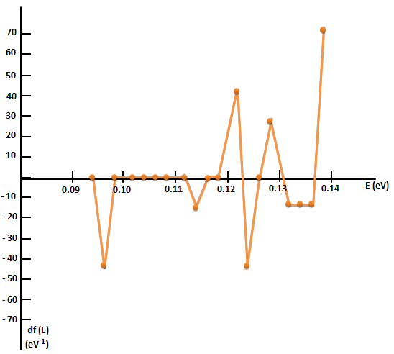

Figure 4. DNES of 1% solution of blood serum of hamsters with tumors with influence of e.m. fields as difference of control group of hamsters with tumors

3.4. Biological parameters
Following biometric parameters have been measured for the evaluation of bioinfluence on the tumor: transplantability, tumor size (mm), lethality/mortality rate and survival rate. Their measurement revealed significant differences between the experimental and control group.

    - Life span of hamsters
Hamsters that have undergone bioinfluence have had low mortality. Until the 35th day, mortality was 0, at day 40- 40%, at day 45 was 80%, and at day 50 it was 100%. At the same time in the control group the lethality was 50% on the 30th day and reached 100% on the 38th day. Thus the average survival rate of hamsters with therapy was 43.6±5.8 days and for control group-without therapy – 31.75±6.8 days, which was 12 days longer than the controls.
Also, some delay in tumor transplantability and growth was registered. The conclusion we can draw from the obtained results is that bioinfluence therapy (in this scheme of application and duration) in hamsters with developed tumor doesn’t stop the tumor growth, but delayed its progression, decreased lethality and prolonged average survival time.
The size of the developed tumors was measured and compared to that of the control animals. As shown in Fig. 4, A the size of tumor in hamsters with ITF and e.m. fields (gr.1) was insignificantly smaller between 12-24th day in comparison with that of control group (gr. 2). Around the 30th day the tumors of the two groups are aligned in size. Lethality rate (expressed in %) was demonstrated in Fig. 4, В. In both groups significant difference was observed. For hamsters with bioinfluence (gr. 1) low mortality rate compared to the control group (gr. 2) was established. Until the 35th day, mortality was 0, at day 40- 40%, at day 45 was 80%, and at day 50 it was 100%. At the same time in the control group (gr.2)-the lethality was 50% on the 30th day and reached 100% on the 38th day. The average survival rate of hamsters with therapy (gr.1) was 43.6±5.8 days, for control group-without therapy (gr. 2) – 31.75±6.8 days (fig.2, C), which was 12 days longer than the controls. The chart in fig.2, D shows the extended survival rate for hamsters with therapy (gr. 1) in comparison with control group-without therapy (gr. 2).

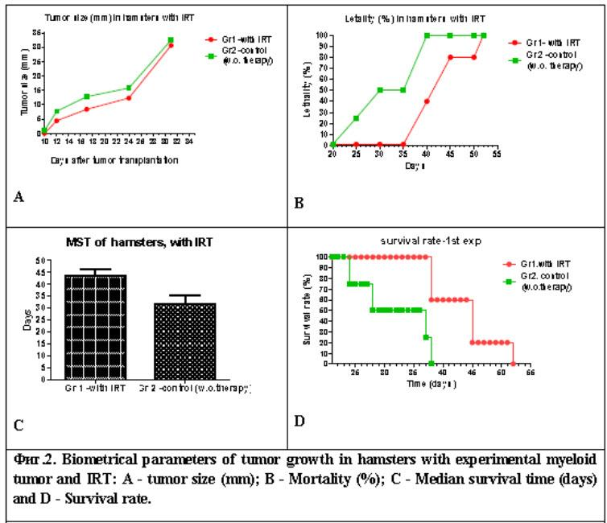

Figure 4. Biometrical parameters of tumor growth in hamsters with experimental Graffi myeloid tumor and ITF; A-tumor size (mm); B – Mortality (%), Average survival time (days)
and D – Survival rate

Photographs of hamsters from gr. 1 (with ITF and e.m. fields) and gr. 2 (control group) in Fig.5 illustrates the above results. They are taken on the 17th and the 32nd days after tumor transplantation in gr.1 (Fig. 5, A, A1) with bioinfluence therapy, and control gr.2 (Fig. 5,B, B1) without therapy.
The conclusion we can draw from the obtained results is that bioinfluence therapy (in this scheme of application and duration) in hamsters with developed tumor doesn’t stop the tumor growth (Fig.5, A), but delayed its progression, decreased lethality and prolonged average survival time.

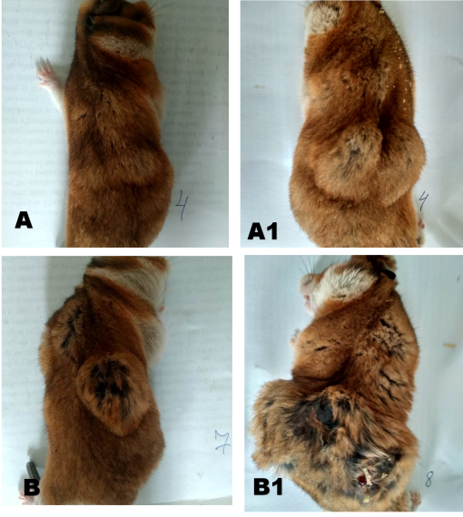
Fig.5. Pictures of hamsters from gr. 1 (with ITF) (top line) and gr.2 (control group without bioinfluence) (bottom line) on the 17th and 32nd day respectively.
3.4.2. Hematological research
Cytological differences in the erythrocyte /RBCs-/ morphology and differentiation were noticed in the blood smears of hamsters from control group vs bio-influenced hamsters with implanted myeloid tumours of Graffi. The observed differences probably indicate positive effects of the near infrared bio-influence on the erythropoiesis of Graffi tumour-bearing hamsters, that may lead to improvement of the anemia-syndrome - obligatory developed in this and/or in other experimental models of myeloid malignancies.
Differences in the erythrocyte /RBC-/ morphology and degree of red cell differentiation were evaluated in the blood smears of controls /healthy hamsters and untreated-tumor-bearing animals/, vs. bio-influenced tumor-bearing hamsters - with implanted myeloid tumours of Graffi /as shown in Fig. 6 - A, B, C/.

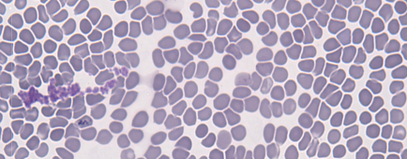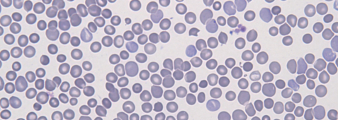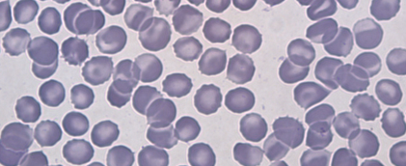
A) B) C)

Figure 6. Light-microscopic characteristics of erythrocytes (RBCs) in the blood smears /stained by the method of May-Grunwald-Giemsa/:
- control groups {A - healthy animals (x 20); B - Graffi myeloid tumors-bearing hamsters (x 20)};
- experimental group {C - bio-influenced tumor-bearing hamsters - with implanted myeloid tumors of Graffi (x40)}. One could see normal erythrocytes (discocytes) (A), anizocytosis and poikilocytosis of RBCs, as biomsarker of anemia - in the blood smears of untreated, tumor-bearing animals (B), as well as RBCs - transformed into discocytes, stomatocytes and echinocytes – in the tumor-bearing animals, bioinfluenced with ITF and e.m. fields (C).

Conclusion
The results achieved from the tests with 5 days course of ITF and e.m. waves treatment of hamsters with experimental subcutaneous tumor are positive. Prolonged survival rate and decreased mortality between the experimental and control group, as well as lowered transplantability and slowed tumor growth were observed. The present results are the base for conducting further tests that aim to establish the optimum regimen of bioinfluence with regards to frequency and duration of the therapeutic procedures,
The mathematical model of blood serum solution of hamsters with cancer after the Drossinakis’ influence gives significant information about the possible number of hydrogen bonds as a percent of H₂O molecules with different distribution of energy relative to the same number in the two control groups.
As a result of different energies of hydrogen bonds, the surface tension of the blood serum solution of cancer hamsters is increased after the treatment relative to the control samples. This effect is connected with the preservation and increase in the energy of the biochemical processes between water molecules and biomolecules.
The achieved results of hamsters from experimental bio-influence of Christos Drossinakis reveal their biological efficiency and can be subject of future studies. Extending the life of the hamsters is an indicator of improving immune status. The obtained results correspond to recent data from the medical scientific literature for the positive effect of the near infrared irradiation on the structure and function of erythrocyte membrane in normal and pathological conditions. The mitochondrial polarity in cancer cells was found to be lower than that of normal cells. Drossinakis is increasing the mitochondrial polarity.
The basic conclusion is that Drossinakis is able to increase the average energy of hydrogen bonds among water molecules in the blood of hamsters with cancer after treatment compared to the average energy of hydrogen bonds among water molecules in the blood of non-treated hamsters hamsters as control group.
In the report there are results with DNA. DNES spectrum of 1% solution of blood serum of hamsters with tumors with influence from e.m. fields, and control group of hamsters with tumors. At the x-axis of Fig. 4 are reported the values of energy (-E) of hydrogen bonds. A portion of these bonds are in DNA. At the y-axis is given the function of distribution by energies for DNES df (E) в eV⁻¹. The positive values of the spectrum indicate effects over the tumor cells. Biological studies reveal improvement of the life status of tumor cells compared to the condition of healthy ones. It comes as a result of the improved replication of DNA. After the influence the hydrogen bonds among oxygen (O) and hydrogen (H) in DNA helix have bigger energy.
During the study of physiological saline is observed 5-times increase of hydrogen ions and a change in conductivity. It is a proof for recovery of the ion balance. In the healthy cells the potential for transmission of hydrogen ions H+ through the membrane is (-140 mV), and in the cancer cells it is (-70 mV). The tendency is recovery of potential when influencing with ITF and e.m. waves. The potential of hydrogen ions in a healthy cell is -140mV, and in a cancer cell -70 mV. The increase of the number of hydrogen ions reveals a process of recovery in the potential of a cancer cell to a healthy condition.

References

Alberts, B. et al.: (1994) Molecular Biology of the Cell 3rd ed.., Garland Publishing, New York and London.
Antonov, A. Galabova, T. (1992) Ext. Abstr. Of the 6th National Conference of Biomedical Physics and Engeneering, 60.
Antonov, A., Galabova, T., Todorova, L., Tomov, (1993) Observatoire de Montagne de Mussala OM2, Edit par J.P. Carbonel and J. N. Stamenov, Sofia, 113.
Antonov, A. (1995) Research of the Non-equilibrium Processes in the Area in Allocated Systems. Dissertation thesis for degree “Doctor of physical sciences“, Blagoevgrad, Sofia.
Azab B. et al. (2013) Pretreatment Neurophil/lymphocyte Ratio is Superior to Platelet/lymphocyte Ratio as a Predictor of Long-term Mortality in Breast Cancer Patients, Med. Oncol., 30, 432
Calvin, Yu. et al. (2012) The Potential of Terahertz Imaging for Cancer Diagnosis. A Review of Investigations to Date.
Tang et al. (2018) Detection of DNA Oligonucleotides with Base Mutations by Terahertz Spectroscopy and Microstructures, PLoS ONE, 13 (1): e0191515.
Gluhchev, G., Ignatov, I., Karadzhov, S., Miloshev, G., Ivanov, N., Mosin, O.V. (2015) Electrochemically Activited Water. Biophysical and Biological Effects of Anolyte and Catholyte as Types of Water, Journal of Medicine, Physiology and Biophysics, 10, 1-17.
Drossinakis, Ch., Toshkova, R., Zvetkova, E, Ignatov, I,. Gluhchev, G. (2019) Methods of Research in Vivo Research of Therapeutical Effect in Hamsters with Experimental Myeloid Tumor of Graffi, 8th World Congress on Immunology, Pulsus, London, 3: 21.
Ignatov, A., Antonov, A., Galabova, T. (1998) Medical Biophysics – Biophysical Fields of Man, Gea Libris, Sofia.
Hoeijmakers, J.H. (2009) DNA Damage, Aging, and Cancer, 361(15):1475-85.
Ignatov, I., Mosin, O. V. (2013) Structural Mathematical Models Describing Water Clusters, Journal of Mathematical Theory and Modeling, 3 (11), 72-87.
Ignatov, I., Mosin, O. V., Niggli, H., Drossinakis, Ch. (2014) Evaluating of Possible Methods and Approaches for Registering of Electromagnetic Waves Emitted from the Human Body, Advances in Physics Theories and Applications, 30, 15-33.
Ignatov, I., Toshkova, R., Gluhchev, G., Drossinakis, Ch. (2019) Results of Blood Serum from Cancer Treated Hamsters with Infrared Thermal Field and Electromagnetic Fields, Journal of Health, Medicine and Nursing, 58: 101-112.
Toshkova R. (1995) Attempts for Immunomodulation in Hamsters with Transplanted Myeloid Tumor, Previously Induced by Graffi Virus, Bulgarian Academy of Sciences, PhD Dissertation, Sofia.
Toshkova, R., Ignatov, I., Zvetkova, E., Gluhchev, G. (2019) Bioinfluence with Infrared Thermal and Electromagnetic Fields as a Therapeutic Approach of Hamsters with Experimental Graffi Myeloid Tumor, Journal of Natural Sciences Research, 9 (4):1-11.
Toshkova, R., Ignatov, I., Zvetkova, E., Gluhchev, G., Drossinakis, Ch. (2019) Beneficial Effects of Drossinakis Bio-influence (with Infrared Thermal and Electromagnetic Fields) on the Development of Experimental Graffi Myeloid Tumors in Hamsters. Hematological studies, Journal of Medicine, Physiology and Biophysics, 54, 13-17.
Toshkova, R., Ignatov, I., Zvetkova, E., Gluhchev, G. (2019) Effects of Catholyte Water on the Development of Experimental Graffi Tumor on Hamsters, Cells&Cellular Life Sciences Journal, 4 (1), 000140
Toshkova, R., Ignatov, I., Zvetkova, E., Gluhchev, G. (2019) Effects of Catholyte Water on the Development of Experimental Graffi Tumor on Hamsters, European Journal of Medicine,
7(1): 45-56.
Zvetkova E. (2006) F.140. Quantitative Reduction in the RNP-Contents of Peripheral Blood Lymphocytes in Cancer Patients. Conference: 6th Annual Meeting of the Federation-of-Clinical-Immunology-Societies Location: San Francisco, CA Date: JUN 07-11, Clinical Immunology,: 119:S100.
Zvetkova E., Fuchs, D., 2017 – Medical Significance of Simultaneous Application of Red Blood Cell Distribution Width (RDW) and Neopterin as Diagnostic Biomarkers in Clinical Practice, Pteridines, 28(3-4):133-140.

