Abstract Template
Abstract Title: Environment and Cancer
Dr Sajal Goel¹, Anjali Sharma²
Dr Shikha Chawla³, Dr Anchal Agrawal⁴, Christy Alekchander⁵

^{1,3,4}Department of Radiation oncology, Patel Hospital, Jalandhar (Punjab, India)
^{2,5} Department of Medical Physics, Patel Hospital, Jalandhar (Punjab, India)

Abstract (not more than 300 words)

Cancer is a global giant killer. As per WHO, 1 in 6 deaths can be attributed to it. Cancer’s etiological risk factors are non-modifiable such as age, genetic alterations or modifiable such as environment, lifestyle, occupation, biological agents, viruses etc. How does our environment contribute to cancer? It is the biggest and most consistent risk factor. The soil in which we grow our food, the air we breathe, the water we drink, the food we eat and the waste we dispose, all have bearing on our health. The significant adverse environmental factors nowadays include radiation, nuclear energy, plastics, chemicals etc. In today’s life, all these factors are overlooked and people become prone to cancer. As the diagnostic and treatment facilities are improving, the overall survival is increasing. The burden of chronic diseases such as cancer will increase in world in near future. The developing countries have lack of access to prevention, early detection, treatment and infrastructure for medical and public health. It is of utmost importance that we look into the contributing modifiable risk factors for cancer today and improvise our thoughts so that we can give something good to live and cherish to our future generations. We have to remember that with constant evolution of thoughts, we need persistent, honest, organized multicultural and multinational human efforts to implement it. Let us pledge and stand together to save and protect our environment and thus cancer.

Keywords— Cancer, environment, modifiable, protect

Professional Biography (100-150 words)

Dr Sajal Goel is a Junior Consultant in Department of Radiation Oncology at Patel Hospital, Punjab. He had done MBBS from Baroda Medical College, Gujarat. He completed his postgraduate DNB training in Radiation Oncology from Rajiv Gandhi Cancer Institute and Research Center and All India Institute of Medical Sciences, Delhi. He passed his final exams from Tata Memorial Hospital, Mumbai. He had gained teaching experience at Delhi State Cancer Institutes and Bhagwan Mahavir Cancer Hospital, Jaipur. He had attended various training programs, national and international conferences, presented multiple posters; published abstracts, case reports and papers in national and international journals. His interests include preventive oncology, head and neck, gastrointestinal cancers, stereotactic techniques and particle therapy. He was awarded Fellowships in High Precision Radiotherapy and Stereotaxy by Kokilaben Dhirubhai Ambani Hospital, Mumbai. He is participating in Cancer Awareness Camps regularly and serving people.

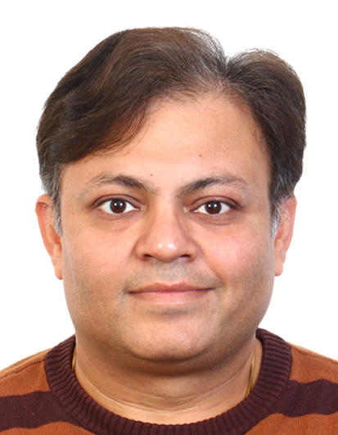

Email Id: drsajal.goel@gmail.com

Any Comments:
I would like to acknowledge the inputs from my dear wife, Ruchika Goel. I would also like to thank the conference organisers, my family, parents, colleagues and patients without which this article would not have been possible.

