Abstract Title: Advanced research and developments of cancer tissues: the properties of cancer stem cells
Xianming Mo
Laboratory of Stem Cell Biology, State Key Laboratory of Biotherapy, West China Hospital, Sichuan University, Chengdu, China 610041. xmingmo@scu.edu.cn
Abstract (not more than 300 words)
The growth of cancers depend on the formation of blood vessels that provide the supply of nutrients and oxygen and the nervous system acts as a crucial part of cancer microenvironment. The angiogenesis and vasculogenesis are essential during cancer progression. Recently, several studies have reported that glioblastoma stem cells are able to give rise to tumor vascular endothelial cells (ECs) and vascular pericytes for tumor vascularization. However, there is no evidence to show that the tumor stem cells from other kinds of tumors including carcinoma produce endothelial cells to constitute the functional blood vessels in cancer. In addition, recent evidences have demonstrated that the stimulation of both cancer growth and metastasis by members of nervous system such as neurons. How the nervous system built in cancer tissues is unknown. We transplanted the cancer stem cells that were isolated from the patients with gastric and colorectal carcinoma into nude mice via subcutaneous and intraperitoneal injections to produce human cancer xenografts. Then the innervations, angiogenesis were examined and the origins of the neural cells and endothelial cells were determined in cancer tissues. A single cancer stem cell from the cancer tissues of human patients was able to generate neurons including sympathetic and parasympathetic cells to take part in the nervous system in cancer tissues. Knocking down the neural generating capabilities of the human cancer stem cell inhibited the growth of tumors. Next, we show that cancer stem cells of the human colorectal carcinoma (CoCSCs) give rise to vascular endothelial cells and compose the vasculatures in cancer tissues. NuMA⁺ EC incorporated blood vessels were functional. Dependent on the biology of cancer stem cell, we identified small molecules to drive the differentiation of the cancer stem cell for restricted cancer grow. Our data demonstrate that neural cells and endothelial cells originated from human cancer stem cells constitute blood vessels and nerve system for the cancer progression in the cancer tissues. The findings are able to guide the development of therapeutic approaches to restrict cancer.

Professional Biography (100-150 words)

Biography: Dr. Xianming Mo is a professor of internal medicine and acts as Director of Laboratory of Stem Cell Biology, State Key Laboratory of Biotherapy, West China Hospital, Sichuan University. He obtained his medicine degree from North Sichuan Medical College. Then he was trained in pathology and accept Master of Medicine in West China University of Medical Science. After obtaining a PhD degree in Peking Union Medical College, He moved to Humboldt-Universität zu Berlin and then to Medical College of Georgia as postdoctoral fellows. Then, he became junior faculty in Medical College of Georgia and senior scientist in Max Delbruck Center for Molecular Medicine. In 2006, he returned back to West China Hospital.
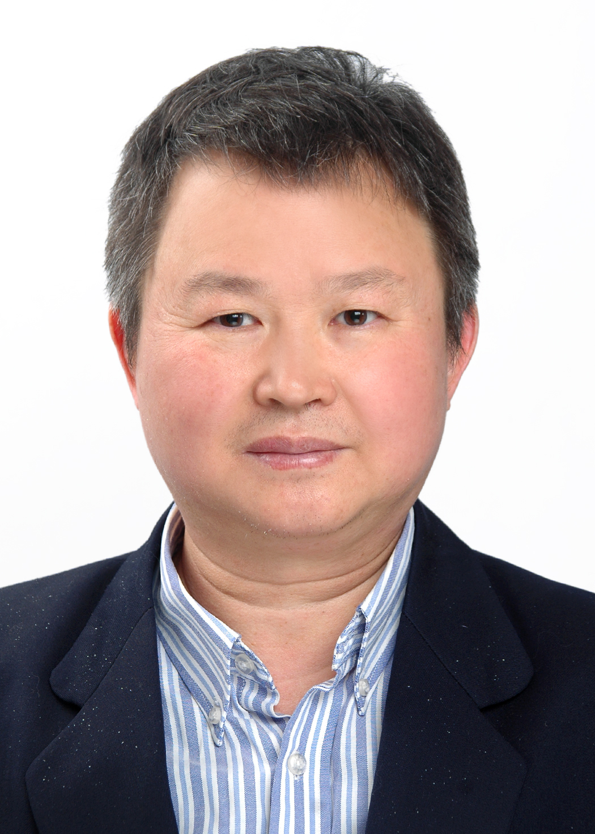Email Id: xmingmo@scu.edu.cn

Any Comments:

