Abstract
Abstract Title: Eating Away Your Cancer
Xu Chen, William Wargo,

¹ Xu Chen (University of the Rockies)
²William Wargo (University of the Rockies)

Abstract (not more than 300 words)

During recent forty years, thyroid cancer rates had gone up constantly. Generally, the best treatment for thyroid benign or malignant nodules is surgery, but surgery is very costly. Thyroid health affected mental health, while mental health affected suicide rate. During the recent 15 years, American suicide rate also went up. This paper was about how to eat, exercise, and improve mental health to better thyroid health and consequently improve mental health. To understand this topic, this researcher went through more than five thousand threads/emails online long-term thyroid cancer survivors group. Among the survivors, this researcher picked out five typical cases who survived thyroid cancer from eight years to close to 50 years. From these five cases’ discussion, this researcher tentatively summarized the best practices in diet, exercise, and improving mental health in improving thyroid health, and consequently keeping thyroid cancer in remission.

Keywords— Cancer, exercise, diet, thyroid.

Professional Biography (100-150 words)

Xu Chen is not an academic guru. She did research about thyroid cancer due to personal reasons because thyroid problems are very common among women. Xu Chen is currently working on her Doctoral degree through University of the Rockies in Colorado, US. Currently, Xu does not have an academic job. She is an actor in Boston Tea Party, Boston, MA.
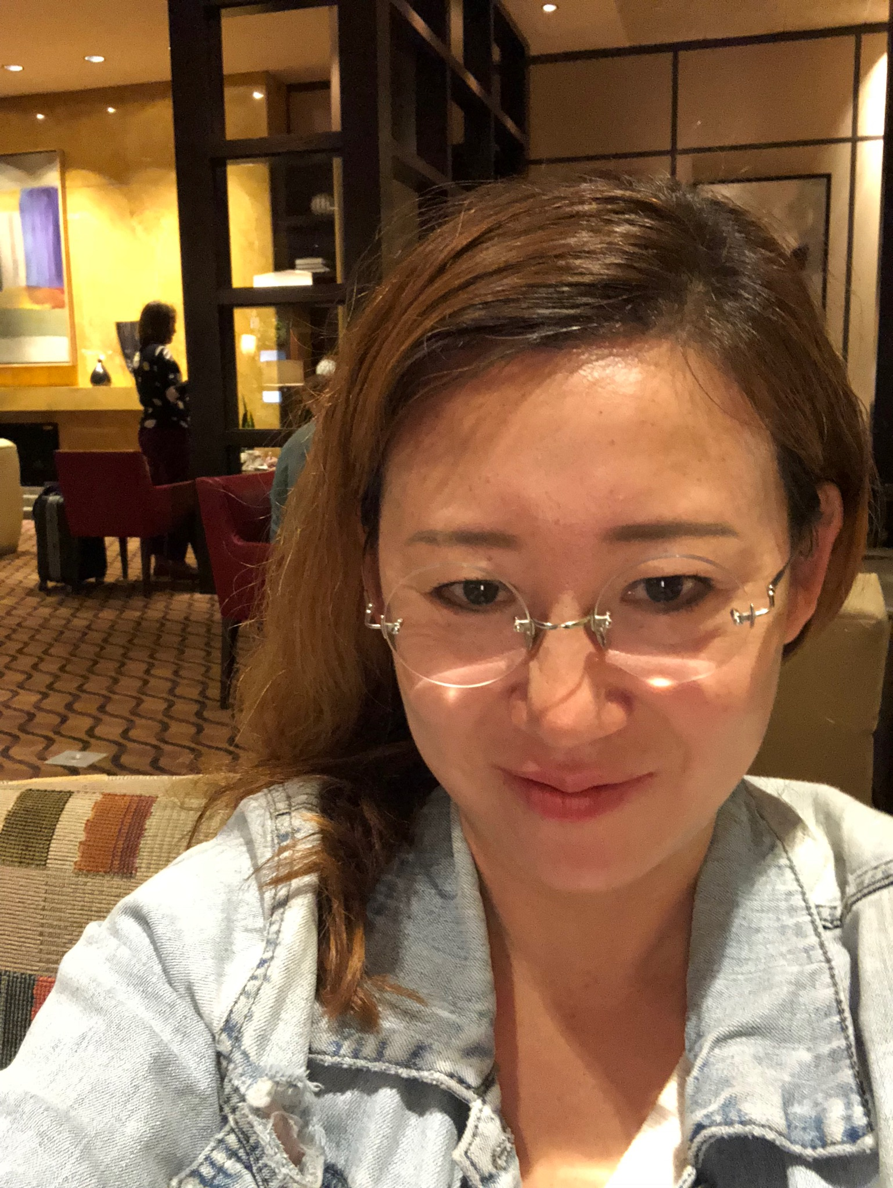

Email Id:

Any Comments: Actually, I am hoping to gain connections with pharmaceutical companies to make an efficient thyroid medicine according current theories.

