Stem Cell Treatment Regulatory Issues
Dec 02, 2016
PMI Admin
Articles
(No Comments)
Because stem cell treatments have been so effective in certain conditions, there has been increased hope for their effectiveness for others. This has sometimes led to less ethical researchers and medical professionals offering stem cell treatments to patients when there was no preclinical or clinical evidence of their safety or efficacy. Because of this, organizations, such as the International Society for Stem Cell Research (ISSCR) have drawn up global standards for the study of stem cells and treatments using them.
These standards are merely guidelines, however, so governmental agencies, like the Food and Drug Administration (FDA), have established regulations regarding the procurement, modification, and use of stem cells. These regulations are updated as the understanding of the use of stem cells increases.
The FDA may regard the stem cell or stem cell-based product under study as a biologic, drug, xenotransplantation product, medical device, or a human cell, tissue, and cellular and tissue-based product. Each of these designations requires adherence to specific regulations and guidelines. For example, biologic products fall under Section 351 of the Public Health Safety Act, while human cells, tissues, and cellular and tissue-based products fall under Section 361 of the Public Health Safety Act.

Preclinical Safety and Efficacy Regulations
When carrying out preclinical studies on stem cell treatments, the FDA requires that several questions be addressed and thoroughly documented and reported.
These questions include:
- Is there any risk to the proposed treatment recipient of disease from stem cells provided by a donor?
- Does the processing of the stem cells intended for treatment pose any risk of damage or contamination to the intended recipient?
- What type of cells are being studied and at what potency and purity?
- Will the treatment under study be safe and effective in animal models?
When animal models are used in the preclinical study of stem cell treatments, there is the additional responsibility for ethical animal selection and maintenance. This may involve additional agencies to the FDA, for example, the Department of Defense or the Department of Agriculture. Also, veterinary specialists are often included as staff or advisors when using animal models in preclinical stem cell research, since they are knowledgeable in procedures, protocols, and regulations regarding animal welfare and subject suitability.

Keeping Up-to-date with FDA Regulations
With the quickly expanding knowledge of stem cells and their suitability for treatments of conditions such as diabetes, regulatory agencies are constantly modifying their regulations and the terminology used in them. For example, the FDA requires premarket approval of most stem cell therapies, regulating them as biologics and, in some cases, new drugs. Treatments that are deemed “minimally manipulated” have been exceptions to this rule in the past, but the FDA has recently taken a harder line on the issue. Future regulations and guidelines may make it clearer as to what “minimal manipulation” means in operational terms. Keeping current with these changes is essential in the field of stem cell research.
The focus of stem cell research is to discover safe and effective treatments for human diseases. The FDA and other regulatory and advisory organizations have developed and continue to update requirements to achieve valid, robust, and replicable outcomes. These requirements can be confusing, but contract research organizations like PMI provide staff well-versed in the regulations and practices that ensure reliable procedures and results.

Summary Points from Individual Speakers about Regulatory and Legal Issues Related to Stem Cell Therapies
- In the United States, stem cell therapies are regulated as biologics and are subject to premarket approval under the risk-based approach to approving cellular and tissue-based products. Treatments that are “minimally manipulated” are exceptions to this regulation, but this phrase could use further clarification. (Riley)
- European Union law states that cells or tissues that are “substantially manipulated” are subject to regulation; however, an exemption is given to member states in the non-routine case of custom-made treatments for individual patients. (Bianco)
- The Japanese government has made innovation, including innovation in stem cell research, a national priority, and new laws regarding regenerative medicine products are expected to provide a more efficient path to the translation of these therapies to the clinic. (Miyata)
- Mexico has benefited economically from offering stem cell therapies that are not available in other countries; however, regulations for treating patients with cells and tissues that are based on evidence could help to address challenges relating to therapy, safety, and efficacy. (Arellano)
- While stem cell therapies offered in China must be registered, there are not yet approved quality control guidelines available. (Zhou)
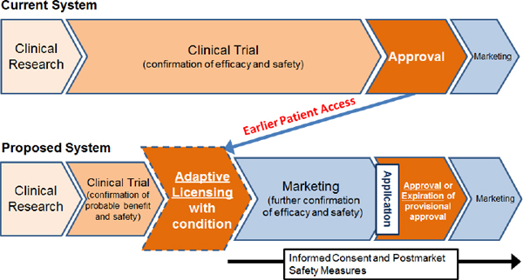

FIGURE 4-1A new approval system under consideration in Japan would create earlier patient access to cellular therapy products

Dr Sudeep Kumar

Head Biotech

Tel.: +91 (832) 2405000, Direct: +91 (832) 2405102, Mobile:9909971750 / 9130024750

Email: sudeep.kumar@unichemlabs.com

UNICHEM LABORATORIES LTD

Bioscience Centre: Plot No. 17A, Pilerne Industrial Estate, Pilerne, Bardez, Goa – 403 511, India. • Website: www.unichemlabs.com

