Abstract Title: The effect of the anti-cancer preparation NSC631570 (Ukrain) on the dendritic cells
Name: Dr. Wassil Nowicky
“Nowicky Pharma”/ Ukrainian Anti-Cancer Institute,
Margareten Street 7, A-1040, Vienna, Austria

Abstract (not more than 300 words)

Dendritic cells are immune cells that act as messengers between the innate and adaptive immunity. Their main function is to process antigen material and present it on the surface to other cells of the immune system, thus functioning as antigen‐presenting cells and are seen as the most potent population executing this function. In the experiments with the mononuclears from the peripheric blood of healthy persons the effect of the anti-cancer preparation NSC-631570 (Ukrain) on the phenotypic and functional properties of dendritic cells was studied. The most prominent induction of the expression of the cell surface molecules CD86 and HLA‐DR was achieved with NSC-631570 at the lowest and highest concentration, 0.6 μg/mL and 10 μg/mL, respectively. Lipopolysaccharide as standard comparative agent induced similar increase of the cell surface receptors. The proliferation index of the incubated lymphocytes was used as the indicator of the dendritic cells activity. After addition of NSC631570 to the incubated dendritic cells, the lymphocyte proliferation index increased from 22.6% up to 32.30% at 0.6 μg/mL or 29.34% at 10 μg/mL, respectively. These values are similar to the one of 31.82%, i.e. proliferation index achieved at the
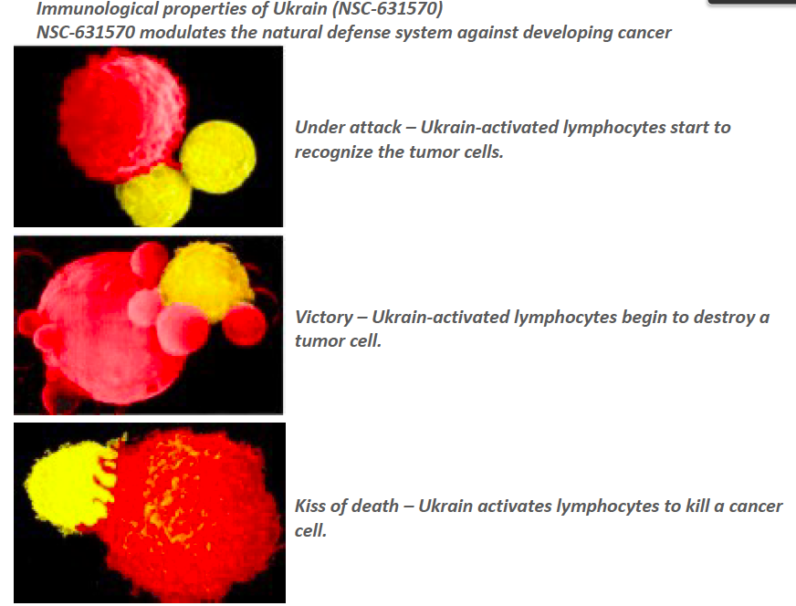
incubation of lymphocytes with the phytohemagglutinin. The authors concluded dendritic cells incubated with NSC-631570 are strong stimulators of the lymphocyte proliferation. They postulate also NSC-631570 can take an important part in the immune therapy of cancer [].

Keywords— anticancer, proton, NSC-631570, Ukrain

Professional Biography (100-150 words)

Dr. Wassil Nowicky — Dipl. Ing., Dr. techn., DDDr. h. c., Director of “Nowicky Pharma” and President of the Ukrainian Anti-Cancer Institute (Vienna, Austria). Has finished his study at the Radiotechnical Faculty of the Technical University of Lviv (Ukraine) with the end of 1955 with graduation to “Diplomingeniueur” in 1960 which title was nostrificated in Austria in 1975. Dr. Wassil Nowicky became the very first scientist in the development of the anticancer protonic therapy and is the inventor of the preparation against cancer with a selective effect on basis of celandine alkaloids “NSC-631570”. He used the factor that cancer cells are more negative charged than normal cells and invented the Celandine alkaloid with a positive charge thanks to which it accumulates in cancer cells very fast. Author of over 300 scientific articles dedicated to cancer research. Dr. Wassil Nowicky is a real member of the New York Academy of Sciences, member of the European Union for applied immunology and of the American Association for scientific progress, honorary doctor of the Janka Kupala University in Hrodno, doctor “honoris causa” of the Open international university on complex medicine in Colombo, honorary member of the Austrian Society of a name od Albert Schweizer. He has received the award for merits of National guild of pharmasists of America. the award of Austrian Society of sanitary, hygiene and public health services and others.
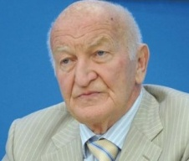

Presenting author details
Full name: Dr. Wassil Nowicky
E-mail: dr.nowicky@yahoo.de
Website: www.ukrin.com
Contact number: +436644020692
Session name/ number:
Category: Oral presentation

Iagodina OV (2010): [Comparative substrate‐inhibitor analysis of liver monoamine oxidases of minks]. Zhurnal evoliutsionnoi biokhimii i fiziologii, 46(5):380‐386. http://www.ncbi.nlm.nih.gov/pubmed/21061647

