Hepatocellular carcinoma Incidence at National and Provincial level of Iran from 2000 to 2016: a Meta regression analysis
Nima Fattahi, MD, Non-Communicable Diseases Research Center, Endocrinology and Metabolism Population Sciences Institute, Tehran University of Medical Sciences, Tehran, Iran
Negar Rezaei , MD, PHD, Non-Communicable Diseases Research Center, Endocrinology and Metabolism Population Sciences Institute, Tehran University of Medical Sciences, Tehran, Iran
Moein Yousefi , Non-Communicable Diseases Research Center, Endocrinology and Metabolism Population Sciences Institute, Tehran University of Medical Sciences, Tehran, Iran
Farshad Farzadfar ,MD, ,PH, PHD, Endocrinology and Metabolism Research Institute, Tehran University of Medical Sciences, Tehran, Iran

Abstract (300 word limit)

Background: The incidence of Hepatocellular carcinoma (HCC), the most common primary liver cancer with high lethality, is undergoing global change due to evolving risk factor profiles. We aimed to accurately describe to demonstrate the epidemiologic incidence of HCC by sex, age, and geographical distribution from 2000 to 2016 in Iran. Method: Annual percent change, Total Percent change, number of new cancer cases, age standardized incidence rates (ASIR) from 2000 to 2016 Are reported for HCC among Iranian adult population. Cancer incidence data were extracted from the Iran Cancer Registry, and several statistical procedures were applied to overcome the incompleteness and misclassification of the dataset. Results: age standardized incidence rate (ASIR) increased 1.17 times from 0.57 (0.37-0.78) per 100,000 in 2000 to 0.67 (0.50-0.85) in 2016. It had 21.89% total percentage change increase during mentioned 17 years with 1.28 annual percentage change in both sexes .Male to female ASIR ratio in 2000 was 1.51 and in 2016 it was 1.57. Overall, after the age of 50 years, the incidence of hepatocellular carcinoma increased dramatically with age and increased from 1.19 (0.98-1.40) in 50-55 age group to 6.65 (5.45-7.78) in above 85 years old age group. The geographical distribution of this cancer has always been higher in the central and southern and southwestern regions of Iran. Conclusion: Generally, HCC incidence rate increased during 2000 to 2017 with more increase in subgroups such as men and over 50 years of old. Also we observed a geographic difference with more incidence in central and southern and southwestern regions of Iran.

Key words: HCC, Iran, incidence trend, National, Provincial
Image
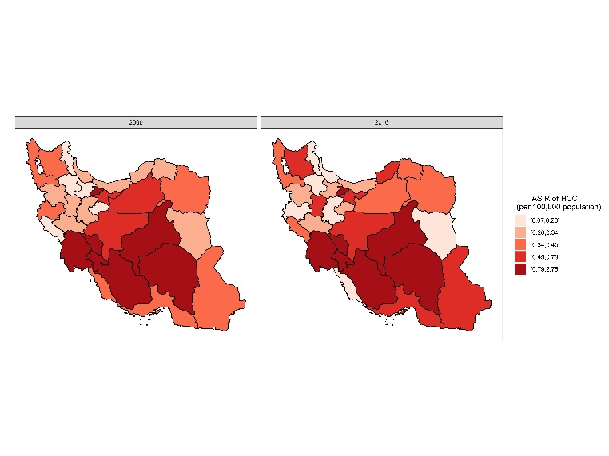
Recent Publications (minimum 5)
1- Nima fattahi, karim sharifi, ghobad moradi, rehmatulla iri, romina reshadat, pedram ataee, ali jalili, farshad sheikh esmaseili. Prevalence of non alcoholic fatty liver disease in Kurdistan provience,iran, 2013-2014: a population based study, GOVARESH, 2018, accepted
2- Nasiri Kalmarzi, R., Fattahi, N., Kaviani, Z., Ataee, P, Mansouri, M., Moradi, G., Yousefzade, A, Abbassi, J.M, Inverse correlation of soluble programmed cell death-1 ligand-1 (sPD-L1) with eosinophil count and clinical severity in allergic rhinitis patients, Allergology International 2017, 66(2), pp. 326-331
3- Moloudi, J, Zamani, A., Fatemi-Naeini, F, Fatahi, N, Amini, A., Moloudi, M.R, The relationship of androgenic alopecia and opium consumption in men: A comparative study, Journal of Isfahan Medical School,Volume 34, Issue 407, January 2017, Pages 1375-1380
4- Reshadat, R., Fattahi, N*, Iri, R, Saeedi, B, Shahabbaspoor, Z, Emami, L, Zamani, M, Sheikhesmaeili, F, Moradi, G, Sharifi, K, Prevalence of gastroesophageal reflux and its related factors in Sanandaj, 2017-2015, Scientific Journal of Kurdistan University of Medical Sciences, Volume 22, Issue 4, 2017, Pages 36-44

5-Fattahi, N, Moradi, G, Rashahmadi, N, Nick-Khoo, B, Ghaderi, B, Large cell calcifying Sertoli cell tumor(LCCSCT): a case report, Scientific Journal of Kurdistan University of Medical Sciences,Volume 20, Issue 1, 2015, Pages 105-111

Photograph

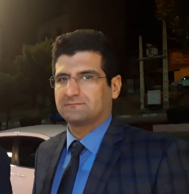
Biography (150 word limit)
I’m graduated of medicine and 27 years old . working as research assistant at Non Communicable research center of Tehran university of medical sciences. I have several publications in ISI and Scopus indexed journals, I have had several oral and poster presentation in international and national conferences, and I participated in holding several research conferences as executive secretary, member of scientific committee, and member of the jury. Furthermore, I have conducted several research workshops as the trainer.
It is worth noting that, I was recognized as “National outstanding student researcher” of the year in 2017 by the deputy of research and technology of Iran’s Ministry of Health. I was also recognized as the “best juror” of the 18th annual research congress of Iranian medical students in 2017, and the best “best student researcher” of Kurdistan University of Medical Sciences in2013, 2014, and 2015.

Research Interest
Neurology, Cardiology, Gastroesophageal Reflux
Email: dr_nima_f@yahoo.com

Notes/Comments:

