Human cytolytic fusion proteins targeting CSPG4 for the treatment of triple-negative breast cancer
Neelakshi Mungra, PhD candidate, MB&I Unit, UCT, South Africa
Sandra Jordaan, PhD candidate, MB&I Unit, UCT, South Africa
Dr Stefan Barth, Professor, MB&I Unit, UCT, South Africa

Abstract
Conventional chemotherapeutic approaches face obstacles such as off-target toxicity and therapy-resistance in certain cancers. Human cytolytic fusion proteins (hCFPs) are targeted therapeutic agents composed of a disease-specific humanized antibody-based ligand recombinantly fused with a conditionally apoptosis-inducing human oligopeptide. They exhibit low off-target toxicity and can overcome tumor resistance depending on the biomarker selected. We generated hCFPs targeting chondroitin-sulphate proteoglycan (CSPG4), a biomarker of aggressive and treatment-resistant cancers, for the treatment of triple-negative breast cancer (TNBC). These hCFPs are designed to bind to CSPG4-positive TNBC cells and deliver cytotoxic proteins intracellularly, where they induce tumor cell death by disrupting biosynthesis (angiogenin) or mitosis (microtubule-associated protein tau or MAP tau) in a compartment-dependent manner.We designed recombinant hCFPs based on angiogenin and MAP tau as lead agents, as well as a CSPG4-targeting SNAP-tag fusion protein (as a fluorescent mimic for binding). All fusion proteins were expressed in a transient secretory mammalian expression system and purified from the cell culture supernatant by ion metal affinity chromatography. Binding of CSPG4(scFv)-SNAP to CSPG4-positive and -negative TNBC cell lines was validated both quantitatively (by flow cytometry) and qualitatively (by confocal microscopy). Preliminary proof-of-concept data demonstrate that the CSPG4-targeting, fluorescently-labeled CSPG4(scFv)-SNAP binds effectively to CSPG4-positive TNBC cells. The combination of hCFPs with a robust companion diagnostic tool such as SNAP-tag technology represents the first step towards the effective management of African TNBC.

Image
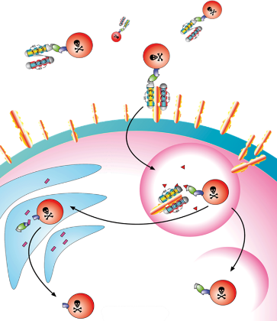
Figure 1. Mechanism of action of hCFPs involving specific binding (to tumor-associated antigen), internalization, translocation of the cytotoxic component into the cytosol and activation of the catalytic component, culminating in the apoptosis of the tumor cell
Recent Publications
- Akinrinmade, O., Jordaan, S., Hristodorov, D., Mladenov, R., Mungra, N., Chetty, S. and Barth, S. (2017). Human MAP Tau Based Targeted Cytolytic Fusion Proteins. Biomedicines, 5(3), p.36.
- Jordaan, S., Chetty, S., Mungra, N., Koopmans, I., van Bommel, P., Helfrich, W. and Barth, S. (2017). CSPG4: A Target for Selective Delivery of Human Cytolytic Fusion Proteins and TRAIL. Biomedicines, 5(3), p.37.
- Hlongwane, P., Mungra, N., Madheswaran, S., Akinrinmade, O., Chetty, S., and Barth, S. (2018). Human Granzyme B Based Targeted Cytolytic Fusion Proteins. Biomedicines, 6(2), p72.

Photograph

Biography
Neelakshi has always been fascinated by the realm of medicinal chemistry and cancer research. Being a Doctoral student in Chemical Biology, her primary aim is to excel in her field through hard work, research, skills and perseverance. She has demonstrated self-motivation, commitment and determination in achieving her goals, come what may. She has a strong sense of responsibility, leadership and organizing skills that definitely serve as a stepping stone to help her succeed in any environment of growth and excellence. Neelakshi is an exceptional young lady, but a humble person. She is much appreciated for her warmth and pleasant personality.
Email: mngnee002@myuct.ac.za

Notes/Comments:

