Gastric Adenocarcinoma at the Joliot Curie Institute in Dakar: Epidemiological, Diagnostic and Therapeutic Aspects about 54 Cases

Kanta Ka, Doudou Diouf, Sidy Ka, El Hadj Amadou Sall, Daniele Presti, Mamadou Moustapha Dieng, Papa Macoumba Gaye, Ahmadou Dem

Abstract
Objectives: To study the epidemiological, diagnostic, therapeutic and prognostic aspects of gastric adenocarcinoma at the Joliot Curie Institute in Dakar.
Materials and Methods: We conducted a retrospective study over a seven-year period from January 2010 to December 2017 at the Joliot Curie Institute in Dakar. All cases of gastric adenocarcinoma proven by fibroscopy followed by histology or proven on the histological analysis of a surgical specimen were taken into account. The parameters studied were age, risk factors, stages of the disease, treatment and prognosis. Results: There were 54 cases of gastric adenocarcinoma over a period of 7 years. The average age was 54.74 years with extremes of 25 and 84 years. A male predominance was noted (35/54). The main risk factors found were alcohol (5/54), tobacco (13/54), Helicobacter pilori (4/54), gastric ulcer (12/54). Epigastralgia was the most frequent clinical manifestation. FOGD was carried out in 77.8% of patients. Histology was obtained before surgery in 40 patients (74.1% of cases) and on the operating room in 14 patients (25.9%). Patients were classified as stage II in 2/54 cases, stage III in 5/54 cases and stage IV in 47/54 cases. Gastro-entero-anastomosis was the main surgical procedure performed. External radiotherapy was performed in 1/54 patients. Chemotherapy was done in 52/54 patients, 96.3% of the cases. It was palliative in 66.7% of cases, neoadjuvant in 1.9% of cases, adjuvant in 24.1% of cases, perioperative in 3.7% of cases. Mortality was 79.6%. Patient survival times were relatively short: in less than 6 months 24/54 cases, 13/54 cases between 6 - 12 months, 5/54 cases between 13 - 24 months and 6/54 cases beyond 24 months. 6/54 patients were lost from view. Conclusion: Gastric adenocarcinoma is diagnosed lately in our conditions. It is responsible for a high mortality rate. Palliative treatment is often the only option because of the delay in diagnosis.

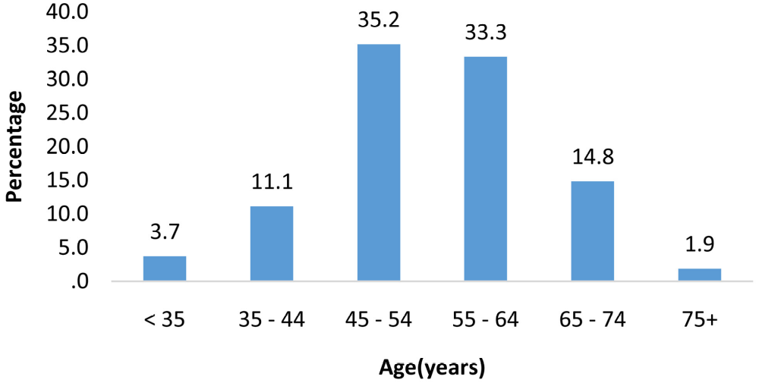
Figure 1. Breakdown of patients according to age.

Table : Patient survival time

Survival duration (month) | Number | Percentage (%)
< 6 | 24 | 50,0
6- 12 | 13 | 27,1
13-24 | 5 | 10,4
>24 | 6 | 12,5
Total | 48 | 100

References
[1] Aparicot, T., Yacoub, M., Karila-Cohen, P., et al . (2004) Adénocarcinome gastrique: Notions fondamentales, diagnostic et traitement. EMC-Chirurgie, 1, 47-66. https://doi.org/10.1016/j.emcchi.2003.10.003
[2] Richard, N., et al . (2019) Cancers de l’estomac. Traité de medicine AKOS , 2, 1-7.
[3] Gangloff, A. and Michel, P. (2013) Cancers de l’estomac. EMC-AKOS (Traité de Médecine ), 8, 1-6.
[4] Correa, P., Haenszel, W., Cuello, C., Zavala, D., Fontham, E., Zarama, G., et al . (1990) Gastric Precancerous Process in a High Risk Population: Cohort Follow-Up. Cancer Research, 50, 4737-4740.
[5] D’Elia, L., Rossi, G., Ippolito, R., Cappuccio, F.P. and Strazzullo, P. (2012) Habitual Salt Intake and Risk of Gastric Cancer: A Meta-Analysis of Prospective Studies. Clinical Nutrition, 31, 489-498. https://doi.org/10.1016/j.clnu.2012.01.003
[6] Ajani, J.A., Lee, J., Sano, T., Janjigian, Y.Y., Fan, D. and Song, S. (2017) Gastric Adenocarcinoma. Nature Reviews Disease Primers , 3, Article No. 17036. https://doi.org/10.1038/nrdp.2017.36
[7] Watabe, H., Mitsushima, T., Yamaji, Y., et al . (2005) Prévision du développement du cancer gastrique à partir de la combinaison des anticorps d’Helicobacter pylori et du statut des pepsinogènes sériques: Une étude de cohorte endoscopique prospective. Gut, 54, 764-768. https://doi.org/10.1136/gut.2004.055400
[8] Ghizlane, H. (2016) L’adénocarcinome gastrique: Etude analytique. Thèse de médecine FES N°051/16.
[9] Lambert, R. (2010) Épidémiologie du cancer gastrique dans le monde. Cancéro digest, 2, 31-37. https://doi.org/10.4267/2042/30746
[10] Faye, I.J. (2010) Prise en charge des cancers gastriques au service de chirurgie générale de l’hôpital Grand Yoff. Thèse de médecine, Dakar, N° 75.
[11] Idrissi, S. (2013) Les cancers de l’estomac à l’institut Juliot curie de l’hôpital Aristide Le Dantec de Dakar à propos de 136 cas. Thèse de médecine, UCAD, N° 132.
[12] Ladeiras-Lopes, R., Periera, A.K., Nogueira, A., et al . (2008) Smoking and Gastric Cancer: Systematic Review and Meta-Analysis of Cohort Studies. Cancer Causes Control , 19, 689. https://doi.org/10.1007/s10552-008-9132-y
[13] Gpnzalez, C.A., Pera, G., Agudo, A., et al . (2003) Smoking and the Risk of Gastric Cancer in the European Prospective Investigation into Cancer and Nutrition (EPIC). International Journal of Cancer , 107, 629-634. https://doi.org/10.1002/ijc.11426
[14] Barstad, B., Sorensen, T., Tjonneland, A., et al . (2005) Intake of Wine, Beer and Spirits and Risk of Gastric Cancer. European Journal of Cancer Prevention, 14, 239. https://doi.org/10.1097/00008469-200506000-00007
[15] Tramacere, I., Negri, E., Pelucchi, et al. (2012) Une méta-analyse sur la consommation d’alcool et le risque de cancer gastrique. Annals of Oncology, 23, 28. https://doi.org/10.1093/annonc/mdr135
[16] (1994) Groupe de travail du CIRC sur l’évaluation des risques cancérogènes pour l’homme, les schistosomes, les douvements hépatiques et Helicobacter pylori. Vol. 61 des monographies du CIRC sur l’évaluation des risques cancérogènes pour l’homme. Centre international de recherche sur le cancer, Lyon, Vol. 61.
[17] Karila-Cohen, P., Petit, T., Aparicio, T., et al. (2004) Adénocarcinome gastrique Éditions Françaises de Radiologie, Paris, 2004. Journal de Radiologie, 85, 1695-1698. https://doi.org/10.1016/S0221-0363(04)97733-5
[18] Aparicot, T., Yacoub, M., Karila-Cohen, P., et al . (2004) Gastric Carcinoma: Epidemiology, Diagnosis and Treatment. EMC-Chirurgie , 1, 47-66. https://doi.org/10.1016/j.emcchi.2003.10.003
[19] Takemoto, Y. (2003) Caractéristiques clinicopathologiques du cancer gastrique précoce: Résultats de 100 cas d’un hôpital général rural. The European Journal of Surgery , 165, 319-325.
[20] Xiong, B., Ma, L., Cheng, Y., et al . (2014) Clinical Effectiveness of Neoadjuvant Chemotherapy in Advanced Gastric Cancer: An Updated Meta-Analysis of Randomized Controlled Trials. European Journal of Surgical Oncology, 40, 1321-1330. https://doi.org/10.1016/j.ejso.2014.01.006
[21] Hermans, J., Bonenkamp, J.J. and Boon, M.C. (1993) Traitement adjuvant après une résection curative pour le cancer gastrique: Méta-analyse d’essais randomisés. Journal of Clinical Oncology , 11, 1441-1447. https://doi.org/10.1200/JCO.1993.11.8.1441
[22] Paoletti, X., Oba, K., Burzykowsky, T., et al. (2010) Benefit of Adjuvant Chemotherapy for Resectable Gastric Cancer: A Meta-Analysis. JAMA, 303, 1729-1737. https://doi.org/10.1001/jama.2010.534
[23] Earle, C.C. and Maroun, J.A. (1999) Adjuvant Chemotherapy after Curative Resection for Gastric Cancer in Non-Asian Patients: Revisiting a Meta-Analysis of Randomised Trials. European Journal of Cancer , 35, 1059-1064. https://doi.org/10.1016/S0959-8049(99)00076-3
[24] Cunningham, D., Allum, W., Stenning, S.P., et al . (2006) Perioperative Chemotherapy versus Surgery Alone for Resectable Gastroesophageal Cancer. The New England Journal of Medicine , 355, 11. https://doi.org/10.1056/NEJMoa055531
[25] Mornex, F. and Chauffert, B. (1998) Chimioradiothérapie concomitante dans la stratégie thérapeutique des adénocarcinomes du pancréas exocrine et de l’estomac. Cancer /Radiothérapie , 2, 696-702. https://doi.org/10.1016/S1278-3218(99)80010-9
[26] Bertuccio, P., Chatenoud, L., Levi, F., et al . (2009) Recent Patterns in Gastric Cancer: A Global Overview. International Journal of Cancer , 125, 666-673. https://doi.org/10.1002/ijc.24290
[27] Quero, L., Guillerm, S. and Hennequin, C. (2015) Néoadjuvant ou thérapie adjuvante pour le cancer gastrique. World Journal of Gastrointestinal Oncology , 7, 102-110.

 Biography
Dr Kanta Ka is a radiation oncologist at the National University center of Dalal Jamm in Senegal.He is currently doing translational and clinical research at the Institut Gustave Roussy in Paris after a one-year internship in the radiotherapy department. Dr Ka also has a diploma in radiobiology, radiotherapy of head and neck cancers, master of Biology health. I am currently leading 2 research projects of the brachytherapy group of the French Society of Oncological Radiotherapy.

