Evaluation the role of Branched Fatty Acids on Pancreatic beta cells and on different type of Cancer.
Dr Moath alqaraleh

Abstract (300 word limit)
Background: monomethyl branched chain fatty acids (mmBCFA; including (10 MTD, 12 MTD, 13 MTD and 14 MTD)’ can be closely associated with metabolic dysregularities. We aimed to explore the potential role of mmBCFA as potential treatment option for diabetes and/or cancer. Methods: Pancreatic MIN6 beta cell lines were treated with mmBCFA to bioassay their effects on glucose stimulated insulin secretion (GSIS) and β-cell proliferation, glucotoxicity and lipotoxicity (separately and combined). Using Nitric Oxide (NO) Griess and DPPH assays; the mmBCFA modulation of lipopolysaccaride (LPS)-induced acute inflammation in RAW264.7 macrophages and oxidative stress respectively; further confirmed by relative quantitative real time (qRT)– polymerase chain reaction (PCR) for catalase, glutathione peroxidase, IL1β and TNFα gene expression regulation were examined. Using SRB assay; the antiproliferative efficacies of mmBCFA –with or without insulin- on the viability of a panel of colorectal, breast, pancreatic cancer cell lines with subsequent qRT-PCR of apoptosis signal transduction β catenin, cyclin D1 and antiapoptotic Bax were tested. Results: Similar to L-alanine insulinotropic efficacy in MIN6 β-cell, GSIS was potentiated by mmBCFA. Comparable to glucagon-like peptide-1-enhanced β-cell proliferation, a dose dependent augmentation of bromodeoxyuridine incorporation was obtained with mmBCFA. Furthermore, mmBCFA could restore the secretory function of MIN6 β-cell despite stressful gluco-lipo-toxicity; separately or combined. mmBCFA inhibited the proliferation of colorectal HCT116, SW620, CACO2, SW480, breast MCF7 and T47D and pancreatic Panc1 cancer cells but not HT29. Selectively qRT-PCR demonstrated that 12MTD and 13MTD reduced the insulin induced expression levels of β‑catenin and its downstream target proteins Cyclin D1, and proapoptotic Bax in cancer cells. Dose dependent inhibition of LPS-induced NO in RAW264.7 was exerted by mmBCFA and so was the suppressed expression of LPS-induced proinflammatory IL1β and TNFα. Conclusion: Current findings suggest that mmBCFA supplementation may be potential novel therapeutic agents for the treatment of diabetes and/or cancer.

Image
The suggested role of mmBCFA under inflammation, oxidative stress and in cancer cells.
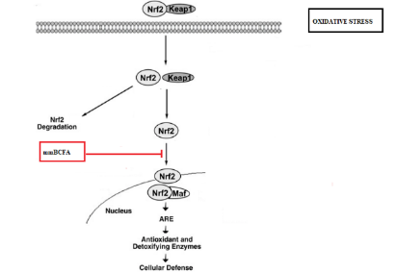
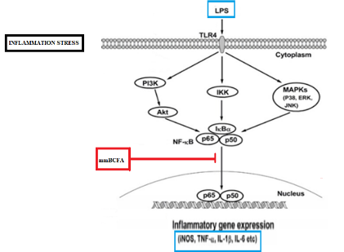
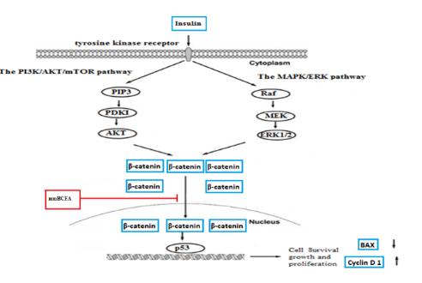

Recent Publications (minimum 5)
1- Alqaraleh, M., Kasabri, V. and Al-Othman, N., 2019. Evaluation of Pancreatic and Extra Pancreatic Effects of Branched Amino Acids. Romanian Journal of Diabetes Nutrition and Metabolic Diseases, 26(2), pp.199-209.

2- Alqaraleh, M., Kasabri, V., Farha, R.A., Naffa, R.G., Yousef, I. and Aljaafreh, A., 2019. Branched amino acids as potential biomarkers in metabolic syndrome patients and as hypolipidemic compounds. EurAsian Journal of BioSciences, 13(2), pp.2233-2241.

3- Alqaraleh, M. and Kasabri, V., 2018. Evaluation of Anticancer and Anti-Inflammatory Properties of Branched Chain Amino Acids. Journal of Biochemistry and Cell Biology. 108

4- Al-Othman, N., Ahram, M. and Alqaraleh, M., 2019. Role of androgen and microRNA in triple-negative breast cancer. Breast Disease, (Preprint), pp.1-13.

5- Al-Othman, N, Alhendi A, Ihbaisha M , Barahmeh M , Alqaraleh, M. and Z Al-Momany, B., 2019. Role of CD44 in breast cancer. Breast Disease, (Preprint), pp.1-12.

Biography
My name is Dr. moath alqaraleh, I was working at cell therapy center in the university of Jordan as Research assistant from 2018 to 2019. during the research I involved in design of different biological experiments. Furthermore, I work as lecture at Faculty of Medical Laboratory Sciences in mutah university from 2018 until now. My interests focus on cancer biology regarding the effect of insulin pathways on the growth of different type of cancer. As well as the effect of hormones and chemotherapy in regulating the miRNA expression in the breast cancer patients.

Email: alqaralehmoath@yahoo.com

