Subconjunctival Carboplatin and Etoposide Polymeric Microparticles for the Effective Therapy against Retinoblastoma
Authors: Rutika D. Godse*¹, Maitreyi Rathod², Rahul Thorat², Abhijit De², Ujwala A. Shinde¹
Affiliations:
*¹ Rutika D. Godse, Ph.D. Student, Department of Pharmaceutics, Bombay College of Pharmacy, Kalina, Santacruz (E), Mumbai - 400098, India. E-mail ID: rutika113@gmail.com
²Maitreyi Rathod, Ph.D student, Molecular Functional Imaging Lab (De lab), Advanced Centre for Treatment, Research & Education in Cancer (ACTREC)
²Dr. Rahul A. Thorat, Scientific Officer ‘D’, ACTREC
²Dr. Abhijit De, Scientific Officer ‘F’ and Principal Investigator, Molecular Functional Imaging Laboratory In-Charge, Molecular Imaging Core Facility, ACTREC
¹Dr. Ujwala A. Shinde, Associate Professor of Pharmaceutics, Department of Pharmaceutics, Bombay College of Pharmacy

Abstract
Purpose: The purpose of this study was to develop carboplatin (CPT) and etoposide (ETP) loaded biodegradable polymeric microparticles as a combination therapy for retinoblastoma via subconjunctival route and to evaluate it by in vitro and in vivo methods.
Methods: CPT and ETP loaded PLGA microparticles (CE-MIP) were prepared by emulsification-spray drying technique by optimizing various process and formulation parameters. The optimized drug loaded PLGA microparticles were characterized for particle size, zeta potential, entrapment efficiency and in vitro release. In vitro cytotoxicity studies of CE-MIP and plain drugs were carried out in Y-79 and WERI-Rb cell lines. Anti-tumor efficacy of CE-MIP was also investigated by carrying out Soft agar assay and apoptosis study on Y-79 cell line. The pharmacokinetic parameters of vitreous and plasma drug levels on subconjunctival administration of CE-MIP and free drug were assessed in Sprague Dawley rats. The in vivo efficacy of CE-MIP in the treatment of orthotropic retinoblastoma in nude mice via subconjunctival route was evaluated.
Results: The particle size of CE-MIP was found to be 3-14 µm and the zeta potential values ranged between -23.0 to -34.2 mV indicating stability. DSC and XRD studies indicated that CPT and ETP were present in the amorphous phase and may have been homogeneously dispersed in the PLGA matrix. SEM micrographs showed discrete and homogenous particles. The entrapment of ETP and CPT in PLGA microparticles was found to be more than 80% and more than 60% respectively. Drug release study showed that CE-MIP released CPT in 4 h and sustained the release of ETP up to 72 h. In vitro cytotoxicity studies CE-MIP showed greater anti-cancer effect (25.33% cell viability) compared to plain drug mixture (38.56% cell viability) in Y-79 cells (200 μM concentration). In WERI-Rb cell lines, the CE-MIP and plain drug mixture at 100 μM showed % cells viability as 37.82% and 66.08% respectively. In the soft agar assay, the CE-MIP treatment demonstrated a significant reduction in the number of colonies (~50% reduction) formed as compared to control. Also, the apoptotic effect of CE-MIP (15.7%) was greater compared to that of control (7.9%). The pharmacokinetic study showed that CPT concentration in the vitreous humor was far higher than that in the plasma, indicating the possibility of minimizing systemic side effects. Mean tumor burden in the CE-MIP treated eyes was significantly smaller compared to the untreated control eyes showing the anti-tumor efficacy of developed CE-MIP.
Conclusion: Taken together, the study demonstrated that CPT-ETP/PLGA MIP based subconjunctival drug delivery system holds significant potential towards the treatment of retinoblastoma.

Image: Graphical Abstract of Research
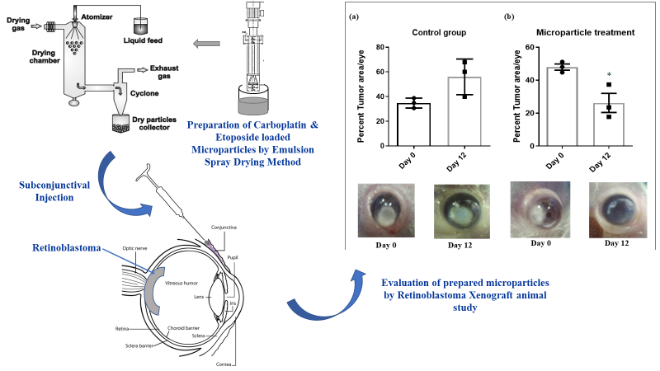

Recent Publications
S. No. | Authors | Title | Journal | Vol. | Pg. | Year
1. | Rutika Godse, Kavita Singh, Agnivesh Shrivastava, Ujwala Shinde | Polymeric Nanoparticulate Systems: A Potential Approach for Ocular Drug Delivery | Nano-Biomaterials For Ophthalmic Drug Delivery | - | 351-387 | 2016
2. | Mangesh Wasnik, Rutika Godse, Hema Nair | Development and evaluation of buccoadhesive tablet for selegiline hydrochloride based on thiolated polycarbophil | Drug development and industrial pharmacy journal. Impact Factor: 2.29 | 40 | 632-8 | 2014
3. | Rutika Godse, Abhijit De, Maitreyi Rathod, Ujwala A. Shinde | Intravitreal Galactose Conjugated Polymeric Nanoparticles of Etoposide for Retinoblastoma | Drug Delivery and Translational Research | In Communication |  | 2019
4. | Ujwala A. Shinde,  Rutika D. Godse, Atul C. Chaskar | Electrohydrodynamic Technique for Fabrication of Chitosan Drug Delivery System | AAPS Pharm SciTech | In Communication |  | 2019

Photograph


Professional Biography
Rutika D. Godse pursuing her PhD (age 30 years) under the guidance of Dr. Ujwala A. Shinde from Bombay College of Pharmacy (Mumbai University). Senior Research Fellow received Fellowship from Department of Biotechnology - DBT (under Pilot Project Grant for Young Investigators in Cancer Biology). Worked as a research associate in Formulation department in Pharma Company: Rubicon Pvt. Ltd. for more than a year. Completed Bachelor’s degree and Master in Pharmaceutics from Bombay College of Pharmacy.

Email: rutika113@gmail.com

