On the Performance of Variable Selection and Classification Via Ranked-Based Classifier
Md Showaib Rahaman Sarker, Department of Mathematical Science, The University of Texas at El Paso.
Dr. Michael Pokojovy, Department of Mathematical Science, The University of Texas at El Paso.
Dr. Sangjin Kim, Department of Mathematical Science, The University of Texas at El Paso.

Abstract
In high-dimensional gene expression data analysis, the accuracy and reliability of cancer classification and selection of important genes play a very crucial role. To identify these important genes and predict future outcomes (tumor vs. non-tumor), various methods have been proposed in the literature. But only few of them take into account correlation patterns and grouping effects among the genes. In this article, we propose a rank-based modification of the popular penalized logistic regression procedure based on a combination of l1 and l2 penalties capable of handling possible correlation among genes in different groups. While the l1 penalty maintains sparsity, the l2 penalty induces smoothness based on the information from the Laplacian matrix, which represents the correlation pattern among genes. We combined logistic regression with the BH-FDR (Benjamini and Hochberg false discovery rate) screening procedure and a newly developed rank-based selection method to come up with an optimal model retaining the important genes. Through simulation studies and real-world application to high-dimensional colon cancer gene expression data, we demonstrated that the proposed rank-based method outperforms such currently popular methods as lasso, adaptive lasso and elastic net when applied both to gene selection and classification.
Image

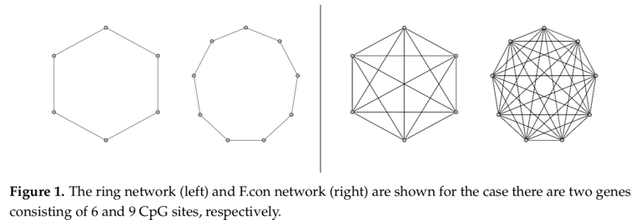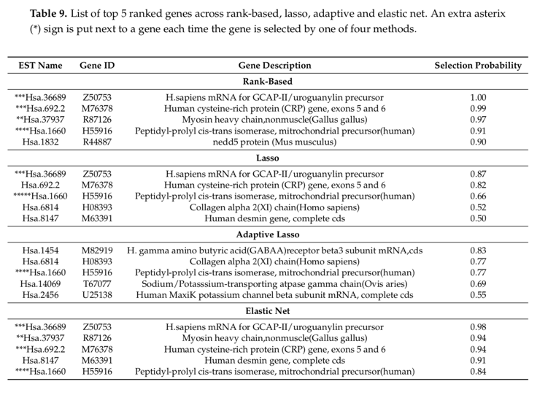
Recent Publication
- Sarker M S R, Pokojovy M, Kim S (2019) On the Performance of Variable Selection and Classification Via Rank-Based Classifier. MDPI, Mathematics, 7(5), 475.


Biography
Md Showaib Rahman Sarker is pursuing his master’s degree in Statistics at The University of Texas at El Paso. He has expertise in Statistical Machine learning application in High-Dimensional Gene Expression Data. Currently he is doing his research in High through-put cancer gene expression data. His main goal is to find out the important genes which are responsible for cancer and classify (tumor vs non-tumor) accurately. He is passionate to apply statistical approach and machine learning approach in cancer research.

Email: msarker@miners.utep.edu

