Determining the Antiangiogenic and Cytotoxic Activity of the Crude Ethanolic Extract from Saccharum spontaneum Linn. (Talahib) on Duck Eggs and Human Breast Cancer Cell Lines (MCF7)

A.A.Gutierrez¹, E.C.M.Limos¹, M.M.B.Medina¹, J.B.B.Guston¹, D.L.C. Hizon¹., K.I.M.L. Hizon¹, P.A.D. Lansang¹, J.G.Legere¹, A.B.Logan¹, D.P.Lopez¹, R.A.C. Maglalang¹, J. D. Marquez¹, R.N.L. Masa¹, N.M.M. Mercado¹, S.R.P. Mercado¹, C.E.G. Muñoz¹, A.Z.P. Miguel¹, C.C. Alapag M.D.²., A.B. Ramos M.D.², R.R. Santos M.D.³
1 Angeles University Foundation, School of Medicine,
2Faculty, Department of Biochemistry Angeles University Foundation, School of Medicine
3 Chair, Department of Biochemistry, Angeles University Foundation, School of Medicine

Corresponding authors’s email: ms.aileengutierrezmd@gmail.com

Background: Anti-angiogenic and antiproliferative properties are major pathological features to consider in treating cancer. Angiogenesis is the growth of new blood vessels from pre-existing vessels. Prevention of new blood vessel formation would reduce tumor size and chances of metastasis.

Methods: The present study was designed to evaluate the anti-angiogenic and anti-proliferative potential of the crude ethanolic extract of Saccharum spontaneum Linn (Talahib) by utilizing Chorioallantoic membrane assay and 3-(4,5-dimethylethylthiazol2-yl)-2,5 diphenyltetrazolium bromide (MTT) Assay respectively.

Results: Results of the chorioallantoic membrane assay showed prevention of new vascular formation when duck eggs were exposed to 100% concentration compared to 25%, 50% and 75% concentration of the plant extract. MTT assay also clearly showed the antiproliferative activity of IC₅₀ of 18.32µg/mL, 12.41µg/mL and 16.12µg/mL which are accepted values of the NIH, National Cancer Institute.

Conclusion: Based on the results obtained in this study, S. spontaneum has anti-angiogenic activity as shown by the prevention of formation of new blood vessels. Results from the anti-proliferative test suggest that the plant extract has huge potential as anticancer drug.

Keywords: Angiogenesis, chorioallantoic membrane assay, MTT assay, Saccharum spontaneum

Introduction
Cancer is one of the leading causes of death worldwide. As of 2012, cancer accounts for 8.2 million deaths while cases are continuously increasing at an alarming rate (WHO, 2015). In 2014, The World Health Organization predicted that the number of new cases will rise by about 70% over the next 2 decades – with an estimated 22 million new cases and 13 million deaths each year by 2032. Majority of the cases occur in developing countries and many of these nations’ health care systems are ill-equipped to deal with the complicated conditions that go along with this disease. The identified problems in the prevalence of cancer include the availability of treatments which are limited and expensive (WHO, 2015).

Currently, the most commonly use cancer chemotherapy includes mainly alkylating agents, antimetabolites, antitumor antibiotics, platinum analogs and natural anticancer agents (Fernando W. & Rupasinghe V., 2013). However, due to the increasing rate of mortality associated with cancer and adverse or toxic side effects of cancer
chemotherapy and radiation therapy, discovery of new anticancer agents derived from nature, especially plants, is currently under investigation. Screening of medicinal plants as a source of anticancer agents was started in the 1950s, with the discovery and development of vinca alkaloids, vinblastine and vincristine and the isolation of the cytotoxic podophyllotoxins (Cragg, et al., 2005). According to WHO (2015), about 82% of the population worldwide depends on herbal drugs. Herbal drugs are gaining popularity because of less side effects and low cost (Kumar, 2001).

According to Folkman J. (1990) Angiogenesis is the formation of new blood vessels from pre-existing vessels. It plays a critical role in many normal physiological processes as well as in tumor neovascularization associated with cancer progression (Deryugina E. & Quigley JP., 2008). The studies of Holmgren et al 1995 and Parangi et al 1996, said that in the absence of vascular support, tumors may become necrotic or even apoptotic. Therefore, angiogenesis is an important factor in the progression of cancer.

1

The MTT Assay (Mosmann, 1983) is a sensitive, quantitative and reliable colorimetric assay used to determine the degree of cytotoxicity after exposure to toxic substances. The assay is based on the capacity of mitochondrial dehydrogenase enzymes in living cells to convert the yellow water-soluble substrate 3-(4,5- dimethylthiazol-2-y1)-2,5-diphenyl tetrazolium bromide (MTT) into a dark blue formazan product that is insoluble in water. Active and viable cells are able to reduce the yellow MTT under tetrazolium ring cleavage to a water- insoluble purple-blue formation which precipitates in the cellular cytosol and can be dissolved after cell lysis. Inactive cells following toxicity cannot transform MTT. The formation of dark blue formazan is proportionate to the viable cell and inversely proportional to the degree of Cytotoxicity. The reaction is mediated by NADH or NADPH within the cell’s endoplasmic reticulum and the mitochondria.

In a comparison of different cytotoxic assays done by Fotakis & Timbrell (2006), the neutral red and MTT assays were the most sensitive in detecting cytotoxic events compared to the other two assays which were LDH leakage and the protein assay. The MCF-7 cell line (Davidson, Lee & Oesterreich 2015) is one of the most important cell lines used in breast cancer research due to the presence of estrogen receptor (ER) alpha, as this cell line is one of a very few to express substantial levels of ER which mimics most of invasive breast cancers that express ER. These MCF-7 models also serve as model for the study of estrogen response in vivo and vitro.

A comparison of MTT, ATP and calcein assays predicting the potency of cytotoxic agents in various cancer cell lines, which used MCF-7, revealed that the MTT assay did not differ in its predictability of the potency of cytotoxic agents compared with the other two assay. Additionally, the MTT assay was further improved to have high-throughput screening-capable (HTS) assay (Kassack, Mueller & Wiese, 2004).

Several studies have been conducted using breast cancer cell (MCF7). Al-Oqail et al (2013) and Graidist (2015) tested the cytotoxicity of Fenugreek seed oil and P. cubeba crude extract, respectively, using breast cancer MCF-7. Both of which proved to be an effective way of testing the viability of cytotoxic property of each specimen. Graidist (2015) used MCF-7 due to its ER positive, low-grade and luminal type properties which appeared to be more sensitive to cytotoxic properties, hence, providing better results. These facts led us to use MCF-7 as means of testing the cytotoxic property of S. spontaneum ethanol extract. A study done by Ripa, Imran-Ul-Haque & Haque (2009) revealed the antioxidant and antimicrobial properties of the chloroform extract of the flower S. Sponateum. The flower extract also revealed the moderate cytotoxic activity using the Brine Shrimp Assay, with the researchers suggesting further cytotoxic activity using human cell lines.

According to Khalid et al (2011), the powdered root of S. spontaneum indicated the presence of carbohydrates, glycosides, proteins, tannins, flavonoids and terpenoids
respectively. Also, on another study conducted by Sathya
M. & Kokilavani R. (2012) it was found that the S. spontaneum root had minerals, organic acids, flavonoids and phenolic compounds which was found to possesses antioxidant, mast cells stabilizing effects. The free radical scavenging activity of S. spontaneum root extract was evaluated based on the ability to scavenge the synthetic DPPH. The results obtained in the study indicated that S. spontaneum root extract exhibit potent free radical scavenging and antioxidant activity. This might be attributed to the presence of various phytoconstituents, alkaloids, flavonoids, tannins, steroids, terpenoids, glycosides and phenolic constituents.

This study is significant to pharmaceutical companies by providing information about the cytotoxicity and antiangiogenic activity in the plant that may be of help in discovering potential drugs that are natural, safe, and have minimal or no side effects for various diseases, and in particular, for breast cancer as the following methods will be used in actual human cell lines.

Materials and Methods
Plant collection and extraction
The roots of the plant (S. spontaneum) were collected from a local farm at Angeles City, Pampanga. Collected roots were air dried and later ground to crude powder. Crude powder was then soaked in 95% ethanol for 72 hours. The extract was filtered using glass funnel and a Whatman No.1 filter paper. The filtrate was concentrated using a rotary evaporator at 42ºC.

Chorioallantoic membrane assay
Fifteen eggs were collected from local hatchery in Angeles City, Pampanga. To avoid contamination, spraying on all eggs was done with 70% ethanol and incubated all eggs were placed in an incubator with the temperature of of 37.7 ºC as described by Ejaz, S, K.B. Seok and L.C. Woong, (2004).

Five groups were made, each having 3 eggs. Group A was kept as a control which received 20 µl DMSO and groups B, C, D and E received 25%, 50%, 75% and 100% dilution of root extract of Saccharum spontaneum. At the eighth day of incubation, eggs were opened and 20 μl fluid of each dilution was introduced on CAM which is in developing stage. Windows were covered again with parafilm tape and eggs were placed in incubator for the next 48hours in the same condition as described above. On the twelfth day, eggs were opened and placed in petri dish for visualization of vasculature under the stereomicroscope. Photos were obtained from each negative and treated groups.

Images were analyzed using Angiosys 2.0 software to determine the number of branches and junctions of CAM vasculature. For further analysis, SPIP was used to measure the primary, secondary and tertiary blood vessel diameters. ANOVA was used to assess the various parameters of quantification given above between the control and treated samples.

MTT Assay

The MTT cytotoxicity assay performed in this study was adapted from Mosmann (1983). In detail, MCF 7 cells were seeded at 6 x 10⁴ cells/mL, in sterile 96-well microtiter plates. The plates were incubated overnight at 37ºC and 5% CO₂. Following incubation, cells were treated with 10µl of each sample dilution. Four concentrations were used for the
4 samples: 50µg/mL, 25µg/mL, 12.5µg/mL and 6.25µg/mL. Doxorubicin served as positive control while DMSO served as negative control. The treated cells were again incubated for 72 hours at 37ºC and 5% CO₂. After incubation, the media was removed and 20µl 3-(4,5- dimethylethylthiazol2-yl)-2,5 diphenyltetrazolium bromide (MTT) at 5 mg/ml PBS was added. The cells were again incubated at 37ºC and 5% CO₂ for 4 hours. Then, 150 µL DMSO was added to each well. Absorbance was read at
570 nm. The lnhibition Concentration 50 (IC₅₀) was computed using the software "icpin" which uses a linear interpolation of the graph of absorbance against concentration.

Results and Discussion

Chorioallantoic membrane assay
Treated and control groups were opened after 48 hours of incubation after induction of plant extracts. Images of each control and treated CAMs were taken through stereomicroscope (Figure 1) and quantified using Angiosys2.0 (Cellworks) to determine the number of branches and junctions of each CAM (Table 1).

Figure I. Vascularization of treated and control group
Group A (Negative Control - DMSO)
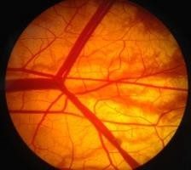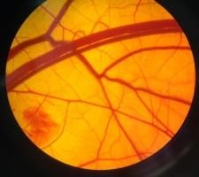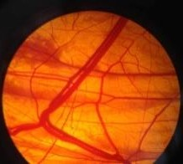
A1 A2 A3
Group B (25% Plant Extract Concentration)

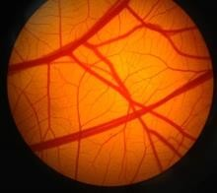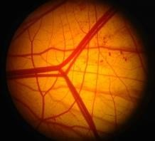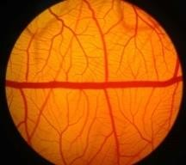
B1 B2 B3
Group C (50% Plant Extract Concentration)

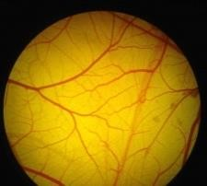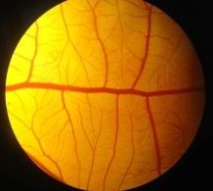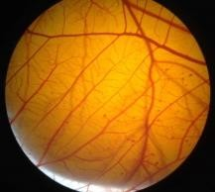
C1 C2 C3
Group D (75% Plant Extract Concentration)

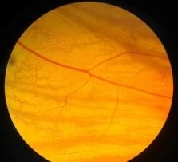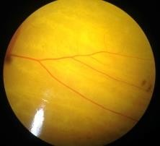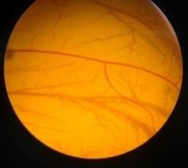
D1 D2 D3

Group E (100% Plant Extract Concentration)

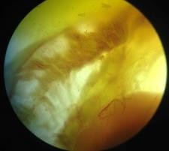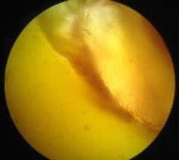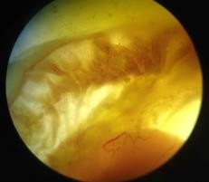
E1 E2 E3

Table 1. Total Length, Junctions, Branches and Mean Branch Length of Blood Vessels of treated and control CAM
 | Sample | Total Length (µm) | Junctions | Branches | Mean Branch  Length
 | A1 | 29028 | 771 | 604 | 48
Negative  Control (DMSO) | A2 | 18897 | 447 | 401 | 47
Negative  Control (DMSO) | A3 | 18040 | 519 | 435 | 41
25%  Concentrat ion | B1 | 24238 | 516 | 410 | 59
25%  Concentrat ion | B2 | 19537 | 393 | 353 | 55
B3 |  | 23260 | 516 | 496 | 46
50%  Concentrat ion | C1 | 10850 | 314 | 275 | 39
50%  Concentrat ion | C2 | 12030 | 350 | 328 | 36
C3 |  | 11903 | 254 | 237 | 45
75%  Concentrat ion | D1 | 2476 | 146 | 135 | 21
75%  Concentrat ion | D2 | 4780 | 135 | 181 | 22
D3 |  | 3793 | 159 | 178 | 24
100%  Concentrat  ion | E1 | 382 | 91 | 95 | 29
100%  Concentrat  ion | E2 | 436 | 22 | 31 | 14
 | E3 | 544 | 21 | 20 | 16

Parameters obtained from the software Angiosys 2.0., such as total length, number of junctions, branches and mean total length showed significant reduction in their values compared to the negative control as we increased the plant extract concentration.

For further analysis, Scanning Probe Image Processor (SPIP) was utilized for computerized quantification of the CAM vasculature to differentiate the primary, secondary and tertiary blood vessels of treated and control groups. The results were tabulated for organization and comparison (Table 2).

Table 2. Blood vessel diameters of treated and control CAM

 | Group A Negative Control (µm) |  |  | Group B  25% Plant Extract Conc.  (µm) |  |  | Group C  50% Plant Extract Conc.  (µm) |  |  | Group D  75% Plant Extract Conc.  (µm) |  |  | Group E  100% Plant Extract Conc.  (µm)
 | A1 | A2 | A3 | B1 | B2 | B3 | C1 | C2 | C3 | D1 | D2 | D3 | E1 | E2 | E3
PRIMARY | 138.66 | 153.06 | 64.37 | 72.03 | 77.56 | 89.31 | 33.98 | 61.11 | 39.15 | 19.01 | 17.23 | 12.09 | * | * | *
SCONDARY | 77.82 | 59.24 | 33.09 | 47.27 | 44.78 | 29.56 | 27.58 | 29.30 | 11.89 | 8.12 | 8.67 | 7.08 | * | * | *
TERTIARY | 26.44 | 46.68 | 19.73 | 23.81 | 28.19 | 21.46 | 15.92 | 9.87 | 8.65 | 5.03 | 5.98 | 4.09 | * | * | *

(*) Diameters were not measured

Results from SPIP showed significant reduction in the blood vessel diameters of the CAM as we increased the plant extract concentration as to compare with the negative control. Vascularization in the 100% concentration treated Group E was very minimal. The researchers were not able to quantify any primary, secondary and tertiary blood vessels.

MTT Assay

Through the performance of MTT Assay, cytotoxicity of Saccharum spontaneum against Human Breast Cancer Cell Lines (MCF7) was observed. A positive control of Doxorubicin was used. Samples were read at 750nm absorbance rates and IC₅₀ levels computed using the software ―Ipcin‖. Three trials with three replicates per concentrations were performed for each test sample (Table 3).

Table 3. Absorbance readings of the treatments and their respective IC₅₀
Sample | µg/mL | Trial 1 |  |  | Trial 2 |  |  | Trial 3
DMSO | 0 | 1.128 | 1.097 | 0.777 | 0.871 | 0.827 | 0.724 | 0.672 | 0.672 | 0.671
 | 25 | 0.273 | 0.258 |  | 0.155 | 0.165 |  | 0.264 | 0.261
Doxorubicin | 12.5 | 0.238 | 0.214 |  | 0.198 | 0.219 |  | 0.273 | 0.242
 | 6.25 | 0.244 | 0.204 |  | 0.237 | 0.228 |  | 0.273 | 0.246
 | 3.13 | 0.191 | 0.185 |  | 0.241 | 0.234 |  | 0.382 | 0.212
IC50 |  | 2.018 |  |  | 2.2512 |  |  | 2.7924

Sample | µg/mL | Trial 1 |  |  | Trial 2 |  |  | Trial 3
DMSO | 0 | 1.128 | 1.097 | 0.777 | 0.871 | 0.827 | 0.724 | 0.672 | 0.672 | 0.671
 | 50 | 0.402 | 0.511 | 0.591 | 0.49 | 0.413 | 0.529 | 0.472 | 0.401 | 0.425
S.  spontaneum | 25 | 0.482 | 0.501 | 0.402 | 0.523 | 0.423 | 0.511 | 0.419 | 0.502 | 0.581
 | 12.5 | 0.426 | 0.414 | 0.482 | 0.589 | 0.256 | 0.491 | 0.417 | 0.501 | 0.463
 | 6.25 | 0.472 | 0.425 | 0.489 | 0.582 | 0.472 | 0.426 | 0.422 | 0.472 | 0.424
IC50 |  | 18.32 |  |  | 12.41 |  |  | 16.12

Trials 1, 2, and 3 of the Doxorubicin sample had IC₅₀ values of 2.018, 2.2512 and 2.7924 while trials 1, 2 and 3 of the plant extract had IC₅₀ values of 18.32, 12.41 and 16.12, respectively. The American National Cancer Institute (NCI) guidelines set the limit of activity for crude extracts at 50% inhibition (IC50) of proliferation of less than 30 µg/mL after the exposure time of 72 hours (Abdel- Hameed ES. et al., 2012). However a crude extract with IC50 less than 20 µg/mL is considered highly cytotoxic (Mahavorasirikul W et al., 2010) .Values for the plant extract fall under the 20ug/ml parameter set by said institute, implying that it possesses good cytotoxic activity and anticancer potential.

Through the statistical program SPSS, Analysis of Variance (ANOVA) was used to determine if there is a significant difference between the said variables. Confidence interval was set at 95% with a significant difference of 0.05.
Table 4 illustrates the significant differences between total length, junctions, and branches and mean branch length of the blood vessels of the samples infused with the plant extract and those infused with DMSO to act as a negative control.

Table 4. Significant Difference Between Total Length, Junctions, Branches and Mean Branch Length of the Blood Vessels of Saccharum spontaneum samples and DMSO Negatice Control Sample
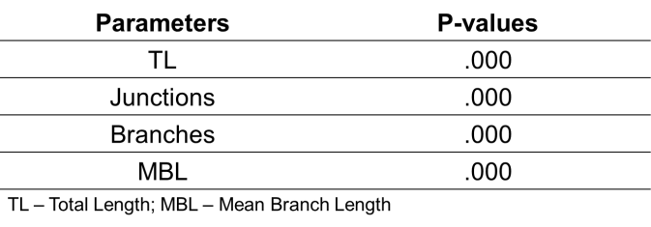

A p-value of 0.00 from all four variables (Total Length, Junctions, Branches, Mean Branch Length) was obtained. This indicates that the p-value is less than the significant difference (0.00<0.05), rejecting the null hypothesis ―There is no significant difference between the antiangiogenic activity of the extract and DMSO only at the different concentrations in the following parameters: Total Length, Junctions, Branches, and Mean Branch Length.‖

Meanwhile, Table 5 illustrates the significant differences between primary, secondary and tertiary blood vessel diameters of the samples infused with the plant extract and those infused with DMSO to act as a negative control.

Table 5. Significant Difference Between Primary, Secondary and Tertiary Blood Vessel Diameter of Saccharum spontaneum Samples and DMSO Negative Control Sample
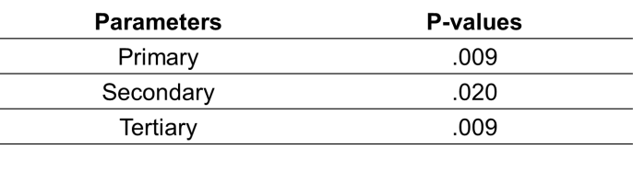
All p-values are less than the set significance level of 0.05, (0.009 < 0.05; 0.020 < 0.05), indicating that there is significant difference between the antiangiogenic activity of the extract and DMSO only at different concentrations in the following parameters: a.) Primary; b.) Secondary; and c.) Tertiary Blood vessel diameters.

Table 6 illustrates the significant difference between IC50 values of the plant extract and Doxorubicin which were obtained through the use of the software ―Ipcin‖. The values were compared through the use of Analysis of Variance (ANOVA).

Table 3. Significant Difference Between Cytotoxic Activity of Doxorubicin and S.spontaneum Extract Using the Mean IC50 parameter
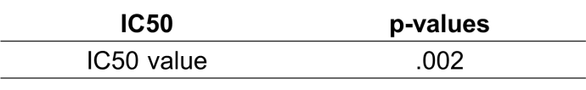

A p-value of 0.002 was obtained, indicating that the p- value is less than the level of significance of 0.05. This implies that there is significant difference between the cytotoxic activity of Doxorubicin and Saccharum spontaneum extract using the mean IC50 parameter. This implies that there is a significant difference between the cytotoxic activity of Saccharum spontaneum and Doxorubicin.

Conclusion
Taken together, our findings, demonstrate that the ethanolic extract of Saccharum spontaneum has potential anti- angiogenic property. Parameters in CAM was decreased in a dose dependent manner. Results from MTT assay suggests that the plant extract also showed cytotoxic activity against MCF-7 which was based on the criteria set by the National Cancer Institute (>20µg/mL). This plant may provide a new source of antiangiogenesis, cytotoxic agent which can be considered as potential candidates in the treatment of angiogenesis and antitumor related diseases. Further studies are required to identify and isolate the active components present in the extracts responsible for its anti-angiogenic and cytotoxic activity.

References
Abdel-Hameed ES, et al (2012). Phytochemical studies and evaluation of antioxidant, anticancer and antimicrobial properties of Conocarpus erectus L. growing in Taif, Saudi Arabia. Eur J Med Plants. 2012;2:93–112.

Al-Oqail, MM. et al. (2013). In Vitro Cytotoxic Activity of Seed Oil of Fenugreek Against Various Cancer Cell Lines. Asian Pac J Cancer Prev. 2013;14(3):1829-32.

Cragg, G. M., & Newman, D. J. (2005). Plant as source of anti- cancer agents. Journal of Ethnopharmacology, 72-79.

Davidson, N., Lee, A. & Oesterreich, S. (2015). MCF-7 Cells— Changing the Course of Breast Cancer Research and Care for 45 years. J Natl Cancer Inst. 2015 Mar 31;107(7). pii: djv073. doi: 10.1093/jnci/djv073

Deryugina E. & Quigley JP., (2008). Chapter 2. Chick embryo chorioallantoic membrane models to quantify angiogenesis induced by inflammatory and tumor cells or purified effector molecules. Methods Enzymol. 2008;444:21-41. doi: 10.1016/S0076-6879(08)02802-4.

Ejaz, S, K.B. Seok and L.C. Woong, (2004). A novel image probing system for precise quantification of angiogenesis. Tumori, 90(6):611-617

Fernando W. & Rupasinghe V. (2013). Anticancer Properties of Phytochemicals Present in Medicinal Plants of North America, Using Old Solutions to New Problems - Natural Drug Discovery in the 21st Century, Dr. Marianna Kulka (Ed.), InTech, DOI: 10.5772/55859

Folkman J. What is the evidence that tumors are angiogenesis dependent? J Natl Cancer Inst. 1990;82(1):4–6. doi: 10.1093/jnci/82.1.4

Fotakis, G., Timbrell, J.A(2006). In vitro cytotoxicity assays: comparison of LDH, neu- tral red. MTT and protein assay in hepatoma cell lines following exposure to cadmium chloride. Toxicology. Letters 160, 171–177.

Graidist P., Martla M., & Sukpondma, Y. (2015). Cytotoxic Activity of Piper cubeba Extract in Breast Cancer Cell Lines. Nutrients. 2015 Apr 10;7(4):2707-18. doi: 10.3390/nu7042707.

Holmgren L, O'Reilly MS, Folkman J. (1995) Dormancy of micrometastases: balance proliferation and apoptosis in the presence of angiogenesis suppression. Nat Med.
1995;1:149–53

Kassack, M., Mueller, H. & Wiese, M. (2004). Comparison of the Usefulness of the MTT, ATP, and Calcein Assays to Predict the Potency of Cytotoxic Agents in Various Human Cancer Cell Lines. Journal of Biomedical Screening 9(6), 506-515.

Khalid, M., & Siddiqui, H. H. (2011). Pharmacognostical Evaluation and Qualitative Analysis of Saccharum spontaneum (L) Root. International Journal of Pharmaceutical Sciences and Drug Research, 3(4), 338- 341.

Kumara, N. (2001). Identification of strategies to improve research on medicinal plants used in Sri Lanka. Proceedings of the WHO Symposium. Galle, Sri Lanka: University of Ruhuna.

Mahavorasirikul W. et al (2010). Cytotoxic activity of Thai medicinal plants against human cholangiocarcinoma, laryngeal and hepatocarcinoma cells in vitro. BMC Complement Altern Med. 2010;10:55.

Mosmann, T. (1983). Rapid colorimetric assay for cellular growth and survival: application to proliferation and cytotoxicity tests. J. Immunol. Methods, 1983; 65, 55–
63

Parangi S, O'Reilly M, Christofori G, et al. (1996). Angiogenesis therapy of transgenic mice impairs de novo tumor growth. Proc Natl Acad Sci U S A. 1996;93:2002–7

Ripa F., Haque M., & Ul-Haque I. (2009). In Vitro Antimicrobial, Cytotoxic and Antioxidant Activity of Flower Extract of Saccharum Spontaneum Linn. European Journal of Scientific Research ISSN 1450-216X Vol.30 No.3 (2009), pp.478-483

Sathya M. & Kokilavani R. (2012). Phytochemical Screening and In Vitro Antioxidant Activity of Saccharum Spontaneum Linn. Int. J. Pharm. Sci. Rev. Res., 18(1) ISSN 0976 – 044X

World Health Organization. (2015, February). Cancer. Retrieved March 28, 2016, from World Health Organization: www.who.int/mediacentre/factsheets/fs297/en

