Title: Anti-cancer potential and mechanism of cytotoxicity of a new 2-aminoimidazoline derivative OAT-449.
Name: Urszula Wojda¹
and Katarzyna Laskowska-Kaszub1, Mykola Zdioruk¹, Joanna Wojsiat¹, Anna Mietelska-Porowska¹, Sylwia Olejniczak², Stanisław Pikul², Jakub Golab²
¹Nencki Institute of Experimental Biology, Polish Academy of Science and ²OncoArendi Therapeutics, Warsaw, Poland

Abstract
Problem: Despite recent progress in cancer treatment using drugs inducing tumor cell death through interaction with tubulin, most of them have complex structures and show poor pharmacological properties. Therefore, the search for new therapeutics of improved pharmacological properties and more effective in microtubule-targeting and cytotoxicity to cancer cells remains necessary. The aim of this study was synthesis and verification of cytotoxicity of a novel, low molecular weight, water-soluble 2-aminoimidazoline derivative with a relatively simple chemical structure (OAT-449, reference 1). Methodology: Cytotoxicity of OAT-449 was assessed by MTT assay. Flow cytometry, confocal microscopy and immunoblotting was used to analyze cell cycle and cell death in response to OAT-449 treatment. Findings: OAT-449 strongly inhibited polymerization of purified tubulin in vitro and disrupted microtubule formation in HT-29 human tumor cells. HT-29 cells treated with OAT arrested at G2/M transition in the cell cycle and revealed increased phosphorylation of such mitosis-related proteins as histone H3, aurora and NuMa. Moreover, OAT-449 induced cell death through mitotic catastrophe, as well as through apoptosis, with nuclear condensation and DNA fragmentation. OAT-449 induced massive cell death with IC50 values ranging from 6 to 22 nM in 8 different cancer cell lines: HT-29, HepG2 (hepatocellular carcinoma), DU145 (prostate carcinoma), Panc-1 (epithelioid carcinoma), SKOV3 (ovary adenocarcinoma), A549 (lung carcinoma), MCF7 (breast adenocarcinoma) and SK-N-MC (neuroepithelioma). Comparing to a well-known microtubule-targeting agent Vincristine, OAT-449 showed similar or increased cytotoxicity. Conclusion & Significance: OAT-449 efficiently targets microtubules in different types of cancer cells what results in massive mitotic catastrophe and cell death. These findings open further steps of development of OAT-449 as a drug for cancer or other diseases characterized by excessive cell proliferation.
This research was supported by the National Centre for Research and Development (NCBR) grant POIG.01.03.01-14-094/12.

Image
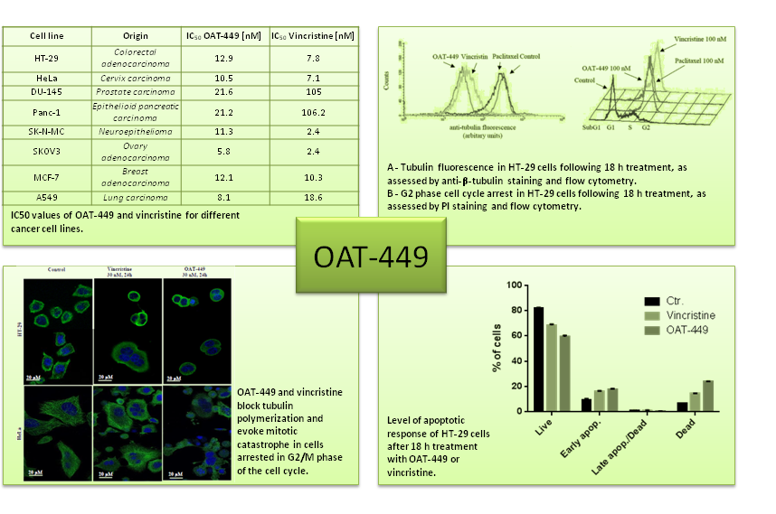
Mechanism of OAT-449 cytotoxicity.
Recent Publications
- United States Patent No. US 8,981,114 B2 and No. US 9,095,575 B2, Pikul et al. Derivatives of 1-(substituted sulfonyl)-2-aminoimidazoline as antitumor and antiproliferative agents.
- Czystowska-Kuzmicz M, (…) and Golab J. Small extracellular vesicles containing arginase-1 suppress T-cell responses and promote tumor growth in ovarian carcinoma. Nat Commun. 2019 Jul 5;10(1):3000.
- Nagaraj S, Zoltowska KM, Laskowska-Kaszub K, Wojda U. microRNA diagnostic panel for Alzheimer's disease and epigenetic trade-off between neurodegeneration and cancer. Ageing Res Rev. 2019 49:125-143.



Paste your Photograph Here
Biography (150 word limit)
Urszula Wojda is a Full Professor of Biological Sciences, Head of the Laboratory of Preclinical Testing of Higher Standard at the Nencki Institute in Warsaw. Her research is focused on molecular mechanisms of neurodegeneration and cancer and on search for novel anti-cancer and neuroprotective compounds. She completed her PhD from the Nencki Institute and conducted research at the Pasteur Institute in France and at the National Institutes of Health, USA (postdoctoral training). She has published more than 45 papers in reputed journals. She serves as Polish expert at the Management Board of the EU Joint Programming for Neurodegenerative Diseases (JPND) and as a member of several international editorial boards.
Email: u.wojda@nencki.gov.pl

Notes/Comments:

