Title: Inhibitory effects of cinnamic acid and its derivatives on tuberculosis and invasion of lung cancer
Name: Chia-Jui Weng
Department of Living Services Industry, Tainan University of Technology, Tainan City, Taiwan

Abstract
Cinnamic acid is a member of phenolics which having several isoforms in nature. The trans-cinnamic acid (t-CA) has been investigated extensively for its potential pharmacological effects whereas the study of cis-cinnamic acid (c-CA) is limited because pure c-CA was hard to obtain. We had developed a practicable method for the transformation of c-CA from t-CA and the isolation of c-CA. Multiple-drug resistant tuberculosis (MDR-TB) is a contagious disease caused by Mycobacterium tuberculosis. Both of c-CA and t-CA decreased the viability of MDR-TB bacilli, but the antituberculosis activity of c-CA was approximately 120-fold of t-CA. Furthermore, the c-CA exhibited higher synergistic effect with two first-line anti-TB antibiotics, isoniazid (INH) and rifampicin (RIF), against tuberculosis than t-CA. Approximately 70% of lung cancer patients die from metastasis. Both of c-CA and t-CA are inhibitors for invasion of human adenocarcinoma A549 cells and the activity of c-CA seems to be higher than t-CA. The c-CA- and t-CA-inhibited invasion might partly through modulating tissue inhibitor of metalloproteinase (TIMP)-1 and plasminogen activator inhibitor (PAI)-2-regulated urokinase-type plasminogen activator (uPA) activity. Several select CA derivatives, caffeic acid (CAA), chlorogenic acid (CHA), and ferulic acid (FA), were also able to inhibit invasion of A549 cells at a concentration of ≥100 μM. The proposed molecular mechanism involved not only decreasing the signaling of MAPK and PI3K/Akt but also inactivating NF-kB, AP-1, and STAT3. In conclusion, c-CA might be a potential anti-mycobacterial or synergistic agent and c-CA and t-CA should be a safe and potential agent to prevent lung tumor cells from metastasizing. The association between structural features and anti-invasive activity of CA derivatives needs to be further verified.

Image
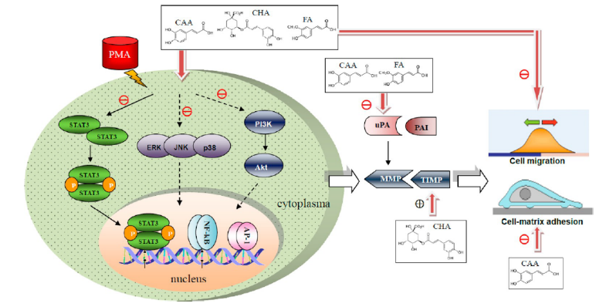
Figure 7. Schematic representation of the signaling pathways and invasive behaviors involved in the inhibition of invasion of PMA-treated human adenocarcinoma cells by CAA, CHA, and FA.
Recent Publications
- Siegel, R.; Naishadham, D.; Jemal, A. Cancer statistics. CA Cancer J. Clin. 2012, 62, 10−29.
- Hagedorn, E. J; Sherwood, D. R. Cell invasion through basement membrane: the anchor cell breaches the barrier. Curr. Opin. Cell Biol. 2011, 23, 589−96.
- Weng, C. J.; Yen, G. C. Chemopreventive effects of dietary phytochemicals against cancer invasion and metastasis: phenolic acids, monophenol, polyphenol, and their derivatives. Cancer Treat. Rev. 2012,38, 76−87.
- Weng, C. J.; Yen, G. C. Flavonoids, a ubiquitous dietary phenolic subclass, exert extensive in vitro anti-invasive and in vivo anti-metastatic activities. Cancer Metastasis Rev. 2012, 31, 323−51.




Biography
Chia-Jui Weng is a professor/Ph.D. He received his PhD at Department of Food Science and Biotechnology, National Chung Hsing University, Taichung, Taiwan in 2008. He was the Lead Guest Editor of BioMed Research International and Guest Editor of Evidence-Based Complementary and Alternative Medicine (eCAM) Journal. He also to be the Editorial Board Member of Journal of Turgut Ozal Medical Center (ISSN: 1300-1744), Journal of Tumor (ISSN 1819-6187), and Journal of Hepatocellular Carcinoma (ISSN: 2253-5969). His expertises are focusing on Hepatocarcinoma, Natural bioactives and phytochemicals, cancer invasion and metastasis, and single nucleotide polymorphism.
Email: t10044@mail.tut.edu.tw

Notes/Comments:

