Inhibition of ribosomal S6 kinase 1 attenuates cell proliferation, migration and invasion of tongue squamous cell carcinoma cells.

Name: Ekarat Hitakomate
Faculty of Dentistry, Thammasat University, Pathumthani, Thailand

Abstract
Statement of the problem: Tongue squamous cell carcinoma (TSCC) is one of the major health concerns worldwide with high morbidity and mortality rates. Currently, effective therapeutic interventions for TSCC are limited. Therefore, identification of such molecular targets is of clinical relevance. Recent data have shown that the ribosomal protein S6 kinase, 90 kDa, polypeptide 1 (RSK1) a member of Ser/Thr protein kinases plays an important role in regulating cell invasion and metastasis in human cancers. How RSK1 play a role in TSCC remains currently unclear. The purpose of this study was to examine a function of RSK1 in TSCC proliferation, migration, and invasion of the TSCC cell line HSC-3 and its lymph node metastatic counterpart HSC-3-M3 cell line using siRNA approach. Findings: RSK1 expression was efficiently repressed using specific siRNAs compared to that of non-specific siRNA group. We found that silencing RSK1 significantly inhibited cell proliferation in both HSC-3

and HSC-3-M3 cell lines. Live cell migration of HSC-3 and HSC-3-M3 transfected with RSK1 specific siRNA was compared with that of non-specific siRNA transfected cells using live cell imaging. Inhibition of RSK1 expression in both HSC-3 and HSC-3-M3 also affected live cell migration. Importantly, silencing RSK1 interfered with invasive capacity of both HSC-3 and HSC-3-M3 cells lines. How RSK1 is involved in regulating TSCC invasiveness will be discussed. Conclusion & significance: RSK1 may play a role in promoting cell proliferation, cell migration and invasion in TSCC cell lines.
Recent Publication
- Singchat W, Hitakomate E, Rerkarmnuaychoke B, Suntronpong A, Fu B, Bodhisuwan W, Peyachoknagul S, Yang F, Koontongkaew S, Srikulnath K. (2016) Genomic alteration in head and neck squamous cell carcinoma (HNSCC) cell lines inferred from karyotyping, molecular cytogenetics, and array comparative genomic hybridization. PLOS One. 11(8): e0160901.
doi: 10.1371/journal.pone.0160901.

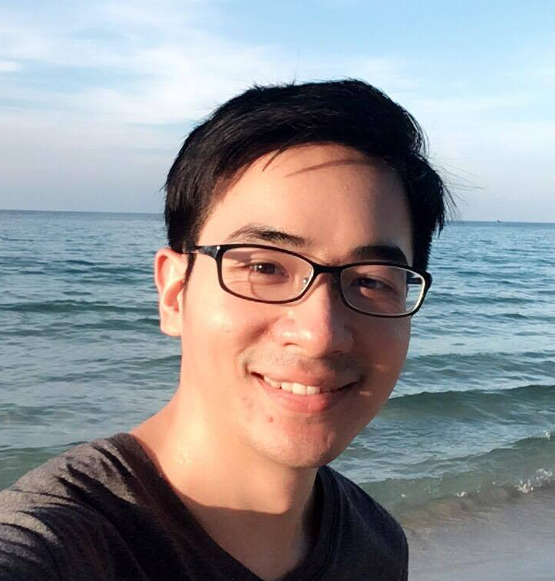
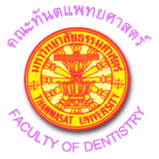
Biography
Dr. Ekarat Hitakomate received his PhD in cell and molecular biology from the university of Dundee in 2010. His PhD thesis was focusing on the molecular mechanisms of RCC1 interaction with chromatin and characterization of its binding partners. His current research interests are biology of oral cancer and the regulation of cancer metastasis.
Email: ekapai9@yahoo.co.uk

