Breast cancer induces tolerogenic state of healthy activated CD4+ lymphocytes, characterized by reduced PI3K, NFκB, JAK-STAT, Notch, and increased TGFβpathway activity.

Anja van de Stolpe¹, Wim Verhaegh¹, Arie van Doorn¹, Grégory Noël², Chunyan Gu-Trantien², and Karen Willard-Gallo². [1] Philips Research, Eindhoven, The Netherlands; [2] Institut Jules Bordet, Brussels

Abstract
Cancer cells can induce a state of immunotolerance, which may be reversed by checkpoint blocker immunotherapy. Prediction of immunotherapy response remains a challenge. CD4+ lymphocytes are important for activating the adaptive immune-response, while conversion to immune-suppressed state impairs the anti-cancer immune-response. Lymphocyte function is controlled by a number of signaling pathways. We developed tests to quantitatively measure activity of signaling pathways (e.g. Hedgehog, Wnt, TGFβ, Notch, NFκB, PI3K, JAK-STAT 1/2 and 3, and MAPK) based on Bayesian model inference of activity from measurements (microarray, qPCR) of mRNA levels of target genes of the transcription factor associated with the respective signalling pathway[1],[2],[3],[4],[5],[6]. Tests were biologically validated on individual cell/tissue samples, including immune cells and can be used to characterize functional activity status of immune cell types. The cellular mechanism underlying breast cancer-induced immunosuppression of CD4+ lymphocytes was investigated. Method. Generation of Affymetrix expression microarray data has been described [7]. In brief, dissected breast cancer tissue fragments from fresh surgical specimens were mechanically dissociated in X-VIVO-20 (SN). Following standard activation, healthy donor CD4+ lymphocytes were incubated with SN. Signaling pathway activities were measured on Affymetrix data from the CD4+ lymphocyte samples.
Results: CD4+ lymphocyte activation resulted in induction of PI3K, NFkB, JAK-STAT1/2, JAK-STAT3, and decrease of TGFβ pathway activities. Incubation with cancer SN only reduced activity of PI3K, NFkB, JAK-STAT1/2, JAK-STAT3 pathways, while increasing TGFβ pathway activity, in activated lymphocytes, but. Conclusion. A soluble factor from breast cancer tissue induces immunotolerance in CD4+ lymphocytes, by increasing TGFβ pathway activity, and reducing activity of effector immune pathways. Investigation as to the nature of the soluble factor is in progress. Signaling pathway assays can quantitatively measure the functional immune activity state of CD4+ lymphocytes. Envisioned application is in prediction and monitoring of immunotherapy response and identification of novel drug targets to reverse cancer-induced immunosuppression.



Figure
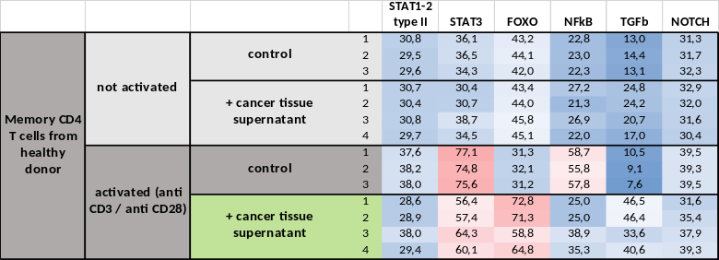Figure 1. Control or activated CD4+ T lymphocytes from healthy individuals, incubated with primary breast cancer culture supernatant or vehicle

[1] W. Verhaegh et al., “Selection of personalized patient therapy through the use of knowledge-based computational models that identify tumor-driving signal transduction pathways,” Cancer Res., vol. 74, no. 11, pp. 2936–2945, Jun. 2014.
[2] W. Verhaegh and A. Van de Stolpe, “Knowledge-based computational models,” Oncotarget, vol. 5, no. 14, pp. 5196–5197, Jul. 2014.
[3] Ooijen H van, Marten Hornsveld, Christa Dam, Meng Dou, Rick Velter, Wim Verhaegh, Boudewijn Burgering, Anja van de Stolpe., “Assessment of functional PI3K pathway activity in cancer tissue using FOXO target gene expression in a knowledge-based computational model. In press Am.J.Pathol.”
[4] Anja van de Stolpe, Laurent Holtzer, Henk van Ooijen, Marcia Alves de Inda, Wim Verhaegh, “Enabling precision medicine by unravelling disease pathophysiology: quantifying signal transduction pathway activity across cell and tissue types.”
[5] P. Beachy et al., “Abstract P5-03-11: Targeted disruption of transcriptional effector GLI2 attenuates breast tumor growth and metastasis,” Cancer Res., vol. 78, no. 4 Supplement, pp. P5-03-11-P5-03–11, Feb. 2018.
[6] A. Creemers et al., “628PSignal transduction pathway activity during neoadjuvant treatment in esophageal adenocarcinomas,” Ann. Oncol., vol. 29, no. suppl_8, Oct. 2018.
[7] C. Gu-Trantien et al., “CD4⁺ follicular helper T cell infiltration predicts breast cancer survival,” J. Clin. Invest., vol. 123, no. 7, pp. 2873–2892, Jul. 2013.

Dr. Anja van de Stolpe is a registered MD/clinical internist (hematology) with >10 years of clinical experience in academic and peripheral hospital setting, with a PhD in cell and molecular biology, and extensive stem cell experience. Before joining Philips, she worked at Stanford University, Rochester University (US), and the Hubrecht Institute (Netherlands). She was co-founder of the stem cell company Pluriomics and the Dutch hDMT Institute, won a number of awards, and published books on stem cell technology. She publishes in peer-reviewed journals, and is (co-)inventor on an increasing number of patent applications. Currently she is Research Fellow (Senior Director) and Clinical Adviser/Thought Leader at Philips Research (High Tech Campus) in Eindhoven, The Netherlands. As such she is scientifically involved in translational research, initiation of new research directions and (inter)national collaborations, with a major focus on oncology. Together with Wim Verhaegh she initiated and leads development of the presented signaling pathway analysis.
Email: anja.van.de.stolpe@philips.com

