Estimates of Cancer Incidence in Ethiopia in 2015 Using Population-Based Registry Data
Dr. Solomon Tessema Memirie, M.D, Ph.D, CMEPS, Addis Ababa University, Ethiopia

Background: Non-communicable diseases, prominently cancer, have become the second leading cause of death in the adult population of Ethiopia. A population-based cancer registry has been used in Addis Ababa (the capital city) since 2011. Availability of up-to-date estimates on cancer incidence is important in guiding the national cancer control program in Ethiopia.
Methods: We obtained primary data on 8,539 patients from the Addis Ababa population-based cancer registry and supplemented by data on 1,648 cancer cases collected from six Ethiopian regions. We estimated the number of the commonest forms of cancer diagnosed among males and females in Ethiopia and computed crude and age-standardized incidence rates.
Results: For 2015 in Ethiopia, we estimated that 21,563 (95% CI, 17,416 to 25,660) and 42,722 (95% CI, 37,412 to 48,040) incident cancer cases were diagnosed in males and females, respectively. The most common adult cancers were: cancers of the breast and cervix, colorectal cancer, non-Hodgkin lymphoma, leukemia, and cancers of the prostate, thyroid, lung, stomach, and liver. Leukemia was the leading cancer diagnosis in the pediatric age group (age 0 to 14 years). Breast cancer was by far the commonest cancer, constituting 33% of the cancers in women and 23% of all cancers identified from the Addis Ababa cancer registry. It was also the commonest cancer in four of the six Ethiopian regions included in the analysis. Colorectal cancer and non-Hodgkin lymphoma were the commonest malignancies in men.
Conclusion: Cancer, and more prominently breast cancer, poses a substantial public health threat in Ethiopia. The fight against cancer calls for expansion of population-based registry sites to improve quantifying the cancer burden in Ethiopia and requires both increased investment and application of existing cancer control knowledge across all segments of the Ethiopian population.

Recent Publications
- Memirie ST, Habtemariam MK, Asefa M, et al. Estimates of cancer incidence in Ethiopia in 2015 using population-based registry data. Journal of Global Oncology 2018; https://doi.org/10.1200/JGO.17.00175.
- Memirie ST, Metaferia ZS, Norheim OF, et al. Catastrophic health expenditure and impoverishment associated with pneumonia and diarrhea treatment costs in Ethiopia. BMJ Global Health 2017; 1:e000166. doi:10.1136/bmjgh-2016-000166.
- Memirie ST, Verguet S, Norheim OF, et al. Inequalities in Utilization of Maternal and Child health services in Ethiopia: the role of primary health care. BMC Health Services Research 2016, 16:51; DOI 10.1186/s12913-016-1296-7.
- Johansson KJ, Memirie ST, Pecenka C, et al. Health gains and financial protection from pneumococcal vaccination and pneumonia treatment in Ethiopia: results from an extended cost-effectiveness analysis. PLoSONE 2015; 10(12):e0142691. doi:10.1371/journal.pone.0142691.
- Pecenka CJ, Johansson KA, Memirie ST, et al. Health gains and financial risk protection: an extended cost-effectiveness analysis of treatment and prevention of diarrhoea in Ethiopia. BMJ Open 2015;5: e006402. Doi:10.1136/bmjopen-2014-006402.
- Verguet S, Olson ZD, Babigumira JB, Desalegn D, Johansson KJ, Kruk ME, Levin CE, Nugent RA, Pecenka C, Shrime MG, Memirie ST, Watkins DA, Jamison DT. Health gains and financial risk protection afforded by public financing of selected interventions in Ethiopia: an extended cost-effectiveness analysis. Lancet Glob Health 2015;3:e288–96.

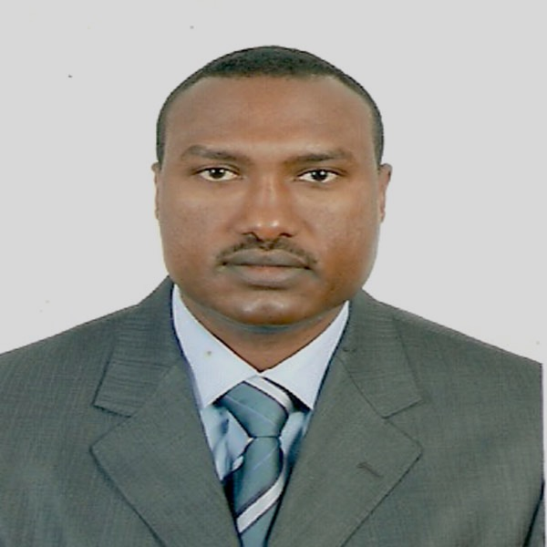
I am a Medical Doctor with specialization in Pediatrics and Child Health from Addis Ababa University (AAU), Ethiopia and have a PhD in Public Health/Health Economics from the University of Bergen. In 2016-2017, I was a Takemi Fellow at the Harvard T.H. Chan School of Public Health. I have over 20 years of experience as a clinician and public health specialist, and held various positions in governmental institutes, non-governmental organizations and the private sector, in Ethiopia. I am a health system researcher with additional academic experience as a lecturer to both undergraduate and postgraduate students at the School of Medicine at AAU. I have also served as a senior PMTCT/Pediatric Clinical Advisor for ICAP-Ethiopia and as a Consultant on Newborn and Child Health to the Ministry of Health of Ethiopia. Currently, I am working as a Senior Researcher at the Center for Medical Ethics and Priority Setting (CMEPS), AAU, Ethiopia.
Email: tess_soul@yahoo.com

