With homeostasis until healing - a case report of a skin pathology

Emina Dervisevic¹, Muamer Dervišević²
¹Department of Forensic Medicine, Faculty of Medicine, University of Sarajevo, Sarajevo, Bosnia and Herzegovina
²Clinic of Lung Diseases; University Clinical Centre Sarajevo, Bosnia and Herzegovina

This paper aims to answer in how far children with eczema and dermal infection use Eif therapy (Therapy of electromagnetic field) and which techniques. Furthermore the evidence basis on the efficacy of Eif in the use for eczema and infection of dermal zone should be reviewed. In Germany about 46% of the general population and up to 51% of inpatients with eczema use complementary medicine. Acupuncture, homeopathy, bioresonance with Eif therapy with diets and supplements comprise the most popular techniques. A British health services research study compared the treatment patterns of dermatologists in Japan, the USA and the UK. The concept of Eif therapy is based on the assumption that a person diseases when electromagnetic frequencies or electric fields in his or her body get out of balance. The users assume that these disturbances in balance modify the chemical composition of the human body. They further believe that these disturbances can be corrected by administering electric energy from outside the body, normally using electronic devices.
We are witnessing that more and more children have skin problems, dermatitis, allergies and infections. It is very important that there is balance in the organism, that homeostasis reigns at the cellular level. If that criterion is met, we have a healthy person. For that purpose we use our date from Private practise. The case report is an 8-year-old boy who has been treated for skin changes such as eczema and dermatosis for two years without results. Papules, pustules and dried sores on the hands are examined. After the examination, a therapeutic protocol is established in combination with a changed diet. After two months, changes are evident that do not recur.
Through therapies, we try to draw out the potential of the optimal cellular level and thus achieve results. We use medical knowledge in combination with complementary medicine and this gives the best results and success of the therapeutic protocol.
Keywords: Eif, eczema, children, allergy, protocol

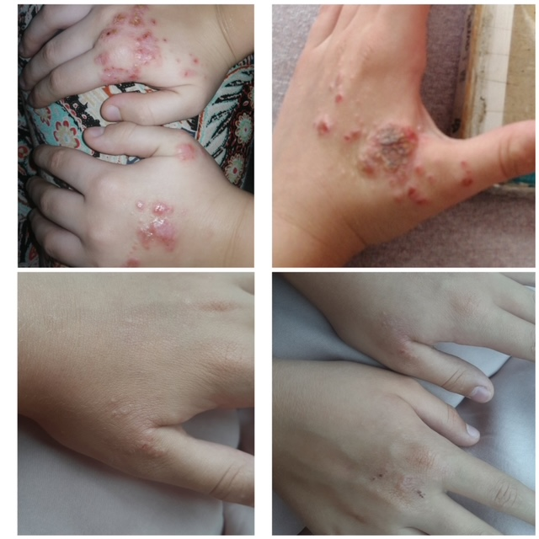

Figure 1. Condition before and after Eif therapy

Biography

EMINA DERVIŠEVIĆ, MD, PhD
04.11.1988-birth
Bosnia and Herzegovina-Country
Senior Assistant on Department of Forensic Medicine, Faculty of Medicine, University of Sarajevo, Sarajevo, Bosnia and Herzegovina
Dr. Emina Dervišević currently works at the Forensic Medicine, Faculty of Medicine, University of Sarajevo. She did researchs in Forensic Medicine,but also in Primary Care and General Medicine. She is Ph.D. in her 32.year of life. She is the author of 22 original scientific research and the one book.
She is the second year of specialization in Forensic Medicine. She actively participated in international congress announcements in the form of oral and poster presentations (BHAAAS-Teslić 2007, Congress of Family Medicine-Sarajevo, 2018, Congress of Forensic Medicine-Pula, 2018; FEBS-Prague, 2018, IALM-2021, Veterinary Congress-2021, Animal Health-2021, BFSC-2021)). She attended Juvenile Osteology Education in Durham, England, in 2018. She attended Advanced Course in Paleopathology in Limassol, Cyprus, in 2022. She received education on the minimum of pedagogical education and strengthening the competencies of the academic person of the University of Sarajevo. She is winner of „Young achiever Award, 2022“ by IRDCP.
Dr Emina has her expertise in evaluation and forensic importance in improving the causes of death. Scientific data on the role and association of hyperthermia as a cause of sudden cardiac death are scarce and further research is needed in this field. Current science suggests that hyperthermia and the cardiac response are causally related according to the very pathophysiological sequence of events in hyperthermia. In the forensic sense, there is scarce evidence of a pathophysiological mechanism leading to sudden cardiac death. This was exactly the PhD thesis to find an adequate model of hyperthermia.The aim of thesis was to prove that the cause of sudden cardiac death was caused by high temperature, and adequate methods of proving and comparing the condition in the body before and after death. Further evaluation is needed in the experimental sense but also on human material.
Email: emina.dervisevic@mf.unsa.ba

The most significant work/manuscript: : "Forensic significance of cTnI serum for the detection of terminal myocardial damage in rats (Rattus norvegicus) caused by hyperthermia" where I was the leader of the study. (Published / Journal of King Saud University – Science/Elsevier/Q1-IF-4,2)

Publications:
Occupational overuse syndrome (technological diseases): carpal tunnel syndrome, a mouse shoulder, cervical pain syndrome  M Tiric-Campara, F Krupic, M Biscevic, E Spahic, K Maglajlija, Z Masic, ...  Acta Informatica Medica 22 (5), 333 | 32 | 2014
Positive correlation between uric acid and C-reactive protein serum level in healthy individuals and patients with acute coronary syndromes  E Spahić, S Hasić, E Kiseljaković, H Resić, M Kulić  Med Glas (Zenica) 12 (2), 128-32 | 23 | 2015
Mean platelet volume predicts the glycemic control deterioration in diabetes mellitus type 2 patients.  D Kadić, S Hasić, E Spahić  Medicinski Glasnik 13 (1) | 21 | 2016
Serum uric acid could differentiate acute myocardial infarction and unstable angina pectoris in hyperuricemic acute coronary syndrome patients  S Hasic, D Kadic, E Kiseljakovic, R Jadric, E Spahic  Medical Archives 71 (2), 115 | 15 | 2017
Dog bites and their treatment in Federation of Bosnia and Herzegovina  M Katica, Z Obradović, NH Ahmed, E Dervišević, S Delibegović  Cyprus J Med Sci 4 (2), 136-40 | 8 | 2019
Impact of temperature and the length of exposure on morphological characteristics of erythrocytes in antemortem and postmortem analysis-Experimental study on Wistar rats  E SPAHIĆ, M Katica, A JOGUNČIĆ, A Katica, S HASIĆ  Kafkas Üniversitesi Veteriner Fakültesi Dergisi 26 (6) | 6 | 2020
Interdisciplinary aspects of possible negative effects of dogs on humans in Bosnia and Herzegovina  M Katica, Z Obradović, NH Ahmed, E Mehmedika-Suljić, Ž Stanić, ...Med Glas (Zenica) 17 (2), 246-251 | 5 | 2020
Experience of nurses in assessing postoperative pain in hip fracture patients suffering from dementia in nursing homes.  F Krupić, M Bišćević, E Spahić, A Jašarević, M Jašarević, K Grbić, ...  Medicinski Glasnik 17 (1) | 4 | 2020
Assessment of the Antidepressant Side Effects Occurrence in Patients Treated in Primary Care  E Ramic, S Prasko, L Gavran, E Spahic  Materia Socio-medica 32 (2), 131 | 3 | 2020
Antidepressant treatment outcomes in family medicine.  S Prasko, N Pranjić, L Gavran, A Alić, I Gledo, E Ramić, E Spahić, ...  Medicinski Glasnik 16 (2) | 3 | 2019
The role of organic urine sediment analysis in the monitoring of renal diseases  M KATİCA, NH AHMED, A SALKİĆ, A MUKAČA, A BAŠİĆ, E DERVİŠEVİĆ  Journal of Advances in VetBio Science and Techniques 4 (1), 40-50 | 3 | 2019
A contribution to the study of crystalluria: significance in the diagnosis of metabolic and renal diseases  M KATİCA, NH AHMED, N GRADAŠČEVİĆ, A SALKİĆ, E DERVİŠEVİĆ  Journal of Advances in VetBio Science and Techniques 5 (2), 81-89 | 2 | 2020
Challenges associated with investigating a mass grave at the Korićani cliffs in central Bosnia  A Jogunčić, A Salihbegović, E Dervišević, N Sarajlić  Journal of Forensic and Legal Medicine 66, 107-112 | 2 | 2019
Poikilocytotic forms caused by hyperthermia and heat stroke-experimental study on Wistar rats  E Dervišević, M Katica, S Hasić, A Jogunčić, L Dervišević, H Vukas, ...  International Journal of Research in Medical Sciences 10 (6), 1225 |  | 2022
THE ANATOMY AND CLINICAL SIGNIFICANCE OF VARIATIONS OF THE TIBIAL NUTRIENT FORAMINA-AN EXPERIMENTAL INVESTIGATION ON DRIED HUMAN BONES IN A BOSNIAN POPULATION.  L Dervišević, A Dervišević, Z Ajanović, E Dervišević, JB Tokić, ...  Romanian Journal of Functional & Clinical, Macro-& Microscopical Anatomy … |  | 2022
Influence of hyperthermia on dimensions of erythrocytes: Experimental preliminary study on rats  E Dervišević, M Katica, Z Ajanović, A Jogunčić, L Dervišević, M Dervišević, ...  VETERINARIA 71 (1), 41-52 |  | 2022
Forensic significance of cTnI serum for the detection of terminal myocardial damage in rats (Rattus norvegicus) caused by hyperthermia  E Dervišević, S Hasić, M Katica, A Salihbegović, Z Ajanović, N Sarajlić  Journal of King Saud University-Science 34 (2), 101753 |  | 2022
Histological observations on adipocere in human remains buried for 21 years at the Tomašica grave-site in Bosnia and Herzegovina  A Salihbegović, J Clark, N Sarajlić, S Radović, F Finlay, A Jogunčić, ...  Bosnian Journal of Basic Medical Sciences 18 (3), 234 |  | 2018
Increased mean platelet volume is associated with acute myocardial infarction in patients with diabetes mellitus type 2  E Spahic, S Hasic, A Joguncic, N Sarajlic, A Salihbegovic, F Krupic  FEBS OPEN BIO 8, 219-219 |  | 2018
Blood levels of cardiac troponin I in the elderly women with and without dementia
S Hasić, L Redžić, N Čamdžić, E Spahic, O Lepara, E Kiseljaković, ...
Folia Medica Facultatis Medicinae Universitatis Saraeviensis 52 (1)
Inflammation-based scores in diabetes mellitus type 2 patients  E Spahic, D Kadic, S Hasic, M Dervisevic  FEBS JOURNAL 283, 243-243 |  | 2016
Impact of Temperature on Morphological Characteristics of Erythrocytes and Heart Weight: Experimental Study on Wistar Rats
E Dervišević, S Hasić, L Dervišević, Z Ajanović, M Katica, A Salihbegović
Animal Models and Experimental Research in Medicine

