Culture and trends of herbal medicine and its effect on dental procedure
Dr Sabrin Ali Azim, City University Ajman, UAE
Dr Varinder Singh Rand, City University Ajman, UAE
Dr. Lovely M. Annama , Ajman University , UAE
Dr. Farah Al Banna , City University Ajman, UAE
Students: Alzahraa Naseer Al Hameedi, Meena Mudhafar Al Obaidi

Abstract (300 word limit)

Introduction:

Hypertension is a major risk factor for cardiovascular disease and is associated with substantial morbidity and mortality. Stress or anxiety is usually accompanied by increased blood pressure. It is claimed that drinking a beverage called Hibiscus tea or its extracts significantly reduces the elevated systolic and diastolic blood pressure in adults.

Objective:

To find out whether drinking the tea prepared from Hibiscus flower can reduce a blood pressure before dental procedure or not. Our null hypothesis was that Hibiscus flower can reduce a blood pressure before commencing the dental procedure.

Methodology:

Hibiscus tea was prepared. Patients who had an elevated blood pressure have been selected and divided in two groups: Experimental and Control groups. The experimental group patients drank two cups of Hibiscus tea: Thirty minutes and fifteen minutes before the appointment, respectively. The control group patients (the placebo group) drank two cups of water: thirty minute and fifteen minutes before the appointment, respectively. Blood pressure has been measured at three-time intervals; Thirty minutes, fifteen minutes and immediately before the appointment. Systolic and diastolic blood pressure readings were recorded and subjected to statistical analysis by using Student’s t tests at significance level of 5%.

Results:

No significant differences were found between experimental and control groups at all three-time intervals regarding the systolic blood pressure or the diastolic blood pressure (p > 0.05).

Conclusion:

Hibiscus tea did not significantly reduce the systolic blood pressure or diastolic blood pressure in medically fit adults with stress- or anxiety-induced elevated blood pressure.

Image
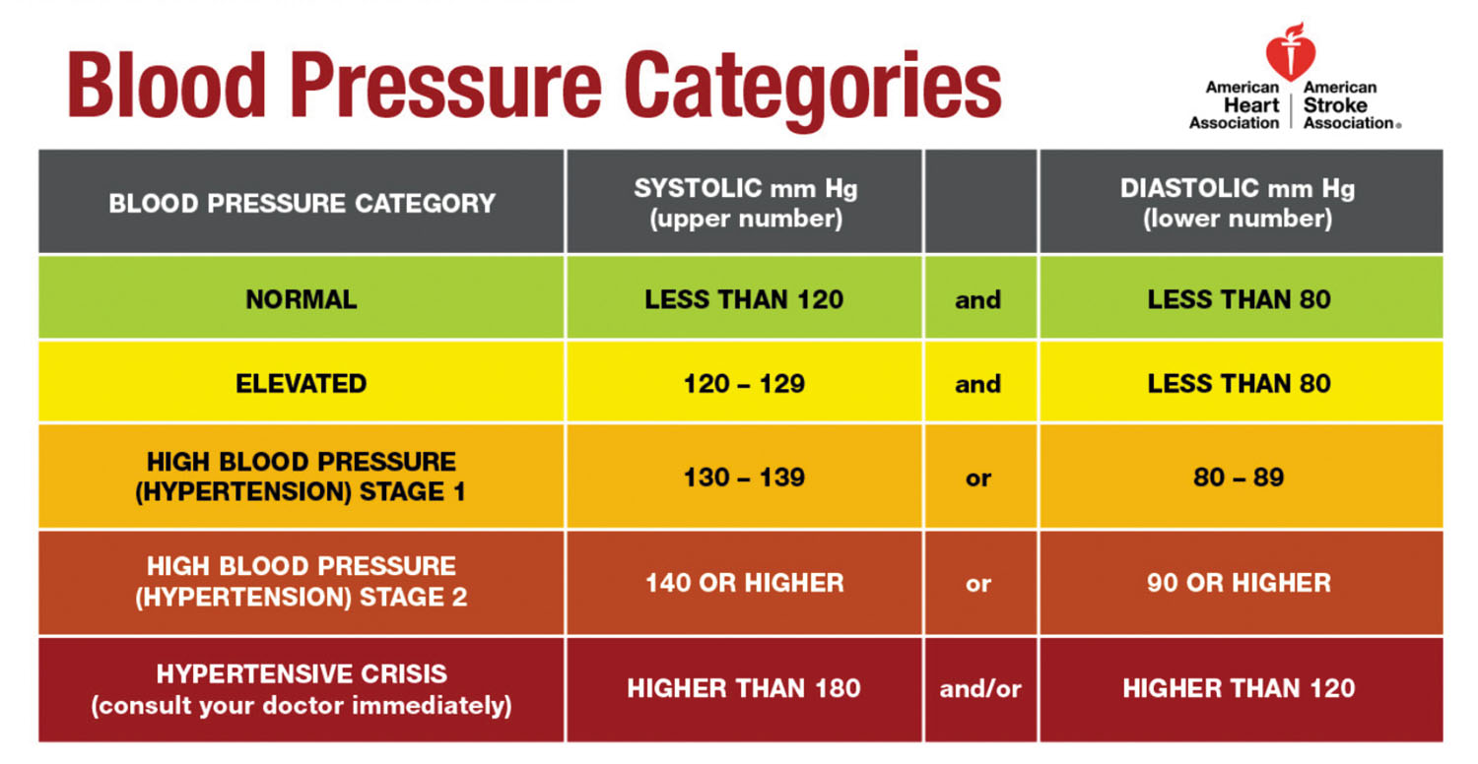
Recent Publications (minimum 5)
1-Padwal R, Straus SE, McAlister FA. Evidence based management of hypertension. Cardiovascular risk factors and their effects on the decision to treat hypertension: evidence based review. BMJ.2001; 322:977–80.
2-Tseng TH, Kao ES, Chu CY, Chou FP, Lin Wu HW, Wang CJ. Protective effects of dried flower extracts of Hibiscus sabdariffa L. against oxidative stress in rat primary hepatocytes. Food ChemToxicol.1997; 35:1159–64.
3-Allison L. Hopkins, Marnie G. Lamm, Janet L. Funk, Cheryl Ritenbaugh.Hibiscus sabdariffa L. in the treatment of hypertension and hyperlipidemia.A comprehensive review of animal and human studies. BMJ, Volume 85, pages 84-94.
4-Daniel ChukwuNwachukwu, Eddy IkemefunaAneke, Leonard Fidelis Obika, and NkiruZuadaNwachukwu.Indian J. Pharmacol. 2015 Sept- Oct: 47(5):540-5. Doi 10.4103/02537613.165194. Effects of aqueous extract of Hibiscus sabdariffa on the renin-angiotensin-aldosterone system of Nigerians with mild to moderate essential hypertension: A comparative study with lisinopril
5-Heron MP, Hoyert DL, Murphy SL, Xu JQ, Kochanek KD, Tejada-Vera B. National Vital Statistics Reports. 2009;57(14). Hyattsville, MD: National Center for Health Statistics
6-High blood pressure. National Heart, Lung, and Blood Institute. https://www.nhlbi.nih.gov/health-topics/high-blood-pressure. Accessed March 9, 2018
7-Hypertensive crisis: When you should call 9-1-1 for high blood pressure. American Heart Association. http://www.heart.org/HEARTORG/Conditions/HighBloodPressure/GettheFactsAboutHighBloodPressure/Hypertensive-Crisis-When-You-Should-Call-9-1-1-for-High-Blood-Pressure_UCM_301782_Article.jsp#.WrqtoOR1rcs. Accessed March 9, 2018
8-Know your risk factors for high blood pressure. American Heart Association. http://www.heart.org/HEARTORG/Conditions/HighBloodPressure/UnderstandSymptomsRisks/Know-Your-Risk-Factors-for-High-Blood-Pressure_UCM_002052_Article.jsp#.WrqvNeR1rcs. Accessed March 12, 2018.

Photograph



Biography (150-word limit)
Dr. Sabrin Ali Azim, MOH (UAE) specialist licensed in oral surgery- Eligible for
practicing as specialist or consultant as per Ministry of Health & Prevention- UAE
regulations, graduated with a PhD (equalized in UAE ministry of education) in oral and
maxillofacial surgery from Azerbaijan Medical University. Experienced in teaching in
UAE colleges since 2016 as assistant professor (RAKCODS five-year successful renewal
of a full time, contract, City University College of Ajman full time since 2021).

Experienced in supervising student projects (around 27 research projects that were
awarded as best poster in Dental facial conference, Chosen as best 10 posters in AEEDC,
Chosen as best poster for Saudi German hospital, Presented in Dubai International Food
Safety conference, MBRU Hacks Covid19, Azerbaijan Diaspora Youth, Presented in
Breast Cancer awareness day).
Organizer of a collaborations:
1. MOU between Azerbaijan Medical University and RAKHMSU and RAKCODS.
2. MOU between Azerbaijan Medical University and Riphaa University in Pakistan.
3. MOU between SOS children’s village Azerbaijan and ALIM scientific association in
France.
4. Collaborated with Catholic medical university of sacred heart, ITALY
5. Collaboration with Ministry of health in Azerbaijan.
6. Organizer of a medical trainings in Azerbaijan Medical university for students of
MBBS and BDS from UAE).
7. Organizing of Advisory board meeting.
8. Collaboration with operation smile, Italy.
Excellent record in community service and scholarly activities (organized Breast Cancer
awareness day with Saudi German hospital, trained supervisors in SOS children’s
village, Visited different schools in UAE, Azerbaijan, Founder of simple talks by Dr.
Sabrin – support for a students and community during Covid 19.
Experienced in Marketing strategy planning.

Email: azim.sabrin@yahoo.com

Notes/Comments:

